ZoomText
Large-Print
Keyboard
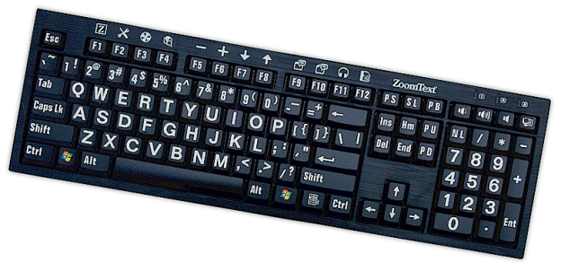
User's Guide v4.1



Copyrights
ZoomText Keyboard Software
Copyright © 2016, Algorithmic Implementations, Inc. All Rights Reserved.
ZoomText Large-Print Keyboard v4.1 User’s Guide
Copyright © 2016, Algorithmic Implementations, Inc. All Rights Reserved.
First Edition: March, 2016
Ai Squared, P.O. Box 669, Manchester Center, VT 05255 USA
Unauthorized copying, duplicating, selling or otherwise distributing this software or documentation is a violation of Federal Copyright Law. No part of this publication can be reproduced, transmitted, stored in a retrieval system, or translated into any language in any form by any means without the express written consent of Algorithmic Implementations, Inc. (d.b.a. Ai Squared).

Trademarks
ZoomText is a registered trademark of Algorithmic Implementations, Inc.
ZoomText Large-Print Keyboard is a trademark of Algorithmic Implementations, Inc.
Windows is a registered trademark of Microsoft Corporation.
Software License Agreement
The software included with this product is licensed, not sold. You must either agree to the license contract in the software Setup screen or promptly return the ZoomText Large-Print Keyboard, along with the software, for a refund, excluding the return costs. After you install the software, you may consult the license and the Limited Warranty for the product at any time by looking in the “Legal Information” section of the software Help files. You may also print a copy for your records.
Contents
Welcome to the ZoomText Keyboard 2
ZoomText Keyboard Features 3
New in the v4.1 Keyboard Software 5
System Requirements 7
Step 1—Connect the ZoomText Keyboard 8
Step 2—Install the Keyboard Software 9
Step 3—Activate the Keyboard Software 10
Step 4—Update the Keyboard Software 15
Step 5—Using the ZoomText Feature Keys 17
Step 6—Reassign the ZoomText Feature Keys 21
Using the Keyboard Software with Other Keyboards 22
The ZoomText Keyboard Settings 23
Accessing the ZoomText Keyboard Settings 24
The ZoomText Keyboard Settings Dialog 25
The Assign Key Wizard 30
Assigning ZoomText Commands 32
Assigning Windows Commands 33
Assigning Program Commands 34
Enabling and Disabling the ZoomText Feature Keys 35
Abbreviated Key Labels 36
Keyboard Status Lights 37
USB Ports 38
Maintenance 39
Troubleshooting 40
Health Warning 43
Limited Warranty 44

Welcome to the ZoomText Keyboard
Welcome and congratulations on your new ZoomText Large-Print Keyboard. We are proud that you have chosen the ZoomText Keyboard and we know that you will enjoy its cutting-edge style, features and performance for many years to come.
The ZoomText Keyboard user guide and Help system provide complete information for setting up and using your ZoomText Keyboard. Before you get started, we recommend that you take a few minutes to learn about all the great features and benefits of the ZoomText Keyboard, which is provided in the very next section, appropriately titled ZoomText Keyboard Features.
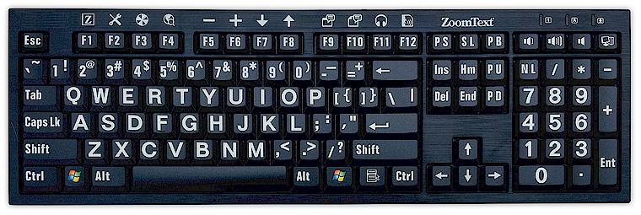
ZoomText Keyboard Features
Your new "4th generation" ZoomText Keyboard provides the following great features and benefits.
- Sleek modern design that compliments any workstation. The ZoomText Keyboard has a brilliant design that is both attractive and low-vision friendly, an accomplishment that was previously thought to be "impossible". This is the keyboard that all of your friends will admire.
- High-contrast keycaps that are easy to see, even in low light! Each and every key on the ZoomText Keyboard has a large-print keycap that's always easy to see, even in low-light conditions. And the ZoomText Keyboard is available in a choice of ultra-high-contrast color schemes, including White on Black and Black on Yellow.
- A full-size keyboard with industry standard layouts. With its full-size keyboard layout, including numeric keypad and navigation keys, the ZoomText Keyboard fulfills your needs in all of your applications. And the ZoomText Keyboard incorporates industry standard layouts, so organizational requirements are fulfilled as well.
- Premium keyboard action that is a joy to type on. The ZoomText Keyboard features premium scissor-switch keys that make typing fast, accurate and enjoyable. You won't believe how great this keyboard feels and how quickly you gain extra confidence in your typing.
- A solid chassis that stays anchored under your hands. Built on a durable weighted chassis, the ZoomText Keyboard stays put on your desktop and always feels solid and stable under your hands, even if you’re an aggressive typist.
- One-touch access to your favorite ZoomText features and more. With the ZoomText Keyboard software installed, the F1 through F12 function keys also become ZoomText Feature Keys, providing one-touch access to your favorite ZoomText commands, Windows commands (Internet and multimedia), or even commands to open an application, document or web page—all without having to memorize complicated hotkeys! And your ZoomText Keyboard software can be used with any keyboard, so the ZoomText Feature Keys are extended to your laptop keyboard, or any other keyboard that you want or need to use.
- Two conveniently located USB ports. The ZoomText Keyboard also includes two "always in reach" USB ports—one at each end of the keyboard. Plug in your mouse, thumb drive, webcam, LED light, or other USB device, without having to reach for those USB ports on the back of your laptop, or even worse, on the back of your computer that’s under your desk.
- The Perfect Companion. The ZoomText Large-Print Keyboard is the perfect companion to ZoomText Magnifier and ZoomText Magnifier/Reader (versions 9.03 and later). When used together, your low-vision workstation is complete.
New in the v4.1 Keyboard Software
The new version 4.1 keyboard software adds the following features and enhancements for using the ZoomText Keyboard.
- Keyboard Update Wizard. With the new Automatic Update Wizard, each time your system starts up, the update wizard will automatically check to see if a new version of the keyboard software is available. If a new version of the software is available the update wizard will give you the option to download and install the new software. Note: An Internet connection is required to use this feature. For more information, see Getting Started: Step 4—Update the Keyboard Software.
- Shorter press/hold times for triggering feature keys. The press/hold time for triggering feature keys and engaging the feature mode can now be set to 0.5 second and 1 second, allowing for faster access to the ZoomText Feature Key commands. For more information, see The ZoomText Keyboard Settings Dialogs.
- Adjustable time out for exiting feature key mode. The time out of the ZoomText Feature Key mode is now adjustable in increments of 3, 4 and 5 seconds. For more information, see The ZoomText Keyboard Settings Dialogs.
- Choice of sound cues to indicate when feature key mode is active. Sound cues can now be enabled to indicate when the ZoomText Feature Key mode is entered and exited. A choice of 4 sounds and three volume levels provide a variety of sound settings for you to choose from. For more information, see The ZoomText Keyboard Settings Dialogs.
System Requirements
The following hardware and software is required to use the ZoomText keyboard:
- USB keyboard connection
- Windows 10, Windows 8.x, Windows 7, Vista or XP
- ZoomText 9.03 or later (to use the ZoomText feature buttons)
Step 1—Connect the ZoomText Keyboard
Your ZoomText Keyboard can be connected to your computer using any available USB port.
- To connect the ZoomText Keyboard
- Plug the rectangular USB connector located at the end of the keyboard cable into one of your computer's rectangular USB ports.
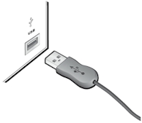
Step 2—Install the Keyboard Software
Installing the ZoomText Keyboard software is very straightforward, allowing you to complete the process in a few simple steps.
- To install the keyboard software
- Insert the ZoomText Keyboard software CD into the CD/DVD drive.
The Setup program will start automatically.
- Follow the on-screen instructions to complete the installation.
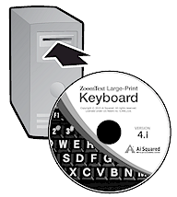
- If Setup does not start automatically
- Press Windows + R to open the Run dialog box.
- Browse to your CD/DVD drive.
- Select the Setup program and click Open.
- Click OK in the Run dialog box.
Step 3—Activate the Keyboard Software
After the Setup program has finished installing the ZoomText Keyboard software, you will be prompted to activate the software. Activation is required before you can begin using the ZoomText Feature Keys. The activation process is straightforward and secure; it takes just a few seconds to complete when performed over the Internet. If you skip the activation process during the Setup process, you will be prompted to activate again when you attempt to use the ZoomText Feature Keys.
- To activate the ZoomText Keyboard software
- To activate the ZoomText Keyboard software, you will need the serial number provided with your purchased product. You can find the serial number in the following locations:
- On the ZoomText Keyboard CD sleeve.
- On the side of the ZoomText Keyboard product box.
- On the back of the ZoomText Keyboard User's Guide.
- In the Activation Wizard, enter your name, company and serial number, then click the Next button.
- If you are connected to the Internet your serial number and system code are automatically passed to the Ai Squared activation server for validation. An activation code is then passed back to your computer, activating your ZoomText Keyboard software license. This process takes just a few seconds to complete.
- If you are not connected to the Internet the wizard displays your serial number and system code, along with instructions on how to manually obtain an activation code. An activation code can be obtained from Ai Squared's activation website (using another computer that is connected to the Internet), or by contacting Ai Squared's Product Support department.
Telephone activation support is available Monday through Friday, 9am to 5pm Eastern Time.
In North America, call: 1 (866) 331-1233
Outside North America, call +1 (802) 362-5393
Activating the ZoomText Keyboard Software on More Than One Computer
Single-user versions of the ZoomText Keyboard software allow you to install and activate the software on up to three computers (in accordance with the ZoomText Keyboard Software License Agreement). Multiple activations are provided to accommodate individuals that use more than one computer, such as a home computer, a work computer and a laptop computer. While the ZoomText Keyboard software may be installed on up to three computers, use of the collective installations is restricted to one user at any given time.
Transferring Your ZoomText Keyboard Software License (deactivating the software)
Should you want to move your ZoomText Keyboard software to a new computer, or need to reformat the hard drive on your current computer, it is important that you first transfer your software license back to the Ai Squared activation server. This preserves your license so that it may be used to activate a new installation of the ZoomText Keyboard software.
- To transfer your ZoomText Keyboard software license
In the Windows system tray (next to the taskbar clock), select the ZoomText Keyboard icon to display the pop up menu. In the menu, choose Transfer Software License... This action will launch the ZoomText Keyboard Activation Wizard and guide you through the transfer process. The completed process will deactivate the installation of the ZoomText Keyboard software and transfer the license back to the Ai Squared activation server.
Frequently Asked Questions about ZoomText Keyboard Software Activation
Below is a collection of questions and answers to provide further understanding of the ZoomText Keyboard software activation.
- What is product activation?
Product activation is an anti-piracy technology designed to verify that the ZoomText Keyboard software has been legitimately licensed.
- How does product activation work?
The activation process verifies that the serial number is legitimate and has not been activated on more computers than allowed by the ZoomText Keyboard Software License Agreement.
- What happens if I don’t activate my product?
If you don’t activate your product, you cannot run the ZoomText Keyboard software until you do so.
- What if my product activation fails?
Product activation will only fail under exceptional circumstances. In most cases, you can reactivate the ZoomText Keyboard software as quickly and easily as the original activation. If your attempt to reactivate fails, contact Ai Squared Product Support for help.
- What if I need to reformat or upgrade my computer?
If you need to reformat your hard drive or upgrade your Windows operating system, you should first transfer your ZoomText Keyboard software license back to the ZoomText Keyboard activation server. See Transferring your ZoomText Keyboard Software License (deactivating the software) in the preceding section.
Note: You do not need to transfer your ZoomText Keyboard software license when installing Windows service packs and hot fixes.
- What if I want to move my ZoomText Keyboard software to another computer?
Should you want to move your ZoomText Keyboard software to a new computer, it is important that you first transfer your software license back to the Ai Squared activation server. This preserves your software license so that it may be used to activate your new installation of the ZoomText Keyboard software. See Transferring your ZoomText Keyboard Software License (deactivating the software) in the preceding section.
Step 4—Update the Keyboard Software
The ZoomText Keyboard software includes automatic online version checking and updating. This service keeps your installation of ZoomText Keyboard software up-to-date with the latest fixes and enhancements. Here's how it works...
Each time you start your system the Update Wizard checks to see if you are online. If so, it quickly checks to see if you are running the latest version. If an update is available, the Update Wizard will ask if you want to download it. By clicking on the 'Yes' button, the update will download and install automatically.
If you or your network administrator does not want to check for updates each time you start ZoomText, you can disable automatic updating as follows:
- To disable automatic updating
- In the Windows system tray (next to the clock), click on the ZoomText Keyboard icon.
The ZoomText Keyboard menu will appear.
- In the ZoomText Keyboard menu, choose ZoomText Keyboard Settings...
The ZoomText Keyboard Settings dialog appears.
- Uncheck Check for online updates each time ZoomText Keyboard is launched.
- Click OK.
In addition to the automatic updating, you can manually check for updates at any time.
- To manually check for updates
- In the Windows system tray (next to the clock), click on the ZoomText Keyboard icon.
The ZoomText Keyboard menu will appear.
- In the ZoomText Keyboard menu, choose Check for Program Updates...
The Update Wizard appears and walks you through the update procedure.

Step 5—Using the ZoomText Feature Keys
About the ZoomText Feature Keys
When the ZoomText Keyboard software is running, a set of ZoomText Feature Keys are layered onto the function keys (F1 through F12). The ZoomText Feature Keys provide one-touch access to the most commonly used features and commands in ZoomText Magnifier and ZoomText Magnifier/Reader. Icons representing the default command assignments are printed above the function keys. Descriptions of these default assignments are described in the Default ZoomText Feature Keys table below. For complete information on these features, refer to the ZoomText User's Guide or the ZoomText Help system.
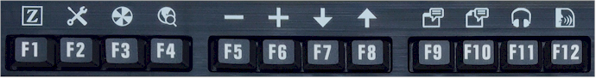
Function keys with ZoomText Feature Key icons.
Using the ZoomText Feature Keys
As already pointed out, the ZoomText Feature Keys are layered on top of the function keys (F1 through F12). So how do you trigger the normal function keys and the ZoomText Feature Keys? It's actually very simple. Here's how it works...
For starters, the ZoomText Feature Keys do not interfere with the normal operation of your function keys. Therefore, normal tapping the function keys will still trigger their normal commands in all of your applications.
To trigger ZoomText Feature Keys, simply press and hold the function key for one-half second. The assigned feature key command will be triggered and the ZoomText Feature Key Mode will become active for a few seconds. While the feature key mode is active, you can tap (rather than hold) the function keys to trigger additional feature key commands. Also, to let you know the mode is active, a ZoomText banner will appear across the top of the screen and a rhythmic sound cue will be played. The feature key mode automatically exits 3 seconds after the last function key is tapped or immediately when you press any other key. You can adjust the press and hold time, exit time, appearance of the banner and the sound cues in The ZoomText Keyboard Setting Dialog.
Important! If you are using a laptop or compact keyboard that is configured so that you have to hold the Fn key in order trigger the normal function key commands, you will also have to hold the Fn key when triggering ZoomText Feature Key Commands.
Using the Feature Keys with ZoomText Magnifier
By default, six of the feature keys (F7 through F12) are assigned to speech and reading commands that are only available when running ZoomText Magnifier/Reader. Therefore, when running ZoomText Magnifier, pressing these six feature keys will not perform their assigned command. Instead you will be prompted to reassign the feature keys to an available command of your choice. For information on reassigning the feature keys, see the section titled The ZoomText Keyboard Settings Dialog.
Default ZoomText Feature Keys
Below are descriptions of the default ZoomText Feature Keys.
Function Key | Feature Key | Description
F1 |  | Starts ZoomText. Also enables and disables ZoomText when ZoomText is running.
F2 |  | Displays the ZoomText Toolbar.
F3 |  | Toggles ZoomText's color enhancements on and off.
F4 |  | Opens the Web Finder.
F5 |  | Decreases ZoomText's magnification level.
F6 |  | Increases ZoomText's magnification level.
The following feature keys are assigned to features that are only available in ZoomText Magnifier/Reader.
F7 |  | Decreases the speech rate.
F8 |  | Increases the speech rate.
F9 |  | Launches AppReader to read text within the last active application.
F10 |  | Launches DocReader to read text from the last active application.
F11 |  | Launches the Background Reader.
F12 |  | Turns speech output on and off.
Reassigning the ZoomText Feature Keys
You can reassign each of the ZoomText Feature Keys to perform your choice of ZoomText command, Internet and multimedia command, or a command to open an application, document or web page. For complete information and instructions on reassigning the feature keys, see the section titled The ZoomText Keyboard Settings Dialog.
Step 6—Reassign the ZoomText Feature Keys
You can reassign each of the ZoomText Feature Keys to perform your choice of ZoomText command, Internet and multimedia command, or a command to open an application, document or web page. For complete information and instructions on reassigning the feature keys, refer to the section titled The ZoomText Keyboard Settings Dialog.
Using the Keyboard Software with Other Keyboards
We know that there are situations where your ZoomText Keyboard is not available or where you need to use another keyboard because it is required or better suited for the task. We don't want you to have to choose between using the ZoomText Keyboard with the ZoomText Feature Keys and using another keyboard without the ZoomText Feature Keys, so we've designed the ZoomText Keyboard software and ZoomText Feature Keys so that they will work on virtually any keyboard you want or have to use.
Using the ZoomText Feature Keys on laptop and compact layout keyboards
Many laptop keyboards and compact desktop keyboards utilize the function keys (F1 through F12) to trigger special commands, such as screen brightness, switching video modes and controlling the audio volume. Triggering these special commands is typically accomplished by holding down the Fn key while pressing the function keys. Therefore, tapping the function keys alone (without holding down the Fn key) still triggers the normal function key commands; and the methods for triggering ZoomText Feature Keys still are still performed as described in Step 5—Using the ZoomText Feature Keys.
However, on some laptops, the Fn key can be reversed so that the special functions are performed without holding the Fn key and triggering normal function key commands requires you to hold down the Fn key. In this case, the Fn key must also be held down when you want to trigger ZoomText Feature Keys.
The ZoomText Keyboard Settings
The ZoomText Keyboard Settings allow you to reassign each of the ZoomText Feature Keys to your choice of ZoomText command, Windows command (Internet and multimedia), or a command to open an application, document or web page. The keyboard settings also allow you to enable and disable the feature keys and adjust the options for the feature keys.
- How to accessing the ZoomText Keyboard Settings
- The Keyboard Settings Dialog
- The Assign Key Wizard
- Assigning ZoomText Commands
- Assigning Windows Commands
- Assigning Program Commands
- Disabling the ZoomText Feature Keys

Accessing the ZoomText Keyboard Settings
When the ZoomText Keyboard software is running, its program icon appears in the Windows system tray (next to the clock). Clicking on the program icon will pop up a menu that allows you to do the following:
- Enable and disable the ZoomText Feature Keys
- Open the ZoomText Keyboard Settings dialog
- Enable and disabled the keyboard banner and sound cues
- Activate or transfer the product license
- Check for updates for the keyboard software
- View information about the ZoomText Keyboard software
- Open the ZoomText Keyboard Help system
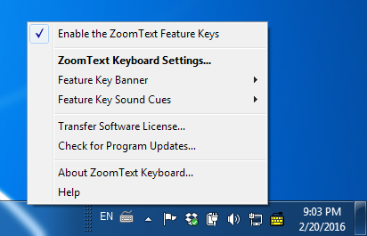
ZoomText Keyboard tray menu
The ZoomText Keyboard Settings Dialog
The ZoomText Keyboard Settings dialog allows you to examine the current feature key command assignments and reassign them to perform alternate commands—using the Assign Key wizard. The Keyboard Settings dialog also allows you to disable all of the feature keys and hide the ZoomText Keyboard tray icon.
- To open the ZoomText Keyboard Settings
- In the Windows system tray, click on the ZoomText Keyboard icon.
The ZoomText Keyboard tray menu appears.
- Select Open ZoomText Keyboard.
The ZoomText Keyboard Settings dialog appears.
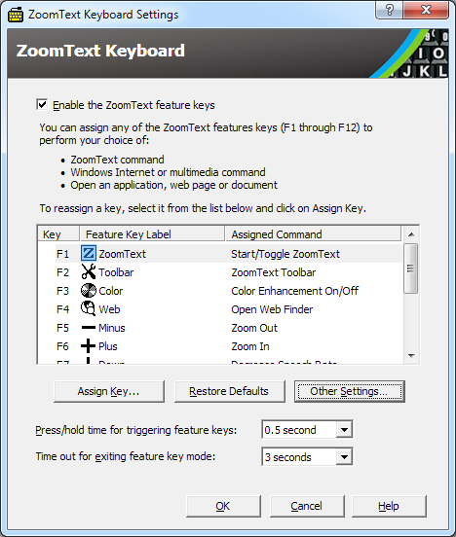
ZoomText Keyboard Settings dialog

Setting | Description
Enable the ZoomText feature keys | Enables all of the ZoomText feature keys. When you uncheck this item the feature keys are disabled.
Key | Displays the function key associated with each feature key.
Feature Key Label | Displays the icon associated with each default feature key.
Assigned Command | Displays a description of the command that’s currently assigned to the feature key.
Assign Key | Opens the Assign Key wizard for the highlighted feature key.
Restore Defaults | Restores all of the feature key assignments to their (factory) default commands.
Other Settings... | Opens the Other ZoomText Keyboard Settings dialog box.
Press/hold time for triggering feature keys: | Adjusts the amount of time that a function key has to be held down to trigger the feature key and activate the feature key mode.
Time out for exiting feature key mode | Adjusts the amount of time that the feature key mode will remain active (before automatically exiting) after each feature key is triggered.

Note: You can also open the ZoomText Keyboard Settings from the Windows Start menu, by choosing Programs > ZoomText Keyboard > ZoomText Keyboard.
Other ZoomText Keyboard Settings
The Other ZoomText Keyboard Settings dialog allows you to enable and disable the display of the ZoomText Keyboard tray icon and the appearance of the ZoomText Keyboard banner.
- To open the Other ZoomText Keyboard Settings
- In the ZoomText Keyboard Settings dialog, click on the Other Settings button.
The Other ZoomText Keyboard Settings dialog appears.
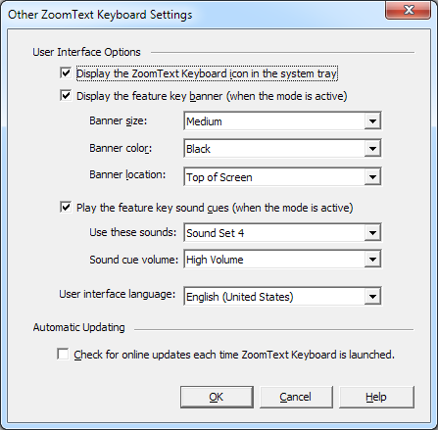
Other ZoomText Keyboard Settings dialog

Setting | Description
Display a ZoomText Keyboard icon in system tray | Displays the ZoomText Keyboard icon in the Windows system tray. Clicking on the icon displays a menu for accessing the ZoomText Keyboard Settings and other options.
Display the feature key banner (when the mode is active) | Displays a "ZoomText Keyboard" banner when the feature key mode is active. The banner provides visual indication that the mode is active.
Banner size | Adjust the size of the keyboard banner.
Banner color | Selects the color of the keyboard banner.
Banner location | Selects the location of the keyboard banner, which can be located at the top or bottom edge of the screen.
Play the feature key sound cues (when the mode is active) | Plays a sound cue when the feature key mode is active. The sound cue provides audible indication that the mode is active.
Use these sounds | Selects the style of sound cue that will be played.
Sound cue volume | Selects the volume level for the sound cue.
User interface language | Selects the language that the ZoomText Keyboard user interface will appear in.
Check for online updates each time the ZoomText Keyboard is launched | Each time you start your system, the update wizard will check online for available program updates. If updates are available, the Update Wizard will give you the option to download and install the updates.
The Assign Key Wizard
When selecting the Assign Key button in the ZoomText Keyboard Settings dialog, the Assign Key wizard appears. The Assign Key wizard allows you to reassign ZoomText feature keys to your choice of ZoomText commands, Windows commands (Internet or multimedia), or to open an application, web page, or document.
- To reassign ZoomText feature keys
- Open the ZoomText Keyboard Settings dialog, and select the key that you want to reassign.
- Click on the Assign Key button.
The Assign Key wizard opens.
- Choose the desired assignment type and then click the Next button.
The wizard will display a list of command options for the selected assignment type.
For information on each of the command options types, see...
Assigning ZoomText Commands
Assigning Windows Commands
Assigning Program Commands
Quick Tip! You can also hold down the Alt key while pressing a feature key to open the Assign Key wizard for that particular key.

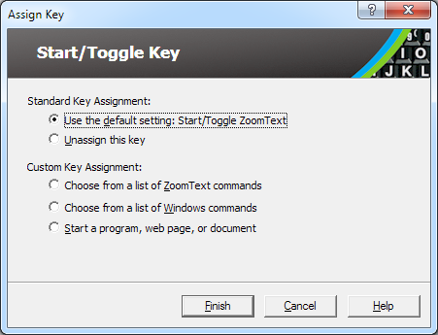
Assign Key wizard – dialog
Setting | Description
Use the default setting: | Sets the selected feature key to use the preassigned (default) command.
Unassign this assign | Disables the selected feature key.
Choose from a list of ZoomText commands | Allows you to assign a ZoomText command to the selected feature key.
Choose from a list of Windows commands | Allows you to assign a Windows command (Internet or multimedia) to the selected feature key.
Start a program, web page, or document | Allows you to specify a program, web page or document to open when pressing the selected feature key.
Assigning ZoomText Commands
When selecting the Choose from a list of ZoomText commands option in the Assign Key wizard, the dialog shown below will appear. This dialog allows you to choose a ZoomText command to assign to the feature key that you've chosen in the ZoomText Keyboard Settings dialog.
- To assign a ZoomText command to a ZoomText feature key
Choose the desired ZoomText command and then click the Finish button.
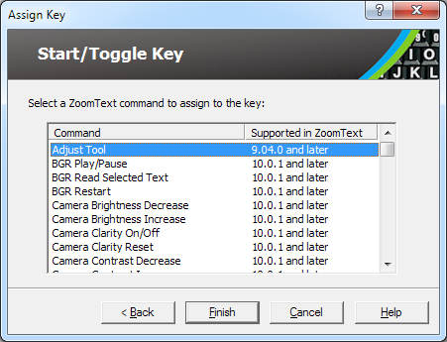
Assign Key Wizard - ZoomText command options
Assigning Windows Commands
When selecting the Choose from a list of Windows commands option in the Assign Key wizard, the dialog shown below will appear. This dialog allows you to choose a Windows Internet or multimedia command to assign to the feature key that you've chosen in the ZoomText Keyboard Settings dialog.
- To assign a Windows command to a ZoomText feature key
Choose the desired Windows command and then click the Finish button.
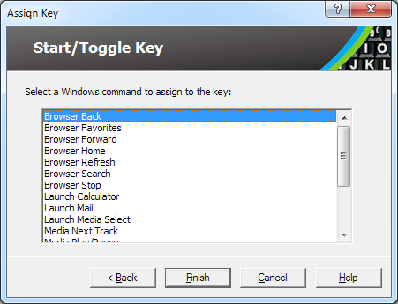
Assign Key Wizard - Windows command options
Assigning Program Commands
When selecting the Start a program, web page, or document option in the Assign Key wizard, the dialog shown below will appear. This dialog allows you to specify a program, web page or document to open when pressing the selected feature key that you've chosen in the ZoomText Keyboard Settings dialog.
- To assign a program command to a ZoomText feature key
Enter the path or URL for the program, web page or document that you want to open and then click the Finish button.
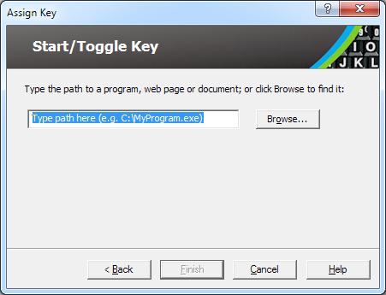
Assign Key Wizard - program command options
Enabling and Disabling the ZoomText Feature Keys
There may be occasions when you want or need to temporarily disable the ZoomText Feature Keys.
- To enable and disable the ZoomText feature keys
In the system tray, click on the ZoomText Keyboard icon and check or uncheck Enable the ZoomText Feature Keys.
The feature keys are enabled when a checkmark appears next to the menu item.
Tray menu with feature keys enabled
Abbreviated Key Labels
To accommodate the large-print labeling format on the ZoomText keyboard, some of the conventional key names are abbreviated to fit the keycap. These keys are listed below.
 | Print Screen |  | Insert
 | Scroll Lock |  | Delete
 | Pause / Break |  | Page Up
 | Home |  | Page Down
 | End |  | Num Lock
Keyboard Status Lights
The keyboard lights, located above the numeric keypad, indicate the status of the Num Lock, Caps Lock, and Scroll Lock toggle keys. For example, if Num Lock is on, the Num Lock light is on; if Caps Lock is off, the Caps Lock light is off.
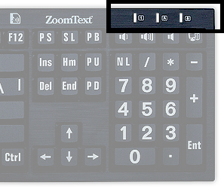
ZoomText Keyboard status lights
USB Ports
The ZoomText Keyboard includes two "always in reach" USB ports, one at each end of the keyboard. These ports can be used to connect most types of USB devices, including a mouse, thumb drives, webcams or LED lights. With their convenient location, you can avoid those hard to reach USB ports on the back of your laptop, or even worse, on the back of your computer that’s under your desk.
Maintenance
- Liquid is spilled on the keyboard.
If any liquid is spilled on the keyboard, switch off your computer immediately and unplug all items. Turn the keyboard upside down to drain the liquid.
- If the liquid is water, simply let the keyboard dry before using it again.
- If the liquid is a sticky substance, drain the liquid and then completely wipe the keyboard with a damp cloth. Allow the keyboard to dry before reconnecting it to the computer.
- Keeping your keyboard clean.
For optimum performance, keep your keyboard clean and free of debris, such as food crumbs or dust. Keyboards should be cleaned on a monthly basis, with a “spray and wipe” cleaner applied to a cloth. Be sure the computer is turned off before cleaning.
Troubleshooting
- The entire keyboard is not responding.
If your keyboard is not responding, try each of the following procedures in the order listed below:
- Bypass any port replicators, USB hubs, KVM switches, and so on. Connect the receiver directly to a port on the computer.
- Check to see that the keyboard connector is securely plugged into the correct port on the computer.
- Try connecting to a different USB port (if multiple ports exist).
- Verify that another USB connected device works on the same port.
- Shut down the system, wait 10 seconds, and then restart the system.
- Some of the keys are not responding
If some of the keys on your keyboard are not responding, there may be a conflict with a component of hardware or software on your system. In some cases, plugging your keyboard into a port replicator, USB hub or KVM switch may cause some of the keys to behave erratically. These issues may also occur if a third-party keyboard control utility is running on your computer. If your keyboard is exhibits this behavior, try connecting the keyboard directly into a USB port on the computer and disabling all third-party keyboard control utilities.
- ZoomText feature keys are not responding.
If the ZoomText feature keys are not responding, make sure that ZoomText Keyboard software is installed and running and that the feature keys are enabled. When the ZoomText Keyboard software is running a ZoomText Keyboard icon appears in the Windows system tray (next to the clock). If this icon does not appear, the software may still be running but with the icon hidden. In this case, go to the Windows Start menu and choose Programs > ZoomText Keyboard > ZoomText Keyboard. This will open the ZoomText Keyboard Settings dialog where you can enable the feature keys and also enable display of the ZoomText Keyboard icon in the system tray.
- ZoomText feature keys are invoking incorrect commands
If the ZoomText feature keys are invoking different commands from those assigned in the ZoomText Keyboard Settings dialog box, another keyboard utility may have taken control of the keyboard. If this is the case, you must disable it or uninstall the other keyboard utility to regain use of the ZoomText Feature Keys.
Health Warning
When using a computer, as with many activities, you may experience occasional discomfort in your hands, arms, shoulders, neck, or other parts of your body. However, if you experience symptoms such as persistent or recurring discomfort, pain, throbbing, aching, tingling, numbness, burning sensation, or stiffness, DO NOT IGNORE THESE WARNING SIGNS. PROMPTLY SEE A QUALIFIED HEALTH PROFESSIONAL, even if the symptoms occur when you are not working at your computer. Symptoms such as these can be associated with painful and sometimes permanently disabling injuries or disorders of the nerves, muscles, tendons, or other parts of the body. These musculoskeletal disorders (MSDs) include carpal tunnel syndrome, tendonitis, tenosynovitis, and other conditions.
While researchers are not yet able to answer many questions about MSDs, there is a general agreement that many factors may be linked to their occurrence, including: medical and physical conditions, stress and how one copes with it, overall health, and how a person positions and uses his or her body during work and other activities (including use of a keyboard or pointing device). Some studies suggest that the amount of time a person uses a keyboard may also be a factor. For guidelines that may help you work more comfortably with your computer and possibly reduce your risk of experiencing an MSD, consult your local physician.
If you have any questions about how your own lifestyle, activities, or medical or physical condition may be related to MSDs, see a qualified health professional.
Limited Warranty
The ZoomText Large-Print Keyboard is warranted against both manufacturing defects and damage sustained via shipping. The details of each type of warranty are covered below.
Shipping Damage
Packages are sometimes damaged in transit by the package carrier. If you need to return a keyboard due to package damage Ai Squared must be notified within seven (7) days of receipt of keyboard. Failure to notify Ai Squared within the above timeframe means that Ai Squared will consider replacement of the keyboard at its sole discretion.
Manufacturing Defects
Keyboards are covered by warranty for manufacturer’s defects for six (6) months after the original shipping date.
Manufacturing defects include but are not limited to items such as sticky or broken keys and broken or inoperable cabling. Damages due to normal use or keyboard wear and tear are not covered. If you have any question as to whether or not a problem you are experiencing is covered under our manufacturer’s warranty please call us at (802) 362-3612.
Your warranty covers your purchase, not the exact keyboard you are using. If your keyboard is submitted for repair or replacement your warranty continues from the original purchase date - it does not restart with arrival of your new or repaired keyboard.
Return Policy for All Keyboard Purchases
In order to return a keyboard to Ai Squared for repair or replacement you must first obtain an RMA (Return Merchandise Authorization) number from Ai Squared. No returns will be processed without a valid RMA Number. To obtain your RMA please contact the Ai Squared sales department at (802) 362-3612.
Ai Squared will pay shipping charges for the return of a defective product for the first 30 days after your original purchase date. Once you have spoken to us we will arrange for our shipper to pick your package up and apply an appropriate shipping label. At our discretion we will repair or replace the keyboard.
If your keyboard fails after the first 30 days of usage you must still obtain an RMA from us and then ship the item to Ai Squared at your own expense. We will repair or replace your keyboard and ship it back to you at no cost to you.



 | Phone: | (802) 362-3612  (800) 859-0270
 | Fax: | (802) 362-1670
 | Email: | sales@aisquared.com  support@aisquared.com
 | Mail: | PO Box 669  Manchester Center, VT 05255 USA

www.aisquared.com

