ZoomText
User Guide

Freedom Scientific, Inc.
www.FreedomScientific.com
440945-001 Rev H

Copyrights
Fusion
Copyright © 2024, Freedom Scientific, Inc. All Rights Reserved.
ZoomText Magnifier
Copyright © 2024, Freedom Scientific, Inc. All Rights Reserved.
ZoomText Magnifier/Reader
Copyright © 2024, Freedom Scientific, Inc. All Rights Reserved.
ZoomText User Guide
Copyright © 2024, Freedom Scientific, Inc. All Rights Reserved.
Unauthorized copying, duplicating, selling or otherwise distributing this software or documentation is a violation of Federal Copyright Law. No part of this publication can be reproduced, transmitted, stored in a retrieval system, or translated into any language in any form by any means without the express written consent of Freedom Scientific, Inc.
Trademarks
ZoomText and xFont are registered trademarks of Freedom Scientific, Inc.
Fusion, ZoomText Magnifier and ZoomText Magnifier/Reader are trademarks of Freedom Scientific, Inc.
Microsoft and Windows are registered trademarks of Microsoft Corporation.
Sentinel is a registered trademark of SafeNet, Inc.
March 2024
Freedom Scientific, Inc.

Contents
Contents 3
Welcome to ZoomText 1
Magnifier Features 3
Magnifier/Reader Features 5
Getting Started with ZoomText 7
Setting Up ZoomText 12
System Requirements 13
Step 1—Install ZoomText 14
Step 2—Start ZoomText 15
Step 3—Activate ZoomText 16
Step 4—Update ZoomText 18
Adding More Voices 19
Using the Startup Wizard 20
Uninstalling ZoomText 21
Running ZoomText 22
Starting ZoomText 23
Enabling and Disabling ZoomText 24
ZoomText's Use of the Caps Locks Key 25
Exiting ZoomText 26
Getting Help with ZoomText 27
Windows Logon and Secure Mode Support 29
The ZoomText User Interface 32
The ZoomText Toolbar 33
Quick Access Bar 35
Screen Shade (Fusion only) 44
Command Keys 45
Types of Command Keys 46
The Essential ZoomText Hotkeys 48
The Command Keys Dialog 50
Layered Keys Banner 55
Resolving Hotkey Conflicts 57
Touch Screen Support 58
Using ZoomText on a Touch Screen 59
Using the ZoomText Touch Icon 60
Accessing ZoomText Features with Touch Gestures 63
Magnifier Features 67
The Magnifier Toolbar Tab 68
Zooming In and Out 70
Using Zoom to 1x 75
Scrolling the Magnified View 76
Zoom Windows 78
Running with One Monitor or Multiple Monitors 79
Selecting Zoom Windows 80
Adjusting Zoom Windows 88
Tethered View 89
Freeze View 94
Using Overview Mode and the View Locator 102
Managing Multiple Monitors 105
Multiple Monitor Options 106
Supported Multiple Monitor Hardware 109
Recommended Monitor Configurations 110
Configuring Displays for Multiple Monitor Support 111
Automatic Adjustment to Display Changes 113
Feature Behaviors in Multiple Monitors 114
Troubleshooting Multiple Monitors 116
Screen Enhancements 118
Color Enhancements 119
Pointer Enhancements 123
Cursor Enhancements 127
Focus Enhancements 131
Using Smart Invert 135
Navigation Settings 136
Tracking 137
Alignment 139
Mouse 142
Panning 144
Reader Features 146
The Reader Toolbar Tab 147
The ZoomText Voice 149
Enabling and Disabling the Voice 150
Adjusting the Voice Rate 151
Voice Settings 152
Text Processing 156
Hints 160
Audio 163
Echo 165
Keyboard Echo 166
Mouse Echo 169
Program Echo 172
Verbosity 174
AppReader 177
AppReader Reading Modes 178
The Text View Environment 180
Starting and Using AppReader 183
App View Settings 187
Text View Settings 190
Shared Settings 194
Reading Zones 197
Creating, Editing and Deleting Reading Zones 198
Using Reading Zones 201
The Reading Zones Toolbar 203
Reading Zones Settings 204
Reading with the Text Cursor 208
Say Commands 211
Tools Features 213
The Tools Toolbar Tab 214
Finder 215
ZoomText Camera 225
Background Reader 235
ZoomText Recorder 240
Voice Assistant 245
Configurations 259
The Default Configuration 260
Saving and Loading Configurations 261
Configurations Hotkeys 262
Application Settings 263
Preference Settings 266
Program Preferences 267
User Interface Preferences 271
Smoothing Preferences 274
Legacy Reading Preferences 279
Run ZoomText As 281
ZoomText Commands 282
AppReader Commands 283
Background Reader Commands 285
Camera Commands 287
Finder Commands 289
Layered Keys Command Mode 291
Magnifier Commands 293
Program Commands 295
Reader Commands 296
Reading Zones Commands 297
Recorder Commands 299
Say Commands 300
Scroll Commands 302
Support Commands 304
Text Cursor Commands 306
Window Commands 307
ZoomText Support 309
System Information 310
Data Reporting 312
Tools (Support) 315
FS Support Tool 316
Remote Desktop 318
Fix-It Command 320
Display Adapter 322
Early Adopter Program 324
Training Center 327
About ZoomText 328
Message Center 330
Scripting 333
What are Scripts and Scripting Languages? 335
Writing ZoomText Scripts 336
Registering Scripts 337
Managing Scripts 341
Script Hotkeys 344
Scripting Documentation for Script Writers 345
Index 346

Chapter 1

Welcome to ZoomText
ZoomText is a powerful computer access solution that allows low vision computer users to see, hear and use everything on Windows desktops, laptops and tablet devices. ZoomText gives you the tools to enlarge, enhance and read everything just the way you want, so that you can fully enjoy using your computer.
ZoomText is available in two product versions: ZoomText Magnifier and ZoomText Magnifier/Reader.
- ZoomText Magnifier provides the complete set of screen magnification tools for enlarging and enhancing everything on your computer screen.
- ZoomText Magnifier/Reader provides all of the features of ZoomText Magnifier, plus a user-friendly set of screen and document reading tools tailored for low vision users. ZoomText reading tools are also perfect for individuals with learning disabilities, low literacy and other print disabilities.
Both versions of ZoomText are designed for users of all ages and skill levels and with the goal of providing independence, productivity and success at home, school and in the workplace.

Magnifier Features
ZoomText Magnifier is an advanced screen magnification program that enlarges and enhances everything on your computer screen.
ZoomText Magnifier features include:
- Flexible Magnification. ZoomText provides a full range of magnification levels up to 60x. Levels include: 1x to 8x in steps of 1, 10x to 16x in steps of 2, 20x to 36x in steps of 4, 42x, to 60x in steps of 6, and fractional powers of 1.2x, 1.4x, 1.6x, 1.8x, 2.5x, 3.5x and 4.5x. You can zoom in and out using All Zoom Levels, Favorite Zoom Levels Only or Whole Power Levels Only.
- Powerful Zoom Windows. ZoomText provides a wide variety of zoom window types for both single and multiple monitor configurations, allowing you to configure the magnified view according to your needs.
- Advanced Smoothing. ZoomText provides two types of advanced smoothing, xFont® and Geometric Smoothing, ensure the text and graphics (including photographs) are crisp and legible at all zoom levels.
- Multiple Monitor Support. ZoomText's Multiple Monitor Support allows you to see more information in a variety of ways. ZoomText’s unique MultiView modes—MultiView Local and MultiView Global (patent pending), allow you to simultaneously view multiple applications or multiple locations within the same application.
- Enhanced Screen Colors. Innovative color controls improve screen clarity and reduce eyestrain. Special effects include color dyes, two-color modes and, replacement of problem colors.
- Visible Pointers and Cursors. Size and color enhancements make it easy to see the mouse pointer. Special locators around the mouse pointer and text cursor make them easy to find and follow.
- Focus Enhancements. Focus enhancements make it easy to locate and follow the control focus when you navigate through menus, dialogs, and other application controls.
- Smooth Navigation. Navigating your applications and scrolling the view is always smooth and comfortable.
- Support for Touch Screen Devices. ZoomText for can be used on Windows 10 and 8.1 touch screen devices including tablets, laptops and desktop monitors. ZoomText follows along as you tap, drag and swipe your way through all of your applications. And you can instantly access key ZoomText features using the ZoomText Touch Icon and gestures. Note: Requires a 5-point or greater multi-touch device. For more information, see Touch Screen Support.
- Finder. Finder helps you search, skim, navigate, and read in documents, web pages and email. You can search for single words or phrases throughout the entire document or only in specific items, such as headers, forms and links.
- ZoomText Camera. ZoomText Camera allows you to magnify printed documents, books and other items using a standard HD webcam.
- Application Settings. Save unique settings for each application that you use. As you switch applications, ZoomText automatically loads the desired settings.
- Windows Logon Support. ZoomText provide magnification and screen reading support in the Windows logon screen and other secure mode prompts.

Magnifier/Reader Features
ZoomText Magnifier/Reader is a fully integrated magnification and screen reading program that enlarges, enhances and reads aloud everything on your computer screen.
ZoomText Magnifier/Reader includes all the features of ZoomText Magnifier, plus:
- Complete Screen Reading. ZoomText automatically speaks all program controls and events as you navigate through applications; including menus, dialogs, list views and messages. Three verbosity levels give you complete control over the amount of information spoken.
- AppReader. With the AppReader you can read right in the target application or switch on-the-fly to the high contrast text view that's better for visual reading. You can also spot read blocks of text by clicking and dragging the mouse. Use AppReader's 'Read from Pointer' command to instantly start AppReader at the word under the mouse pointer.
- Reading Zones. Reading Zones allow you to instantly see and hear selected locations in your applications. Define up to 10 zones per application that you can trigger via a pop-up menu or keyboard commands.
- Full Internet Accessibility. ZoomText reads any web page, in the proper reading order. You can read automatically or manually navigate by word, line, sentence and paragraph.
- Text Navigation. Navigation keys make it easy to read while creating and editing documents. With simple commands you can read by character, word, line, sentence and paragraph, even while selecting text.
- Typing Echo. Each key or word that you type is automatically spoken. You can choose to have all keys spoken or only selected groups of keys.
- Mouse Echo. Mouse echo automatically reads text that you point to. Single words or complete lines of text are spoken instantly or after hovering briefly.
- SpeakIt Tool. The SpeakIt tool allows you to read selected areas of the screen by clicking or dragging the mouse.
- Background Reader. Background Reader allows you to listen to documents, web pages, email or any text while you simultaneously perform other tasks.
- ZoomText Recorder. ZoomText Recorder allows you to turn text from documents, web pages, email or other sources into audio recordings that you can listen to on your computer, or transfer the recordings to your mobile device for listening to on the go.
- Built-in Premium Voices. ZoomText Magnifier/Reader includes a full library of Vocalizer Expressive speech synthesizers, providing voices for the most commonly spoken languages and dialects from around the world.

Getting Started with ZoomText
ZoomText has a lot of features designed to cover the varying needs of users. This topic provides an overview of how ZoomText works along with quick start instructions for the essential features that all users need to learn and use.
How ZoomText Works
Most of the time ZoomText works in the background providing a magnified and enhanced view that follows all of your activity. So as you move the mouse pointer, type text, and navigate your applications, your point of interest is always in view. If you're running ZoomText Magnifier/Reader, ZoomText also echoes and narrates what you're doing, audibly confirming where you are, what you type, and more. All of this happens automatically, so you can think of ZoomText as your personal guide in your computer.
The ZoomText Toolbar
The ZoomText toolbar has a streamlined and modern layout that makes it easy to learn and fast and fluid to use. You can access and operate the entire toolbar using the mouse or the keyboard.
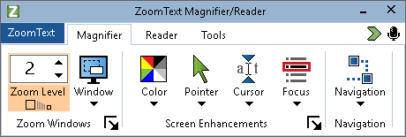
The ZoomText Toolbar
Using the arrow keys, you can navigate in and between the ZoomText menu, toolbar tabs, toolbar controls and button menus. When the focus is on a split button, pressing the Enter key will toggle the feature, while pressing the down arrow will open the attached menu. When the focus is in the Zoom Level spin box (on the Magnifier toolbar) or the Rate spin box (on the Reader toolbar), pressing the Up and Down keys will adjust the spin box value and pressing the Left and Right keys will move the focus to the next control. On the Zoom Level spin box, pressing the Enter key will also toggle the Zoom to 1x feature.
Setting Up the Magnified View
Since the primary purpose of ZoomText is to make everything larger and easier to see, the first task is to adjust the zoom level and screen colors for comfortable viewing. Here are the fast-track methods for making these adjustments.
- To increase and decrease the Zoom Level
Hold down the Caps Lock key and press the Up and Down arrow keys.
- To toggle between the current Zoom Level and 1x
Hold down the Caps Lock key and press the Enter key.
- To invert the brightness of the screen
Hold down the Caps Lock key and press C.
You can learn more about all of ZoomText's visual features and settings in Chapter 5—Magnifier Features.
Setting Up the ZoomText Voice and Echo Features
If you're running ZoomText Magnifier/Reader, ZoomText audibly echoes and narrates everything you do, so your second task is to adjust ZoomText's voice rate and echo settings so that ZoomText speaks program activity the way you like. This includes how the keyboard is echoed when you type, and how ZoomText's program echo announces menus, dialog boxes and other controls as you navigate through your applications. Here are the fast-track methods for making these adjustments.
- To speed up and slow down ZoomText's voice rate
Hold down Caps Lock + Alt and press the Up and Down arrow keys.
- To adjust how the keyboard is echoed when you type
Hold down Caps Lock + Alt and press K. Each press cycles the keyboard echo to hear a choice of characters only, words only, characters and words, or nothing at all.
- To adjust the verbosity level for program echo
Hold down Caps Lock + Alt and press B. Each press cycles the verbosity level between a choice of Low, Medium and High levels. Low verbosity speaks the minimum details about each item, while high verbosity speaks the maximum details.
You can learn more about all of ZoomText's voice and echo features in Chapter 6—Reader Features.
Reading Documents, Web Pages and Email
Once again, if you are running ZoomText Magnifier/Reader, there is one more important feature that you should learn, and that's ZoomText's AppReader. AppReader makes it easy to have documents, web pages and email read aloud with simple commands. You can choose where AppReader starts reading and let it read continuously to the end of the document. You can take control to pause and resume reading, or skim forwards and backwards through the text. And you can choose to read in App View or Text View. App View reads right in the source application, while Text View reads in a special environment where text is displayed in high contrast text in teleprompter and ticker tape style views.
The easiest way to start AppReader is using the Read from Pointer command. Here's how it works...
- To launch AppReader using the Read from Pointer command
Position the mouse pointer over the word where you want to start reading, and then press the Read from Pointer hotkey: Caps Lock + Alt + Left-Click
AppReader launches in the selected mode and begins reading at the clicked on word.
- To stop automatic reading
Press Enter or click.
- To resume automatic reading
Press Enter or double-click where you want to resume reading.
- To skim read by sentence and paragraph
Press the left and right arrow keys to read the previous or next sentence. Press the up and down arrow keys to read the previous or next paragraph.
- To switch between App View and Text View
Press Tab.
- To exit AppReader
Right-click or press Esc.
When AppReader exits, the cursor is automatically positioned at the last word that was highlighted in AppReader, if a cursor exists in the application.
You can learn more about AppReader in the AppReader section of Chapter 6—Reader Features.
Toggling ZoomText Off and On, and Exiting ZoomText
While most ZoomText users keep ZoomText running and active throughout each work session, there may be times when you want to toggle ZoomText off, or exit ZoomText altogether. You can do each of these as described below.
- To toggle ZoomText off (and back on)
Click on the ZoomText menu and select Disable ZoomText or Enable ZoomText. You can also toggle ZoomText off and on by holding down Caps Lock + Ctrl and press the Enter key.
- To exit ZoomText
Click on the ZoomText menu and select Exit ZoomText.
Next Steps
The instructions provided above should allow you to start working productively in all of your applications. But there are many other features and settings to be learned that will help you optimize your use of ZoomText even more. So we recommend that you invest some time in exploring the entire user guide to learn more about how to use ZoomText.

Chapter 2

Setting Up ZoomText
Getting ZoomText set up on your system is a straightforward process that only takes a few minutes and a few steps to complete.
This section will walk you through the steps to get ZoomText fully installed and ready to use.
- System Requirements
- Step 1—Install ZoomText
- Step 2—Start ZoomText
- Step 3—Activate ZoomText
- Step 4—Update ZoomText
- Adding More Voices
- Using the Startup Wizard
- Uninstalling ZoomText

System Requirements
The following hardware and software are required to run ZoomText:
- 64-bit Windows 11, Windows 10, Windows Server 2019, or Windows Server 2016.
- Processor: 2 GHz i7 dual core processor recommended.
- 16 GB recommended.
- Video/Graphics card or integrated graphics with support for DirectX 11 or later.
- 2 GB hard drive space. SSD drive recommended.
- Windows compatible sound card (for speech).
- 5-point multi-touch display for touch screen support.
- USB 2.0 for ZoomText Camera support.

Step 1—Install ZoomText
Installing ZoomText is very straightforward, allowing you to complete the process in a few simple steps.
- To install ZoomText
- If you have not already downloaded ZoomText, you can get it from the Freedom Scientific website. Once the download is complete, navigate to where you saved the executable file, select it, and press ENTER.
The ZoomText Setup program will start automatically.
- Follow the instructions to complete the installation.
- Restart Windows.
When upgrading to a new version of ZoomText, any custom settings from a previous release are automatically imported. This includes features such as magnification level, color, pointer, cursor, and mouse enhancements, and any custom settings you created for applications. (Custom settings older than the two previous versions will not be imported.)
Note: The ZoomText setup program will install system-level components. In order to install these components, you must have administrator privileges. If you do not have these privileges, contact your network administrator before proceeding with the installation.

Step 2—Start ZoomText
By default, the setup program will configure ZoomText to start automatically when Windows starts up. If you unselected this option in the Setup program you will need to start ZoomText manually using one of the methods described below.
- To start ZoomText
Do one of the following:
- In the Windows Start menu, choose ZoomText {version}.
- On the Windows desktop, double-click on the ZoomText {version} program icon.
- Press Windows + R to open the Run dialog, then type "ZT{version}" and press Enter.
When ZoomText starts up, it changes your display to show a magnified view of your Windows desktop and applications. As you move the mouse, type text and navigate within your applications, the magnified view automatically scrolls, keeping the area of activity in view. If you have installed ZoomText Magnifier/Reader, ZoomText will also speak aloud, to echo and narrate each event and action you perform in your applications. All of your Windows programs will operate normally while ZoomText is running.
Note: A shortcut key can be added to the ZoomText program icon allowing you to start ZoomText with a keyboard command. Adding shortcut keys to a program icons is standard Windows functionality. Refer to Windows Help for instructions on adding a shortcut key.

Step 3—Activate ZoomText
The License Manager lets you activate ZoomText using an Internet connection. The activation process begins automatically when you start ZoomText.
Note: If you do not have an Internet connection, you can activate ZoomText by telephone, fax, or by visiting www.fsactivate.com from a computer that has Internet access. For more information on these options, choose Activation Help when the activation process begins.
- To activate ZoomText using the Internet, do the following:
- In the Activation dialog box, choose Start Activation.
- Read the message that displays and then use the arrow keys to select Internet (recommended), and then press Enter.
- If your 20-digit Authorization number is not automatically displayed, type it into the Authorization Number edit box. You can find your Authorization number in print and braille on your ZoomText DVD sleeve.
- Press Enter to continue. You will be asked to connect to the Internet if you have not already done so. You must establish an Internet connection before continuing with the activation.
- If you have not registered ZoomText, you are asked to do so now. Registering ZoomText lets you receive technical support. Choose Register Now and complete the online registration form by following the instructions provided. You can choose to register later, but you must register the next time you activate ZoomText.
- After you submit your registration, Internet License Manager attempts to activate ZoomText. This process may take several minutes. When the activation is successful, choose Finish.
Note: If Internet License Manager cannot activate ZoomText, you may need to reconfigure your firewall. Refer to the Activation Help for more information.
Dongle Authorization
A dongle is a hardware device that you can connect to a computer's USB port. ZoomText is authorized to run on that computer as long as the dongle remains connected. This is useful if you frequently need to use ZoomText on many different computers and do not want to activate the program on each of them.
When ZoomText starts, it first determines whether a dongle is connected to the computer. If one is connected, ZoomText uses the features and information for the license associated with the dongle to authorize ZoomText. If no dongle is connected, ZoomText searches for the license information stored on the computer. You can use the Dongle Viewer utility to view information on the license associated with the dongle currently connected to your computer. To start the Dongle Viewer utility; in the ZoomText menu, choose Manage License > Explore Utilities Folder, then choose Dongle Viewer.
Dongles are sold separately or as an additional ZoomText feature. If you want to purchase one, contact Freedom Scientific Sales.
Network License
If you have a multi-user network license, your system administrator must go to www.fsactivate.com/network and download the network authorization tools and license server. This page also contains simple instructions for setting up the license server and activating the network license.

Step 4—Update ZoomText
ZoomText includes automatic updating that makes sure that your installation of ZoomText is always current with the latest enhancements and fixes, so that you always have the best possible experience. For this reason alone, we highly recommend that you keep the automatic updating feature enabled. If you choose to disable automatic updates, you can still manually check for updates at any time.
Note: An Internet connection is required to use this feature.
- To enable or disable automatic updating
- In the ZoomText menu, choose Preferences > Program
- Check or uncheck the box next to Check for online updates each time ZoomText is launched.
- Click OK.
- To use automatic updating
- When automatic updating is enabled, each time you start ZoomText the Update Wizard checks to see if you are running the latest version. If an update is available, the Update Wizard will ask if you want to download and install the update. Select the Yes button to download and install the update.
- To manually check for updates
- In any version of Windows; In the ZoomText menu, choose Help > Check for Updates
The Update Wizard appears and walks you through the update process.

Adding More Voices
ZoomText Magnifier/Reader includes a library of Vocalizer Expressive voices for the most commonly spoken languages and dialects from around the world. When you install ZoomText, at least one male or female voice matching the language of your Windows operating system is automatically installed with ZoomText.
You can install more Vocalizer Expressive voices using the Add/Remove Voices utility.
- To install additional Vocalizer Expressive voices:
- On the Reader toolbar tab, click the arrow next to Voice or navigate to Voice and press the down arrow key.
- In the Voice menu, choose Add/Remove Voices.
The Add/Remove Vocalizer Expressive Voices dialog box appears.
- In the Select a Language combo box, select the language for which you want to download voices.
- In the Premium Voices list box, select the voices that you want to install. You can select as many voices as you like. To hear a sample of the current voice before deciding if you want to select it, select Play Sample or press ALT+P. If a voice is already installed, this will be indicated in the list.
- Select Install Selected Voices to begin the installation.
- When the installation is complete, select Finish to close the utility. You must restart ZoomText to use the newly installed voices.
Note: In ZoomText, you can switch to any of the installed voices using the Settings option in the Voice menu.

Using the Startup Wizard
The ZoomText Startup Wizard displays a series of simple dialogs that make it easy for you to configure ZoomText's most popular features and settings. The Startup Wizard automatically runs right after you activate ZoomText. The Startup Wizard can also be run at anytime when ZoomText is running.
- To manually run the Startup Wizard
- In the ZoomText menu, choose Preferences > Run Startup Wizard
The Startup Wizard appears and walks you through the startup configuration process.
Note: These settings also appear in ZoomText’s Program Preferences dialog. To learn more, see Program Preferences in Chapter 9—Preference Settings.

Uninstalling ZoomText
If you no longer need ZoomText on your system, you can uninstall it at any time.
- To uninstall ZoomText
- Open the Windows Start menu.
- In the Search box, type: Programs and Features
- Press Enter.
The Windows Programs and Features app will appear displaying a list of applications that are installed on your system.
- In the list of applications, choose Freedom Scientific ZoomText {version}, and then press Enter.
The ZoomText uninstall program will appear and guide you through uninstalling ZoomText.
- Follow the on-screens instructions to complete the uninstall process.

Chapter 3

Running ZoomText
ZoomText is a standard application that you can start up and exit at any time during your Windows session. You can even configure ZoomText to start automatically when Windows starts up, both in the Windows logon screen and at the Windows desktop.
To help you learn and master ZoomText faster, we recommend that you explore the information and resources described in Getting Help with ZoomText (later in this chapter). These resources are always available and we encourage you to use them.
Knowing how to manage your ZoomText software and license is also important. This includes keeping your software up to date with the latest improvements, knowing when and how to transfer the activation, and utilizing the ZoomText Support resources.
- Starting ZoomText
- Enabling and Disabling ZoomText
- Using the Caps Lock Key
- Exiting ZoomText
- Getting Help with ZoomText
- Windows Logon and Secure Mode Support

Starting ZoomText
If ZoomText is not configured to start automatically when Windows starts up, you can start ZoomText manually using any of the following procedures.
- To start ZoomText
Do one of the following:
- On the Windows desktop, select the ZoomText {version} program icon.
- In the Windows Start menu, choose ZoomText {version}.
- Press Windows + R to open the Run dialog, type "ZT{version}" and press Enter.
When ZoomText starts up, it changes your display to show a magnified view of the normal screen. As you move the mouse, type text and navigate within your applications, the magnified view automatically scrolls, keeping the area of activity in view. If you have installed ZoomText Magnifier/Reader, ZoomText will also speak aloud; echoing and narrating each event and action you perform in your applications. All of your Windows programs will operate normally while ZoomText is running.
Note: Once ZoomText is running, you can enable and disable the Start ZoomText automatically when Windows starts option in the Program Preferences dialog. To learn more, see Program Preferences in Chapter 9—Preference Settings.

Enabling and Disabling ZoomText
You can enable and disable ZoomText at any time, without exiting the program. When disabled, ZoomText returns the screen to its normal (unmagnified) state and all speech output is suspended.
- To enable and disable ZoomText
Do one of the following:
- Press the ZoomText On/Off hotkey: Caps Lock + Ctrl + Enter
- In the ZoomText menu, choose Enable ZoomText or Disable ZoomText.
Tip! If you are frequently disabling and re-enabling ZoomText to view the unmagnified screen, try using the Zoom to 1x feature. To learn more, see Using Zoom to 1x in Chapter 4—Magnifier Features.

ZoomText's Use of the Caps Locks Key
The Caps Lock key is used in many of ZoomText’s keyboard commands. These commands involve holding down the Caps Lock key while pressing one or more additional keys. These commands do not toggle the caps lock state and do not interfere with pressing and releasing the Caps Lock key (by itself) to toggle the caps lock on and off.
Announcement of the Caps Lock State
By default, ZoomText does not announce when the caps lock state is toggled on or off. However, you can configure ZoomText to announce the Caps Lock caps lock state as follows:
- On the Reader toolbar tab, click the arrow next to Keyboard or navigate to Keyboard and press the down arrow key.
- In the Keyboard menu, choose Settings.
The Echo Settings dialog box appears with the Keyboard tab displayed.
- In the Echo these keys when they are pressed section, check the Locking Keys check box.
- Click OK.

Exiting ZoomText
You can exit ZoomText at any time. When you exit ZoomText, the screen returns to its normal (unmagnified) state and all speech output is terminated.
- To exit ZoomText
Do one of the following:
- In the ZoomText menu, choose Exit ZoomText.
- In the ZoomText title bar, click the close box.

Getting Help with ZoomText
A wide variety of ZoomText features and services are available to help you get the most from ZoomText. Below are descriptions of these features and services and where to find them.
- ZoomText User Guide. The full package version of ZoomText comes with the English version of the printed ZoomText User Guide, which provides complete instructions for using both ZoomText Magnifier and ZoomText Magnifier/Reader. Features and instructions that are unique to ZoomText Magnifier/Reader are grouped and marked for easy identification. Printable versions of the ZoomText User Guide in all localized languages are available for download.
- ZoomText Help. ZoomText Help is your complete ZoomText User Guide built right into ZoomText. ZoomText Help allows you to quickly browse and search for help topics on the features you want to use. For extra convenience, you can add topics you refer to often to a list of Favorites. To learn how to open ZoomText Help, see Using ZoomText Help below.
- Toolbar Tooltips. When you move the mouse pointer over a control on the ZoomText toolbar, a tooltip will appear, displaying the name, description and the associated hotkeys for the control. This is the quick way to learn what action each of the toolbar controls perform and how to perform the action in any application using the hotkey. To learn how to enable and disable the toolbar tooltips, see Using Toolbar Tooltips below.
- Technical Support. The ZoomText support team is available Monday through Friday from 8:30 am to 7 pm Eastern Time. Give us a call at 727-803-8600.
Using ZoomText Help
You can open ZoomText Help at any time when you are running ZoomText.
- To open the ZoomText Help System
From the ZoomText toolbar, do one of the following:
- Press the F1 key.
- In the ZoomText menu, choose Help > ZoomText Help.
- Inside of a ZoomText dialog boxes, click the Help button that appears in the lower-right corner of the dialog. This action opens a help topic about that dialog and feature.
The ZoomText Help system appears.
- To use the ZoomText Help System
In the Help window, click one of the following tabs:
- Contents. Allows you to choose a topic from a section of the online Help.
- Index. Allows you to use the index to find a topic.
- Search. Allows you to find a topic by searching for a particular word or phrase in the online Help.
Note: Each ZoomText dialog box also contains a Help button that, when selected, displays context-sensitive Help for that dialog.
Using the Toolbar Tooltips
You can enable and disable the toolbar tooltips as needed.
- To enable and disable the Toolbar Tooltips
- From the ZoomText toolbar, choose ZoomText > Preferences > User Interface.
The Preferences dialog appears with the User Interface tab displayed.
- Check or uncheck Display tooltips for the ribbon controls.
- Click OK.

Windows Logon and Secure Mode Support
ZoomText Secure Mode provides essential magnification and screen reading features in the Windows logon prompt and other Windows secure mode prompts. The ZoomText Secure Mode toolbar allows you to zoom in and out, invert the screen colors, and enable the voice to announce each control and action you perform in the secure mode prompts.
ZoomText Secure Mode is enabled by choosing Enable ZoomText in the Windows logon prompt in ZoomText's Program Preferences dialog box. See Enabling and Disabling ZoomText in the Windows Logon Prompt below.
The ZoomText Secure Mode Toolbar
When ZoomText's logon support is enabled, the ZoomText Secure Mode toolbar will appear whenever the Windows logon prompt or a secure mode prompt becomes active. This toolbar provides controls to adjust the settings that are available in ZoomText Secure Mode.
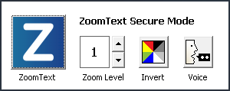
The ZoomText Secure Mode toolbar
- ZoomText button. Enables or disables ZoomText. When ZoomText is disabled, all magnification and screen reading features are turned off without exiting the program.
Hotkey: Caps Lock + Ctrl + Enter
- Zoom Level. Sets the magnification level from 1x to 60x.
Hotkey: Caps Lock + Up / Caps Lock + Down
- Invert. Enables and disables color inverting.
Hotkey: Caps Lock + C
- Voice. Enables and disables the ZoomText voice.
Hotkey: Caps Lock + Alt + Enter
Note: ZoomText Secure Mode settings are automatically saved and restored each time you exit and enter a Windows secure mode prompt.
Enabling and Disabling ZoomText Secure Mode
ZoomText Secure Mode is enabled and disabled in ZoomText's Program Preferences dialog box.
- To enable and disable ZoomText Secure Mode
- In the ZoomText menu, choose Preferences > Program.
The Preferences dialog appears with the Program tab displayed.
- Check or uncheck Enable ZoomText in the Windows logon prompt.
Note: You must be logged in with administrative privileges to adjust this option. If you are not logged in with administrative privileges this option will be grayed out.
- Select OK.
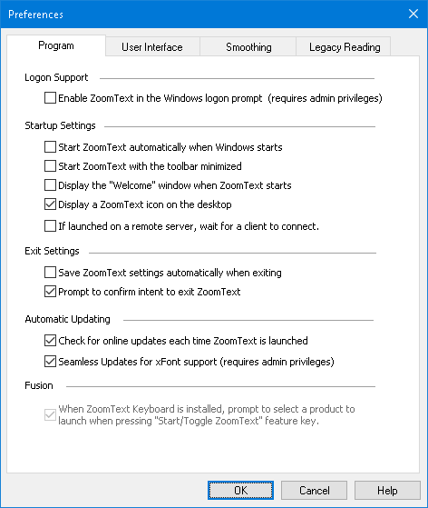
The Program tab
Setting | Description
Logon Support
Enable ZoomText in the Windows logon prompt | Enables the ZoomText Secure Mode utility in the Windows logon prompt and other Windows secure mode prompts.

Chapter 4

The ZoomText User Interface
The ZoomText user interface provides a variety of ways to operate ZoomText, including the ZoomText Toolbar, Command Keys, and touch screen gestures.
The primary way to operate ZoomText is using the ZoomText Toolbar, which provides complete access to all of ZoomText's features and settings through toolbar controls, menus and dialogs that are easy to use. The ZoomText user interface can be fully accessed using the keyboard, mouse, or touch screen gestures.
You should learn to use at least some of ZoomText's Command Keys, which will allow you to adjust and operate ZoomText without having to activate the toolbar and switch away from where you are working. You don't need to learn and use all of the command keys, but utilizing command keys for frequently used features will allow you to work much faster in all of your applications.
If you are using a desktop, laptop or tablet that includes a touch screen, you can use ZoomText's Touch Screen Support to access the ZoomText Toolbar, modal tools, and key feature adjustments using standard touch screen gestures.
- The ZoomText Toolbar
- Quick Access Bar
- Screen Shade (Fusion only)
- Command Keys
- Touch Screen Support

The ZoomText Toolbar
When you start ZoomText the ZoomText toolbar appears on the screen. The ZoomText toolbar contains all of the controls for operating ZoomText, neatly organized in the "ZoomText" menu and several toolbar tabs. Each tab provides quick-action buttons for enabling and adjusting all of ZoomText's core features. Many of these buttons are split-button controls that allow you to toggle the feature on and off and open a menu of related settings. The buttons are grouped by category and have intuitive icons and labels for easy identification.
The ZoomText Toolbar
- ZoomText menu. Displays the ZoomText menu, where you can toggle ZoomText on and off, open ZoomText Help, save and load configurations, configure the command keys, use support tools and more.
- Magnifier toolbar tab. Displays toolbar controls for ZoomText's magnification features.
- Reader toolbar tab. Displays toolbar controls for ZoomText's screen reading features.
- Tools toolbar tab. Displays toolbar controls for ZoomText's Finder, Camera and Listening features.
Note: The Reader toolbar tab only appears when running ZoomText Magnifier/Reader.
Operating the ZoomText Toolbar with the Keyboard
The ZoomText toolbar is fully keyboard accessible using standard Windows navigation commands. For added ease of use, the toolbar can be fully navigated and operated using only the arrow keys and Enter key. Using the arrow keys, you can navigate in, out and between the ZoomText menu, toolbar tabs, toolbar controls and button menus. When the focus is on a split button, pressing the Enter key will toggle the feature, while pressing the down arrow will open the attached menu. When the focus is in the Zoom Level spin box (on the Magnifier toolbar tab) or the Rate spin box (on the Reader toolbar tab), pressing the Up and Down keys will adjust the spin box value and pressing the Left and Right keys will move the focus to the next control. On the Zoom Level spin box, pressing the Enter key will also toggle the Zoom to 1x feature.
Minimizing and Restoring the Toolbar
The ZoomText toolbar can be minimized (hidden) and restored (made visible) without affecting the operation of ZoomText.
- To minimize ZoomText
Do one of the following:
- On the ZoomText title bar, click on the minimize button.
- While the ZoomText toolbar is active, press Esc.
- To restore ZoomText
Do one of the following:
- Click on the ZoomText button in the task bar.
- Press the Show User Interface hotkey: Caps Lock + Ctrl + U.
Note: If the ZoomText toolbar is already open but covered by other applications, restoring it will bring it into view.

Quick Access Bar
The Quick Access Bar is a toolbar that lets you place up to eight shortcuts of your most commonly used magnification and speech features in one convenient place. By doing this, you no longer have the distraction of having to jump to the ZoomText or Fusion user interface and locate various features to perform an action or memorize keystrokes to perform a task. With the Quick Access Bar, you can search for and quickly perform magnification and speech features, add features to your shortcuts list, and read a brief description to learn more about these features.
Choose any of the following to learn more about the Quick Access Bar:
- Accessing and Using the Quick Access Bar
- Using Search to Launch a Shortcut
- Adding Shortcuts
- Application-Specific Shortcuts (Fusion only)
- Deleting Shortcuts
- Restoring Default Shortcuts
- Preferences
Accessing and Using the Quick Access Bar
- To access the Quick Access Bar, do one of the following:
- Press CAPS LOCK+RIGHT-CLICK.
This places the bar at your current location on the screen.
- Press CAPS LOCK+SPACEBAR+Q.
This places the bar at your current location on the screen.
- Use Voice Assistant to place the bar in the center of the screen
- In the ZoomText menu, choose Preferences > Quick Access Bar.
- Click the Quick Access Bar button located on the right side of the ZoomText or Fusion toolbar
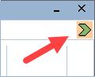
- The Quick Access Bar appears on the screen in either collapsed view or expanded view.
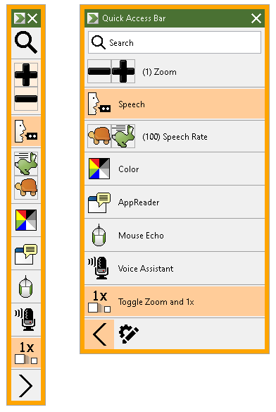
The Quick Access Bar shown collapsed and expanded
- Click the feature that you want to use.
Note: The Quick Access Bar disappears from view when you move focus away from it. If you need to return to the bar, use the methods mentioned in step 1.
Using Search to Launch a Shortcut
The Quick Access Bar can have up to eight shortcuts. If a feature you want to use is not assigned to the bar, you can quickly find it and launch it from the Search box.
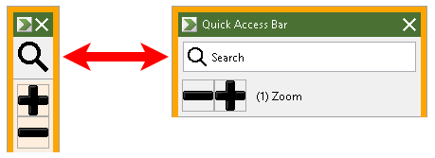
The Search box shown collapsed and expanded
To select and run a feature using Search, do the following:
- Go to Search on the Quick Access Bar, and enter a word associated with the feature you want to use. Search results appear in the Quick Access Bar list. It displays a maximum of six items. If the list is empty, try again using different words.
Note: If you want to learn more about any shortcut displayed in the list, select the More Information button for a brief description. The button is located next to the shortcut in the list and can be selected using your mouse or pressing the Right Arrow key.
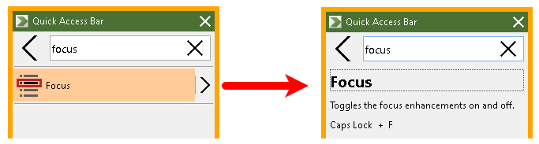
An example showing the More Information button and shortcut description
- Select the feature you want to use.
Adding Shortcuts
Note: You can have a maximum of eight shortcuts on the bar. Before adding another shortcut to the bar, you must delete an existing shortcut. See Deleting Shortcuts for more information.
To add a shortcut to the bar, do the following:
- Launch the Quick Access Bar.
If the bar is collapsed, click the Show Shortcut Names button to expand the bar.
Show Shortcut Names button
- Click the Customize button then Add Shortcut.
Customize button
- In the Search box, enter a word associated with the feature you want to add, and then select it (click, right-click, or press SHIFT+F10) from the list of available features in the Add Shortcut dialog box.
- Click OK to close the Customize dialog box. The feature now appears in the Quick Access Bar.
Note: If necessary, you can restore the Quick Access Bar to its factory default shortcuts. See Restoring Default Shortcuts for more information.
Application-Specific Shortcuts (Fusion only)
The Quick Access Bar has eight default shortcuts. You can create customized shortcut lists for any application you use when running Fusion. When you switch to an application, the Quick Access Bar will automatically change to that application’s shortcut list.
To make an application-specific shortcut list, do the following:
- Go to an application and open the Quick Access Bar (CAPS LOCK+RIGHT-CLICK).
- Click the Customize button and then Add Shortcut.
Customize button
- The Customize window opens.
The Application list shows the current application name followed by (default), for example, Microsoft Word (Using default). This indicates that Word is currently using the bar’s default shortcuts.
- You can delete shortcuts that are currently displayed in the list and add new shortcuts that you want to use for the application. As you add and delete shortcuts, the application name is no longer labeled as a default.
- When finished, click OK to close the Customized dialog box. The shortcut list will now be used when running that specific application.
Note: When you move away from the application, the bar will return to its default shortcuts list.
Deleting Shortcuts
To remove a shortcut from the bar, do the following:
- Launch the Quick Access Bar.
If the bar is collapsed, click the Show Shortcut Names button to expand the bar.
Show Shortcut Names button
- Click the Customize button and then click the Delete icon (located to the right of the shortcut name) to remove the shortcut from the list.
Customize button and Delete icon
- Click OK to close the Customize dialog box.
Restoring Default Shortcuts
To restore the Quick Access Bar to its factory default shortcuts, do the following:
- Launch the Quick Access Bar.
If the bar is collapsed, click the Show Shortcut Names button to expand the bar.
Show Shortcut Names button
- Click the Customize button and then Restore Default.
Customize button
- Click Yes to restore the default shortcuts.
Preferences
Quick Access Bar preferences include:
- Hiding the Quick Access Bar after using it
- Docking the Quick Access Bar to one of four corners of your screen
- Choosing the color and size of the Quick Access Bar's outside border
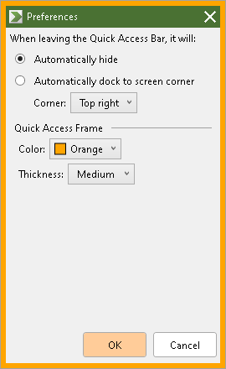
The Quick Access Bar preferences
Setting | Description
When leaving the Quick Access Bar, it will:
Automatically hide | If you choose to hide the Quick Access Bar, it disappears from view immediately when you click in an area of the screen away from the bar.
Automatically dock to screen corner | The Quick Access Bar is docked in one of four corners on the screen. This provides a location for the Quick Access Bar to return to when it loses focus and is not pinned on the screen.  The bar can be docked in the top right corner, top left corner, lower right corner, or lower left corner of the screen.
Quick Access Frame
Color | Sets the color of the outside border of the Quick Access Bar.
Thickness | Sets the thickness of the Quick Access Bar border: None, Thin, Medium, Thick.

Screen Shade (Fusion only)
The Screen Shade feature prevents others from seeing what you are typing or reading by turning your computer screen black. When turned on, the status message "Fusion Screen Shade, Right-click to exit" displays and the message "Screen Shade on" is announced. Screen Shade remains active until it is turned off, or Fusion is restarted.
Note: Screen Shade is strictly a privacy feature and will not increase the battery life on a laptop or tablet.
Toggle Screen Shade On and Off
To toggle Screen Shade on, do one of the following:
- In the Fusion menu, choose Screen Shade
- Press INSERT+SPACEBAR followed by the F11 key
- Triple tap with three fingers on a touch screen
- Use Quick Settings (INSERT+V) and search for Screen Shade
To toggle Screen Shade off, do one of the following:
- Click the right mouse button
- Press INSERT+SPACEBAR followed by the F11 key
- Triple tap with three fingers on a touch screen
Note: If you are using a tool such as AppReader, it will stop reading when Screen Shade is toggled on or off. To resume reading, you must restart AppReader.

Command Keys
ZoomText's Command Keys allow you to adjust and operate ZoomText without having to activate the toolbar and switch away from where you are currently working. Using the command keys will allow you to work faster and more productively in all of your applications.
- Types of Command Keys
- The Essential Command Keys
- The Command Keys Dialog
- The Layered Keys Banner
- Resolving Hotkey Conflicts

Types of Command Keys
ZoomText provides two types of command keys, Hotkeys and Layered Keys.
- Hotkeys are the fastest and recommended way to operate ZoomText, as they allow you to trigger commands in a single keyboard action. Hotkeys are performed by holding down one or more modifier keys and then pressing a primary key. For example, to toggle ZoomText on and off, you hold down the Caps Lock and Ctrl keys and then press the Enter key. This hotkey appears as Caps Lock + Ctrl + Enter in the ZoomText user interface and documentation. Hotkeys for other ZoomText commands appear in this same format.
Note: Some applications may have hotkeys that use the same combination of keys as ZoomText hotkeys. When this occurs ZoomText will process the hotkey without passing it through for processing by the application. To work around this problem, see Resolving Hotkey Conflicts.
- Layered Keys are not as fast to perform as hotkeys, but have the advantage of never conflicting with other applications and being easier to perform if you have limited hand dexterity. Layered keys are performed by pressing a sequence of keys that (1) enters the Layered Key Mode, (2) selects a command group, and (3) triggers the desired command. For example to toggle ZoomText on or off with layered keys, you would (1) press Caps Lock + Spacebar to enter the layered key mode, (2) press P to enter the Program group, and (3) press Enter to toggle ZoomText on or off. This layered key sequence appears as Caps Lock + Space, P, Enter in the user interface and documentation. Layered keys for other ZoomText commands appear in this same format.
Note: Because use of hotkeys is recommended over using layered keys, in the ZoomText documentation the layered keys only appear in feature topics where the feature does not have equivalent hotkeys. To see a full list of the available layered keys, open the ZoomText Command Keys dialog box or see list of command key tables in the ZoomText Commands section.
Tip! For each ZoomText command, the hotkey and layered key use the same key to complete the command, which makes learning both commands intuitive.
Tip! If you are running ZoomText Magnifier/Reader, while you are in any level of the Layered Key Mode, you can type a question mark to hear a list of the commands that are available in the current level. You can also press the F1 key to exit the layered mode and open the help system to the list of commands for the current level.

The Essential ZoomText Hotkeys
To use ZoomText in your applications, it is helpful to learn and use the essential hotkeys. These hotkeys will allow you to adjust and operate the most commonly used features and settings without having to switch away from your application.
Note: Commands specific to each feature and setting are located in the topics throughout the ZoomText documentation. You will also find a complete list of commands hotkeys in the ZoomText Commands section and in the Command Key dialog box.

Essential Commands | Hotkeys
Global ZoomText Commands
Start ZoomText | Ctrl + Alt + Shift + Z
Toggle ZoomText On / Off | Caps Lock + Ctrl + Enter
ZoomText User Interface | Caps Lock + Ctrl + U
Magnifier Commands
Zoom In | Caps Lock + Up
Zoom Out | Caps Lock + Down
Zoom to 1x (toggle) | Caps Lock + Enter
Scroll Up | Caps Lock + Shift + Up
Scroll Down | Caps Lock + Shift + Down
Scroll Left | Caps Lock + Shift + Left
Scroll Right | Caps Lock + Shift + Right
Enhancement Color | Caps Lock + C
Reader Commands (ZoomText Magnifier/Reader only)
Voice On / Off | Caps Lock + Alt + Enter
Voice Rate Faster | Caps Lock + Alt + Up
Voice Rate Slower | Caps Lock + Alt + Down
Verbosity (program echo) | Caps Lock + Alt + B
Echo Keyboard Mode | Caps Lock + Alt + K
Launch AppReader from Pointer | Caps Lock + Alt + Left-Click
Launch App View | Caps Lock + Alt + A
Launch Text View | Caps Lock + Alt + T
Launch SpeakIt Tool | Caps Lock + Alt + S

The Command Keys Dialog
The ZoomText Command Keys dialog box displays a list of all ZoomText commands and allows you to customize the hotkey for each command. You can quickly find any command or group of commands by typing the name, keys or status in the Search box. You can also reassign, unassign and enable/disable hotkeys according to your needs as described in the instructions below. You can sort the list alphabetically by clicking on any column in the list.
Note: Access keys have fixed key assignments that cannot be reassigned.
- To open the ZoomText Command Keys dialog box
- On the ZoomText toolbar choose ZoomText > Command Keys.
The ZoomText Command Keys dialog appears.
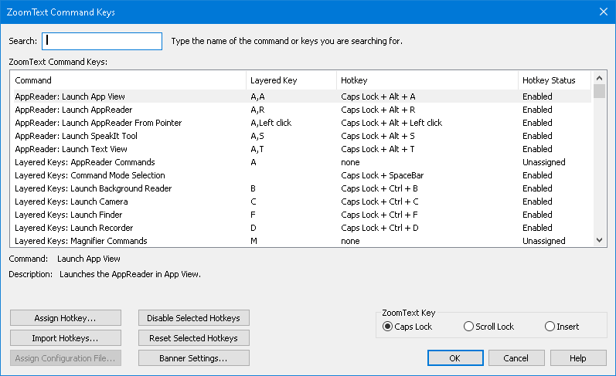
The ZoomText Command Keys dialog box.
Setting | Description
Search | Allows you to search and filter the list of commands by typing the command name, keys or status you are looking for.
ZoomText Command Keys | Displays a complete or filtered list of the ZoomText command keys. You can sort the list alphabetically by any column by clicking on the column title.
Assign Hotkey | Opens the Assign Key dialog box where you can assign (or reassign) the key combination for a command’s hotkey.
Import Hotkeys | Opens the Import Hotkeys dialog box where you can browse to and select a ZoomText configuration file from which to import hotkey assignments.
Assign Configuration File | Opens the Assign Configuration dialog box where you can browse and select an existing ZoomText configuration file to assign to the selected Load Configuration command.  Note: The Assign Configuration File button is only enabled when a Load Configuration command is selected.
Enable Selected Hotkeys | Enables the hotkey for any commands that are currently selected and disabled in the ZoomText Command Keys list.
Reset Selected Hotkeys | Resets the hotkey to the factory default for any commands that are currently selected in the ZoomText Command Keys list.
Banner Settings | Opens the Layered Keys Banner Settings dialog, where you can enable and disable the banner and configure the appearance and sound cues for the banner.
ZoomText Key | With most commands, ZoomText uses the Caps Lock key as a "modifier" key. Caps Lock is pressed in combination with other keys to activate commands. ZoomText lets you choose which key to use for this modifier, which is sometimes referred to as the ZoomText Key. The keys available to use are:  - Caps Lock (default)  - Scroll Lock  - Insert
Viewing and Managing Command Keys
- To search, filter and sort the list of commands
- Click in the Search box or press the Tab key to move the keyboard focus to the Search box.
- Type the command name, keys or status you are looking for and press the Enter key.
- Click on the column titles to sort the list as desired.
- To enable or disable hotkeys for one or more commands
- Select the commands you want to enable or disable.
- Click the Enable Selected Hotkeys button, or the Disable Selected Hotkeys button.
- To reset hotkeys for one or more commands (to the factory default assignments)
- Select the commands that you want to reset.
- Click the Reset Selected Hotkeys button.
- To assign a new key combination to a hotkey
- Select the command that you want to assign a new or different hotkey.
- Select the Assign Hotkey button.
The Assign Key dialog box appears.
- Select the desired modifier keys and primary key.
If the selected combination of keys is already in use by another command, a "KEY CONFLICT!" warning will appear with options to disable the hotkey or save the hotkey and reassign the conflicting hotkey.
- Click OK.
- To import hotkeys from another configuration file
- Select the Import Hotkeys button.
The Import Hotkeys dialog box appears and displays a list of ZoomText hotkey configuration files.
- Select a configuration file from the displayed list or browse to a different folder to select the desired configuration file.
- Click OK.
- To assign a configuration file to a Load Configuration command
- Select the desired ZoomText: Load Configuration command.
- Select the Assign Configuration File button.
The Assign Configuration File dialog box appears. The current assignment to the Load Configuration command is displayed.
- Select the Browse and Select a Configuration File button.
The Select Configuration dialog box appears and displays a list of ZoomText configuration files.
- Select a configuration file from the displayed list or browse to a different folder to select the desired configuration file.
- Click OK.

Layered Keys Banner
When you enter the Layered Keys Mode, a banner can be displayed to let you know that the mode is active and which layered mode you are currently in. You can adjust the appearance of the banner in the Layered Keys Banner Settings dialog box. You can enable and disable the banner and select the size, color and location where the banner will appear. Sound cues are also available to provide audible indication that the layered key mode is active. You can enable and disable the sound cues and select the style and volume level for the sound cue.
- To open the Layered Keys Banner Settings dialog box
- On the ZoomText toolbar choose ZoomText > Command Keys.
The ZoomText Command Keys dialog appears.
- Select the Banner Settings button.
The Layered Keys Banner Settings dialog appears.
- Adjust the banner settings as desired.
- Click OK.
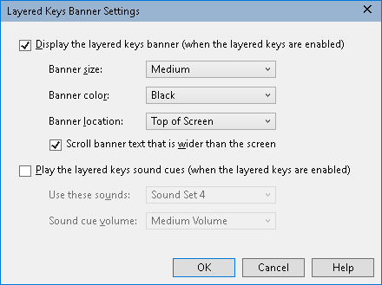
The Layered Keys Banner Settings dialog box.
Setting | Description
Display the layered keys banner (when the layered keys are enabled) | Displays a banner showing the current layered key mode at the top or bottom of the screen when the feature key mode is active. The banner provides visual indication that the mode is active.
Banner size: | Selects the size of the layered keys banner.
Banner color: | Selects the color of the layered keys banner.
Banner location: | Selects the location of the layered keys banner, which can be located at the top or bottom edge of the screen.
Scroll banner text that is wider than the screen | When the text displayed in the banner is wider than the screen, the text will scroll side to side so that the full text can be read.
Play the layered key sound cues (when the layered keys are enabled) | Plays a sound cue when the layered key banner is active. The sound cue provides audible indication that the mode is active.
Use these sounds: | Selects the style of sound cue that will be played.
Sound cue volume: | Selects the volume level for the sound cue.

Resolving Hotkey Conflicts
There may be situations where a ZoomText hotkey uses the same key combination as a hotkey in another application, creating what is known as a "hotkey conflict". When this occurs, ZoomText receives and processes the command and your other application does not. You can work around or resolve this problem using the following methods:
Method 1: Use the Pass Next Hotkey command
- Prior to pressing the conflicting command that you want your application to receive and process, execute the Pass Next Hotkey command using the hotkey or layered keys:
- Hotkey: Ctrl + Alt + Shift + P
- Layered Keys: Caps Lock + Spacebar, U, P
ZoomText will pass the next hotkey through to the active application.
Method 2: Use the ZoomText layered keys instead of the hotkey
ZoomText’s Layered Keys are modal and therefore are free of conflicts with other applications.
Method 3: Reassign or disable the hotkey in ZoomText
- Follow the instructions provided in The Command Keys Dialog.

Touch Screen Support
ZoomText can be used on Windows 10 or later touch screen devices including tablets, laptops and desktop monitors. This means that you can operate ZoomText’s complete feature set and your applications using touch screen gestures; that is, taps and swipes you perform with one or more fingers. ZoomText will not interfere with gestures targeted at your applications, but will respond to gestures the same way it responds to events produced when using the keyboard and mouse. You can also access ZoomText’s user interface (toolbars, menus and dialogs) using the same standard gestures that you are used to from other applications.
To learn how to operate Windows and your applications with touch screen gestures, see the Windows Help system, or search the Microsoft Windows website for articles on using touch screen devices and gestures in Windows.
Note: You must have a Windows device that supports at least five simultaneous touch points. These devices will display the "Designed for Windows" logo.
- Using ZoomText on a Touch Screen
- Using the ZoomText Touch Icon
- Accessing ZoomText Features with Touch Gestures

Using ZoomText on a Touch Screen
There are a few important concepts, behaviors and techniques to keep in mind when using ZoomText on a touch screen display:
- Many applications provide zooming and panning of the documents they display. A screen magnifier will add a second layer of zooming and panning on top of this, which can become disorienting if both the application and the screen magnifier are zooming at the same time. To avoid this disorienting experience, it is recommended that you just use one layer of zooming at a time.
- Using a standalone touch screen device requires the use of an on-screen keyboard. When using ZoomText with a magnified view the on-screen keyboard will not be fully visible, so you will have to pan the magnified view to access all of the keys. This will slow down your typing speed as well as productivity. Therefore, we recommend connecting a physical keyboard when you need to perform large amounts of typing.

Using the ZoomText Touch Icon
ZoomText provides a special ZoomText Touch Icon that allows you to instantly access key ZoomText features using touch gestures. These features include zooming in and out, scrolling the magnified view and using ZoomText’s AppReader and SpeakIt tools. Here’s how it works...
When enabled on a touch screen device, the ZoomText Touch Icon will appear on one edge of the screen. This floating icon remains visible even when you zoom in and out or scroll the magnified view. You can move the icon to several anchor points along the edges of your screen. This lets you position the icon where you want it and move it if it is covering an item you need to see.
Note: Use of the ZoomText Touch Icon and associated gestures requires a 5-point (or greater) multi-touch display.
The ZoomText Touch Icon has two modes of operation: Windows Touch Mode and ZoomText Touch Mode.
- Windows Touch Mode passes all touch gestures to Windows and applications that are open on the screen, just as if ZoomText was not running on the system. This is the mode you need to be in when you want to interact with your desktop or applications using touch gestures, including the ZoomText toolbar. When Windows Touch Mode is active, the icon appears as a group of Windows Start Screen tiles with a pointing finger at the bottom.
- ZoomText Touch Mode passes all touch gestures to ZoomText. This is the mode you need to be in when you want to access the ZoomText features that are supported by gestures. When in ZoomText Touch Mode, the icon appears as a ZoomText logo with a pointing finger at the bottom. This icon will also pulse to let you know that ZoomText Touch Mode is active.
Enabling and Operating the ZoomText Touch Icon
In this section you will learn how to enable and operate the ZoomText Touch Icon.
- To enable and disable the Touch Icon
In the ZoomText menu, choose Preferences > Touch Screen Support > Enable Touch Icon.
When enabled, the Touch Icon appears on one edge of the screen. When disabled, the icon is hidden. Note: The Touch Icon is also hidden when ZoomText is disabled.
- To adjust the size of the Touch Icon
In the ZoomText menu, choose Preferences > Touch Screen Support > Touch Icon Size {size}.
The Touch Icon resizes according to the selected size.
- To select a color scheme for the Touch Icon
In the ZoomText menu, choose Preferences > Touch Screen Support > Touch Icon Color {color}.
The Touch Icon changes to the selected color.
- To move the Touch Icon around the screen
Press and hold one finger on the icon and drag it to a desired location anywhere along the edge of the screen.
When you remove your finger from the icon, the icon will automatically snap to the nearest anchor point.
- To switch between Windows Touch Mode and ZoomText Touch Mode
Double-tap the Touch Icon with one finger.
When in Windows Touch Mode, the icon appears as a group of Windows Start Screen tiles. When in ZoomText Touch Mode, the icon appears as a ZoomText logo.
Tip! You can momentarily switch touch modes by holding one finger on the touch icon. When you move your finger off of the icon, the previously active touch mode is automatically restored. This means that when Windows Touch Mode is active, you can momentarily switch to ZoomText Touch Mode to pass a gesture to ZoomText, automatically returning to Windows Touch Mode when you move your finger off of the icon. Conversely, when in ZoomText Touch Mode, you can momentarily switch to Windows Touch Mode to pass a gesture to an application, automatically returning to ZoomText Touch Mode when you move your finger off of the icon.

Accessing ZoomText Features with Touch Gestures
In this section you will learn how to use the ZoomText Touch Icon and gestures to access and operate key ZoomText features. Remember that the Touch Icon must be in ZoomText Touch Mode when performing these gestures.
- To display the ZoomText user interface
Double-tap with four fingers.
- To adjust the magnification level (zoom in and out)
Double-tap and hold three fingers, then drag up to zoom in and drag down to zoom out.
- To pan the magnified view
Drag three fingers to move around the screen.
- To adjust the size and location of a zoom window
- On the Magnifier toolbar tab, choose Window > Zoom Windows Adjust Tool.
The Adjust tool becomes active and sizing handles appear on the zoom window frame.
- To resize the window, hold one finger on a sizing handle and drag it until it’s the size you prefer.
- To move the window, hold one finger inside the zoom window and drag it around.
- To exit the Adjust tool, double-tap with three fingers.
- To use View Mode
- Double-tap with three fingers.
Magnification is temporarily turned off and the view locator appears.
- To move the view port, hold one finger inside the view port and drag it to the desired location.
- To exit View Mode and be moved to the new viewport location, double-tap with one finger.
- To exit View Mode and move to the previous viewport location, double-tap with three fingers.
- To use the SpeakIt Tool
- On the Reader toolbar tab, choose SpeakIt.
The SpeakIt tool becomes active and sizing handles appear on the zoom window frame.
- To speak a single word, tap on the word.
- To speak a block of words, drag diagonally with one finger to highlight the words you want to have spoken. When you complete the drag, all highlighted text will be spoken.
- To exit the SpeakIt tool, double-tap with three fingers.
- To use AppReader
- Open the document, web page or email that you wish to read.
- Start AppReader using one of the following two methods:
- To start reading at any word: Double-tap with one finger on the word where you want to start reading.
- To start reading from the location of the text cursor, double-tap with two fingers.
AppReader begins reading.
- To start and stop reading or navigate/read by word, line, sentence and paragraph, use the AppReader Reading Gestures listed in the table below.
- To speak a block of words, drag diagonally with one finger to highlight the words you want to have spoken.
When you complete the drag, all highlighted text will be spoken
- To exit AppReader, double-tap with three fingers.
When AppReader exits, the cursor is automatically positioned at the last word that was highlighted in AppReader (if a cursor exists in the application).
AppReader Reading Gestures
Command | Gesture
Toggle Reading (Play/Pause) | 2-finger single-tap
Read from new location | 1-finger single-tap.
Say Next Word | 1-finger swipe right
Say Previous Word | 1-finger swipe left
Say Current Word | 1-finger double-tap  Note: Repeating this gesture on the same word within two seconds or less will cycle through the following options: say/spell/military spell. Resets after a lapse of more than two seconds.
Say Word Below | 1-finger swipe down
Say Word Above | 1-finger swipe up
Say Next Sentence | 2-finger swipe right
Say Previous Sentence | 2-finger swipe left
Say Next Paragraph | 2-finger swipe down
Say Previous Paragraph | 2-finger swipe up
End of Document | 4-finger swipe down
Beginning of Document | 4-finger swipe up

Chapter 5

Magnifier Features
"Magnifier Features" represent all of the visual enhancements that are available in ZoomText Magnifier and ZoomText Magnifier/Reader. These features include selection of the zoom level, zoom window types, screen enhancements, and navigation options.
- The Magnifier Toolbar Tab
- Zooming In and Out
- Using Zoom to 1x
- Scrolling the Magnified View
- Zoom Windows
- Screen Enhancements
- Navigation Settings

The Magnifier Toolbar Tab
The Magnifier toolbar tab provides quick-action buttons for enabling and adjusting all of ZoomText's Magnifier features. Many of these buttons are split-button controls that allow you to toggle the feature on and off and open a menu of related settings. The buttons are grouped by category and have intuitive icons and labels for easy identification.
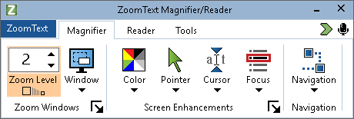
The Magnifier toolbar tab
- Zoom Level. Sets the magnification level from 1x to 60x.
- Window. Selects the zoom window type for the magnified view. The types of zoom windows that are available depend on whether you are running your system with one monitor or multiple monitors that are set to "Extend these displays".
- Color. Toggles the color enhancements on and off, and displays a menu of color enhancement settings. Color enhancements improve screen clarity for easier viewing and reduced eyestrain. You can choose from a variety of preset color schemes or configure your own custom color settings.
- Pointer. Toggles the pointer enhancements on and off, and selects mouse pointer enhancement settings. Pointer enhancements make it easy to locate and follow the mouse pointer. You can choose from a variety of preset pointer enhancement schemes or configure your own custom pointer enhancements.
- Cursor. Toggles the cursor enhancements on and off, and selects cursor enhancement settings. Cursor enhancements make it easy to locate and follow the text cursor. You can choose from a variety of preset cursor enhancement schemes or configure your own custom cursor enhancements.
- Focus. Toggles the focus enhancements on and off, and selects focus enhancement settings. Focus enhancements make it easy to locate and follow the control focus when you tab and arrow key through menus, dialogs and other application controls. You can choose from a variety of preset focus enhancement schemes or configure your own custom focus enhancements.
- Navigation. Displays a menu that opens the Navigation Settings dialog where you can adjust how ZoomText will scroll the zoom window to keep moving objects in view, including the mouse pointer, text cursor, keyboard focus and other objects that appear and move about the screen.

Zooming In and Out
ZoomText provides a wide range of zoom levels allowing you to adjust the magnified view according to your needs. Zoom levels include:
- 1x to 8x in steps of 1
- 10x to 16x in steps of 2
- 20x to 36x in steps of 4
- 42x to 60x in steps of 6
- Fractional powers of 1.2x, 1.4x, 1.6x, 1.8x, 2.5x, 3.5x and 4.5x.
You can zoom in and out at any time using the Zoom In and Zoom Out hotkeys, Mouse Wheel Zooming, or the Zoom Level spin box on the Magnifier toolbar tab.
Note: When using multiple monitors with the zoom window type set to MultiView Local or MultiView Global, each view (on each display) has its own zoom level. The zoom level commands and controls always adjust and reflect the zoom level for the active view. You can force the active and inactive views to zoom in and out together by enabling Keep views at the same magnification level in the Multiple Monitor Options dialog box.
- To zoom in and out using hotkeys
- Press the Zoom In and Zoom Out hotkeys:
- To Zoom In, press Caps Lock + Up
- To Zoom Out, press Caps Lock + Down
- To zoom in and out using mouse wheel zooming
- Hold down Caps Lock + Shift and roll the mouse wheel to zoom in and out.
- To zoom in and out using the Zoom Level spin box
- On the Magnifier toolbar tab, adjust the level in the Zoom Level spin box by clicking the up and down button or by pressing the Up and Down keys (when the spin box has focus).
Choosing a Set of Zoom Levels
ZoomText provides three sets of zoom levels for zooming in and out. You can zoom in and out using All Zoom Levels, Favorite Zoom Levels Only or Whole Power Levels Only.
- All Zoom Levels uses the complete set of zoom levels for zooming in and out. This is the default mode.
- Favorite Zoom Levels uses a custom set of user-defined zoom levels for zooming in and out. You can choose any combination of zoom levels to define your favorite zoom levels.
- Whole Power Levels excludes all of the fractional powers when zooming in and out.
- To choose a set of zoom levels and customize the Favorite Zoom Levels
- On the Magnifier toolbar tab, select the Zoom Windows button, which appears in the lower-right corner of the Zoom Windows group.
The Zoom Windows Settings dialog appears.
- Select the Magnification tab.
- In the Use these zoom levels combo box, choose the set of zoom levels that you want to use.
- If you selected Favorite Zoom Levels Only, go to the Favorite Zoom Levels list box and check the zoom levels that you want to use and uncheck the zoom levels you do not want to use.
- Click OK.
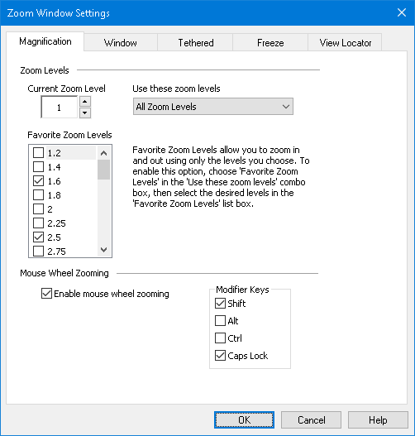
The Magnification tab
Setting | Description
Zoom Levels
Current Zoom Level | Sets the magnification level. Magnification levels include: 1x to 8x in steps of 1, 10x to 16x in steps of 2, 20x to 36x in steps of 4, 42x to 60x in steps of 6, and fractional powers of 1.2x, 1.4x, 1.6x, 1.8x, 2.5x, 3.5x and 4.5x.
Use these zoom levels | Selects the set of magnification levels that ZoomText will use for zooming in and out.
Favorite zoom levels | A list of checkboxes for selecting the favorite zoom levels. The change these selections you must choose Favorite Zoom Levels Only in the Use these zoom levels combo box.

Customizing Mouse Wheel Zooming
Many applications use the mouse wheel to scroll documents and perform other actions. ZoomText combines modifier keys with the mouse wheel to avoid interfering with these applications. By default, ZoomText's Mouse Wheel Zooming uses Caps Lock + Shift for the modifiers. If necessary you can choose a different combination of modifiers or disable mouse wheel zooming altogether.
- To configure mouse wheel zooming
- On the Magnifier toolbar tab, select the Zoom Windows button, which appears in the lower-right corner of the Zoom Windows group.
The Zoom Windows Settings dialog appears.
- Select the Magnification tab.
- Make sure the Enable wheel zooming box is checked
- Select the modifier key (or keys) that must be pressed in order for the mouse wheel to be used for zooming.
- Click OK.
The Magnification tab
Setting | Description
Mouse Wheel Zooming
Enable wheel zooming | Enables use of the mouse wheel to change the magnification level.
Modifier Keys | Selects the key combination to be used for mouse wheel zooming. The selected keys must be held down while rotating the mouse wheel in order to change the magnification level.

Using Zoom to 1x
Zoom to 1x feature lets you instantly switch between zoomed and 1x views, without having to zoom out and zoom back in one zoom level at a time. When you Zoom to 1x, all of ZoomText's other magnifier and reader features remain active, so you can still use ZoomText's other features even while the screen is unmagnified.
- To use Zoom to 1x
Do one of the following:
- Press the Zoom to 1x hotkey: Caps Lock + Enter
- On the Magnifier toolbar tab, click the Zoom to 1x button beneath the Zoom Level spin box, or navigate to the Zoom Level spin box and press Enter.
With each press of the hotkey toggles between the current zoom level and 1x.
The Zoom to 1x button
Note: When you Zoom to 1x you can also use the Zoom In commands and controls to zoom back in.

Scrolling the Magnified View
ZoomText's magnified views automatically scroll to follow movement of the mouse, text cursor and application focus. You can also use the Scroll Commands to scroll in any direction and to any area of the screen. The smooth scrolling behavior of the Scroll Commands is particularly helpful when you want to scroll and read at the same time. The Scroll Commands also allow you to jump instantly to any edge, jump to the center of the screen, and save and restore a view of any location on the screen.
- To scroll the zoom window
While holding down the Caps Lock + Shift keys:
- Press the arrow key that corresponds to the desired scroll direction: Left, Right. Up or Down.
- To increase the scrolling speed, press the same arrow key. Each press will increase the speed.
- To decrease the scrolling speed, press the opposite arrow key. Each press will decrease the speed until scrolling stops.
- To scroll in a different direction, press the arrow key that corresponds to the new direction.
- To stop scrolling, press Enter or release the Caps Lock + Shift keys.
- To jump to an edge or the center of the screen
While holding down the Caps Lock + Ctrl keys:
- Press the arrow key that corresponds to the desired edge: Left, Right. Up or Down.
- Press Home to jump to the center of the screen.
- To save and restore a specific view of the screen
The current view can be saved and then restored at a later time using the following hotkeys:
- To save the view, press Caps Lock + Ctrl + Page Down
- To restore the view, press Caps Lock + Ctrl + Page Up

Zoom Windows
A zoom window displays a magnified view of the computer screen. You can think of a zoom window as a magnifying glass held in front of the screen. A zoom window can only display a portion of the screen at any one time, but by scrolling the magnified contents, any area of the screen can be viewed. The magnified view automatically tracks and scrolls to follow all on-screen activity, including movement of the mouse pointer, text cursor, and the keyboard focus.
- Running with One or Multiple Monitors
- Selecting a Zoom Window
- Adjusting Zoom Windows
- Tethered View
- Freeze View
- Overview Mode
- Managing Multiple Monitors

Running with One Monitor or Multiple Monitors
When your system is running with one monitor, or with two monitors set to "Duplicate these displays", you can set the magnified view to any of the following zoom window types: Full, Overlay, Lens, Line and four Docked positions; Top, Bottom, Left and Right.
When your system is running with multiple monitors set to "Extend these displays", you can set the magnified view to any of the following zoom window types: Span, Clone, Zoom with 1x, MultiView Local and MultiView Global.

Selecting Zoom Windows
You can select a different zoom window at any time while ZoomText is active. The types of zoom windows that are available depend on whether your system is configured with one monitor or multiple monitors that are configured with extended desktops.
Note: This section provides descriptions and instructions for using the multiple monitor zoom windows types and options. For additional information on using ZoomText’s multiple monitor support, including supported hardware, recommended configurations and troubleshooting, see Managing Multiple Monitors.
- To select a zoom window
- On the Magnifier toolbar tab, select the Window button.
- Select One Monitor or Multiple Monitors according to your current monitor configuration.
- Select the desired zoom window type.
The magnified view on your monitors will change according to the selected zoom window type.
Tip! You can also cycle through the available zoom window types by pressing the Zoom Window Type hotkey: Caps Lock + Z
A zoom window type can also be selected in the Zoom Windows dialog, as follow:
- On the Magnifier toolbar tab, select Window > Settings.
The Zoom Windows dialog appears with the Window tab displayed.
- Select the desired zoom window type.
- Click OK.
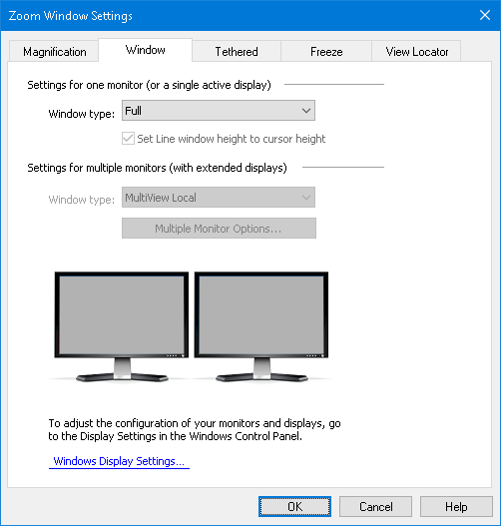
The Window tab (when using one monitor)
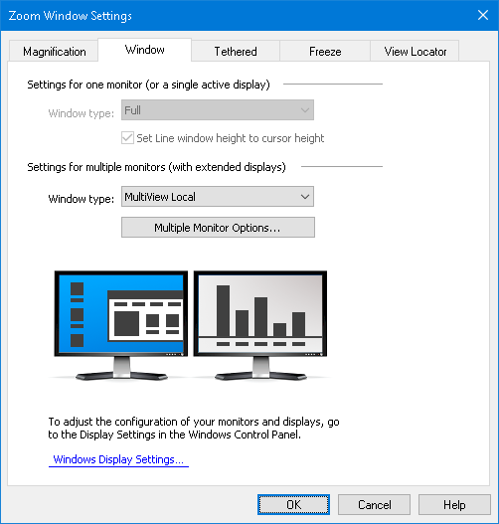
The Window tab (when using multiple monitors)
Setting | Description
Settings for one monitor (or a single active display)
Window type | Selects the zoom window type when using one monitor or a single display duplicated across multiple monitors.  Full. Displays a zoom window that occupies the entire screen.  Overlay. Displays a zoom window that lies on top of the normal screen and can be sized and moved to occupy any area.  Lens. Displays a zoom window that moves over the normal screen like a magnifying glass, displaying what is directly beneath it. The lens automatically follows as you move the mouse pointer, type text and navigate through your programs.  Line. Displays a zoom window that moves up and down the screen like a magnifying ruler, displaying what is directly beneath it. The line automatically follows as you move the mouse pointer, type text and navigate through your programs.  Docked. Splits the screen in half, displaying a magnified 'docked' view on one side and a normal (unmagnified) view on the other. The magnified view can be docked against any edge of the screen: top, bottom, left, or right.  For information on adjusting zoom windows, see Adjusting a Zoom Window.
Set window height to cursor height | As the text cursor moves through larger or smaller text, the height of the Line window increases or decreases, so that only the current line of text is displayed.
Settings for multiple monitors (with extended displays)
Window type: | Selects the zoom window type when using multiple monitors that are configured with extended displays.  Span. Displays a single contiguous magnified view that spans across all of your monitors. The magnified view tracks and scrolls to follow activity across the entire extended display.  Span view is designed for users that want to use two monitors to create one larger magnified view.  Clone. Displays the same magnified view on two or more monitors. The magnified view tracks and scrolls to follow activity across the entire extended display. Note: Clone view is only available when the displays are set to the same screen resolution and to the same orientation; Portrait or Landscape.  Clone view is designed for situations where two or more users need to see the same magnified view on separate monitors.  Zoom with 1x. Displays a magnified view on your main display and a non-magnified (1x) view on your secondary display. Both views (magnified and 1x) track and scroll to follow activity across the entire extended display.  Note: When using multiple monitors configured with extended displays, Windows designates one of the display devices as the "main display", which is where the desktop icons, taskbar with Windows menu, and Task Switcher appear. You can select which display is your main display in the Screen Resolution dialog box, which can be accessed by right-clicking any empty area of your desktop and then clicking Screen resolution.  Zoom with 1x view is designed for users that want to see both a magnified view and a normal (bird’s-eye) view of their workspace. Zoom with 1x is also ideal for situations where a low-vision user and normal-sighted user are working together on the same system. The low-vision user sees the magnified view while the normal-sighted user sees the unmagnified view.  MultiView Local. Displays separate magnified views on each monitor, with each monitor’s view limited to its own desktop area. In other words, monitor 1 will only show desktop 1 and monitor 2 will only show desktop 2, and so on.  When using MultiView Local:  - Only one magnified view is active and moving at a time.  - When the mouse pointer or application focus move from one desktop to another, the active view automatically switches monitors to follow along. You can switch the active view at any time by pressing the Active View hotkey: Caps Lock + V. When you hold down the Active View hotkey the magnified views will lock in place. In this locked state you can move the mouse pointer and any objects that you are dragging with the mouse from the magnified view on one monitor directly into the magnified view on another monitor.  - By default, each view has its own magnification level, which is adjustable only when the view is active. The Zoom In and Zoom Out hotkeys, mouse wheel zooming and Power controls always reflect and adjust the magnification level in the active view. You can force the active and inactive views to zoom in and out together by enabling "Keep views at the same magnification level" in the Multiple Monitor Options dialog box.  MultiView Local is designed for users that want separate magnified views of each desktop, with each view constrained so that it never scrolls outside of its own desktop.  MultiView Global. Displays separate magnified views on each monitor, with each monitor’s view able to scroll and track activity across all desktop areas. In other words, each monitor’s magnified view can show its own desktop as well as the other monitor’s desktop.  When using MultiView Global:  - Only one magnified view is active and moving at a time and that active view scrolls from one desktop to another to follow the mouse pointer and application focus. To switch the active view, press the Active View hotkey: Caps Lock + V. When you hold down the Active View hotkey the magnified views will lock in place. In this locked state you can move the mouse pointer and any objects that you are dragging with the mouse from the magnified view on one monitor directly into the magnified view on another monitor.  - By default, each view has its own magnification level, which is adjustable only when the view is active. The Zoom In and Zoom Out hotkeys, mouse wheel zooming and Power controls always reflect and adjust the magnification level in the active view. You can force the active and inactive views to zoom in and out together by enabling "Keep views at the same magnification level" in the Multiple Monitor Options dialog box.  MultiView Global is designed for users that want to view two locations within the same application window or desktop.
Multiple Monitor Options | Opens the Multiple Monitor Options dialog box, where you can select and configure options for ZoomText’s multiple monitor views.
Windows Display Settings | Opens the Windows Control Panel to the Display Settings, where you can adjust the configuration of your monitors.

Adjusting Zoom Windows
ZoomText provides a choice of zoom window types that occupy the full screen or a portion of the screen. Zoom window types that occupy a portion of the screen include: Overlay, Lens, Line and Docked. When using a partial-screen zoom window, you can size and/or move the zoom window to occupy a different portion or location on the screen.
- To size and move a zoom window
- On the Magnifier toolbar tab, click the arrow next to Window or navigate to Window and press the down arrow key.
- In the Window menu, choose Zoom Window Adjust Tool.
The Adjust tool becomes active and sizing handles appear on the zoom window frame.
- To size the window, drag any handle.
- To move the window, drag inside the window frame.
- To scroll the contents of the window, hold down Ctrl, and then drag inside the window frame.
- To exit the Adjust tool, right-click or press Esc.
Note: You can also activate the Zoom Windows Adjust Tool by pressing the Zoom Windows Adjust Tool hotkey: Caps Lock + A

Tethered View
When using higher zoom levels, there is often an activity that occurs on the screen that is outside of the magnified viewing area. Using the Windows Start menu search as an example, while you can see the text entered in the search box within your magnified view, you cannot see the results that are visible elsewhere on the screen. To view them, you must scroll to the results, which can take time and be inconvenient.
This is where Tethered View is helpful. It opens a new window inside the magnified area and displays the output, results, or selection alongside the action you are performing. In the Start menu search example, the first result at the top of the list appears in the Tethered View window next to the search box. The Tethered View window follows along and displays other results as you scroll through the list using the up and down arrows.
Tethered View is available in ZoomText and Fusion. It supports the following scenarios, but more will be available in future updates: Windows Start menu search, Excel formula bar, Word Comments pane, and Links List on a web page (Fusion only). These scenarios are enabled by default. See Tethered View Scenarios for more information.
Note: Tethered View can be used with the following zoom window types: Full, Docked, MultiView Local, Clone, Span, and Zoom with 1x.
- To enable and disable Tethered View
- On the ZoomText or Fusion Magnifier toolbar tab, select the Window button.
- Choose Tethered View.
- Choose Enable or Disable.
- To change Tethered View settings
- On the ZoomText or Fusion Magnifier toolbar tab, select the Window button.
- Choose Tethered View.
- Choose Settings.
The Zoom Windows Settings dialog box appears with the Tethered tab displayed.
- Change the Tethered View settings as desired.
- Click OK.
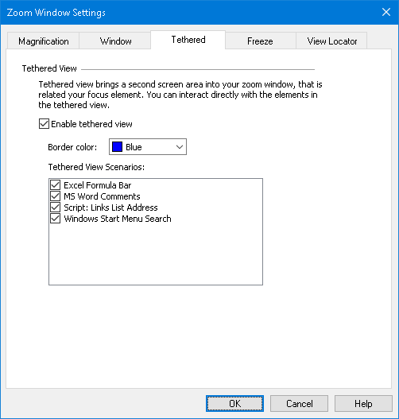
The Tethered View tab
Tethered View Scenarios
Tethered View scenarios are preset actions you can perform with ZoomText and Fusion. You can enable and disable scenarios using the Tethered View settings.
Tethered View currently supports the Windows Start menu search, Excel formula bar, Word Comments pane, and Links List on a web page (Fusion only). It is enabled by default for these items.
- To enable and disable scenarios
- On the ZoomText or Fusion Magnifier toolbar tab, select the Window button.
- Choose Tethered View.
- Choose Settings.
The Zoom Windows Settings dialog box appears with the Tethered tab displayed.
- Select or clear items in the Tethered View Scenarios list.
- Click OK.
The following are examples showing how to use Tethered View.
Windows Start Menu Search
When you use the search box in the Windows Start menu, you may notice that you cannot see the top search result in the magnified view. With Tethered View enabled, the best match appears in a window next to the search box. You can click the result or scroll through the list using the up and down arrows to see other items.
The following Tethered View keystrokes are available when using the Windows Start menu:
- To expand or collapse the Tethered View window, press CAPS LOCK+T.
- To view the result at the top of the search list, press CAPS LOCK+SHIFT+T.
Excel Formula Bar
Tethered View is available when working with formulas in an Excel worksheet. Excel displays the formula related to a cell in the formula bar located at the top of the worksheet. This position is far away from the actual cell. The Tethered View brings the formula to you and displays it next to the cell that has focus. If you want to switch to the formula field, you can click it or use the CAPS LOCK+SHIFT+T keystroke.
Other times you may want to read the Excel spreadsheet without the formula displayed. In this case, you can toggle the Tethered View with CAPS LOCK+T. In Excel, the Tethered View window is collapsed by default.
The following Tethered View keystrokes are available when using Excel:
- Expand or collapse Tethered View window: CAPS LOCK+T
- View the Formula bar: CAPS LOCK+SHIFT+T
Microsoft Word Comments
If you distribute a Word document for review, others may add comments to the document. The Comments pane or list is positioned to the far right side of the screen. In Tethered View, each comment is placed next to the text where it is inserted. This eliminates the need to scroll across the screen, find and read the comment, and then scroll and return to the text.
The following Tethered View keystrokes are available when using Word:
- Expand or collapse Tethered View window: CAPS LOCK+T
- View the comment: CAPS LOCK+SHIFT+T
- Return to the text at the insertion point: ESC
Fusion Links List (Fusion only)
When reading a web page while running Fusion, you can press INSERT+F7 to display a list of links that are on the page. With Tethered View, as you scroll through the list, the current link’s URL appears next to the item in the list. You can click or press ENTER to select the link.
The following Tethered View keystrokes are available when using the Fusion links list:
- Expand or collapse Tethered View window: CAPS LOCK+T
- View the URL for the link: CAPS LOCK+SHIFT+T
- Open the links list: INSERT+F7

Setting | Description
Tethered View Settings
Enable tethered view | Enables and disables the Tethered View feature.
Border color | Sets the color for the Tethered View window border.
Tethered View Scenarios | Enables and disables actions supported by Tethered View.

Freeze View
In a magnified view, it is impossible to see the entire screen at once. As a result, items of interest, such as the clock and Start menu, cannot be seen at the same time since they are on opposite sides of the screen. Freeze View solves this problem by letting you draw a window around an area of the screen that you want to monitor. When you have completed your selection, the Freeze View automatically appears on top of the Full zoom window displaying the selected area. The Full zoom window continues to operate normally, tracking all on-screen activity and allowing you to navigate and work in all areas of the screen.
You can create up to four Freeze Views and place them anywhere on your screen. Multiple views can appear simultaneously. For example, you can create a view of the ZoomText app icon located in the system tray and drag it to an area on the screen that is convenient for you to access. This lets you quickly bring the ZoomText toolbar into view instead of scrolling with the mouse pointer to the system tray and then clicking the app icon. Another example is to create a view of the clock, which is located in the notification area. Again, you can position it on the screen so that it is always in view. Both views can appear simultaneously.
- To create a Freeze View
- Do one of the following:
- For one monitor, set the zoom window type to Full.
- For multiple monitors, set the zoom window type to Span, Clone, Zoom with 1x, or MultiView Global.
- On the Magnifier toolbar tab, click the arrow next to Window or navigate to Window and press the down arrow key.
- In the Window menu, choose Freeze View > New Freeze View.
The Freeze tool becomes active.
Freeze tool
Note: You can have up to four Freeze Views. If you try to create a fifth Freeze View, you must first delete an existing Freeze View.
- Move the mouse pointer until the area you want to freeze is scrolled into view.
- Hold down the left button and drag a selection rectangle around the desired freeze area and release the button.
Freeze Selection tool
When you complete the drag, the Freeze View will appear with sizing handles on the frame.
Freeze View Adjustment frame
- To size the window, drag any handle. To move the window, drag inside the window frame. To scroll the contents of the window, hold down CTRL and drag inside the window frame.
- To exit the Freeze tool, right click or press ESC.
Note: The Freeze View can be resized or moved using the Adjust tool.
- To create additional Freeze Views, repeat steps 1-7. You can have a total of four Freeze Views.
Note: If you try to add a fifth Freeze View, the Freeze View Settings dialog opens. You must delete at least one Freeze View from the Views list before adding another.
- To save Freeze View changes, in the ZoomText menu, choose Configurations > Save As Default.
- To enable and disable the Freeze window
Do one of the following:
- Press the Freeze View On/Off hotkey:
- CAPS LOCK+CTRL+1 for Freeze View 1
- CAPS LOCK+CTRL+2 for Freeze View 2
- CAPS LOCK+CTRL+3 for Freeze View 3
- CAPS LOCK+CTRL+4 for Freeze View 4
- On the Magnifier toolbar tab, choose Window > Freeze View, and then select a Freeze View to toggle it on or off.
- To delete a Freeze View using Hotkeys
- Press CAPS LOCK+A until the Freeze View you want to delete is selected.
- Press DELETE.
The Freeze tool appears.
- Press ESC.
- Repeat steps 1-3 to delete other Freeze Views.
- To delete a Freeze View using the Freeze View settings
- On the Magnifier toolbar tab, select the Zoom Window Settings button, which appears in the lower-right corner of the Zoom Window group.
The Zoom Window Settings dialog appears.
- Select the Freeze tab.
- Choose a Freeze View from the Views list and click the Delete button.
- Repeat steps 1-3 to delete other Freeze Views.
- To move a Freeze View between multiple monitors
Note: Freeze View windows can only be moved between multiple monitors when the window zoom type is set to Span.
- Press CAPS LOCK+A until the Freeze View you want to move is selected.
The Freeze Selection tool becomes active.
- Place the Freeze Selection Tool inside the Freeze View and drag it to the other monitor.
- To exit the tool, right click or press ESC.
- To save the Freeze View’s new position, in the ZoomText menu, choose Configurations > Save As Default.
- To customize a Freeze View
- On the Magnifier toolbar tab, select the Zoom Windows Settings button, which appears in the lower-right corner of the Zoom Windows group.
The Zoom Windows Settings dialog appears.
- Select the Freeze tab.
- Choose a Freeze View from the Views list and do any of the following:
- Assign a name
- Choose a zoom level
- Decide if you want the mouse pointer to appear in front of or behind the Freeze View. When in front, you can click and use the items in the Freeze View. When behind, you can only view what is in the Freeze View.
- Repeat steps 1-3 to customize other Freeze Views
- Click OK.
- To save Freeze View changes, in the ZoomText menu, choose Configurations > Save As Default.
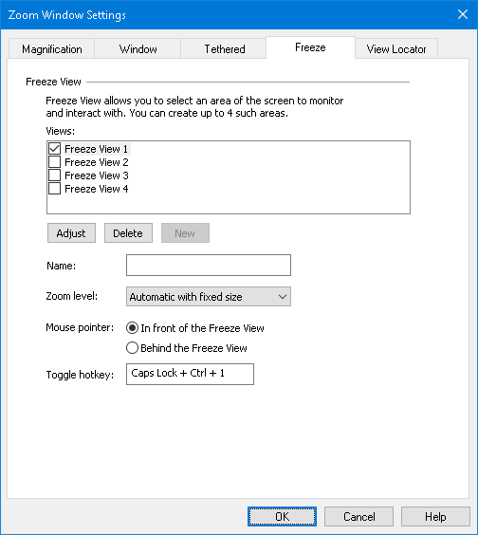
The Freeze View tab
Setting | Description
Freeze View Settings
Views | Shows a list of all Freeze Views. Select a check box to enable a Freeze View. Clear a check box to disable a Freeze View.
Adjust | Resizes and moves the selected Freeze View.
Delete | Deletes the selected Freeze View.
New | Activates the Freeze Tool.
Name | Renames the selected Freeze View.
Zoom level | Sets the magnification level for the selected Freeze View.  Automatic with fixed size: Sets the Freeze View to use the same magnification level as ZoomText.  Other magnification levels include: 1x to 8x in steps of 1, 10x to 16x in steps of 2, 20x to 36x in steps of 4x, 42x to 60x in steps of 6, and fractional powers of 1.2x, 1.4x, 1.6x, 1.8x, 2.25x, 2.5x, 2.75x, 3.5x and 4.5x.
Mouse pointer | Sets the mouse pointer to appear in front of or behind the selected Freeze View. When in front, you can click and use the items visible in the Freeze View. When behind, you can only view what is in the Freeze View.
Toggle hotkey | Displays the hotkey assigned to the selected Freeze View. To assign a new hotkey, see ZoomText Command Key dialog.
Freeze View Commands
Command | Hotkeys
Create new Freeze View | CAPS LOCK+N
Adjust Freeze View size and position | CAPS LOCK+A
Delete Freeze View | CAPS LOCK+A (to select a Freeze View) and then press DELETE
Toggle on and off Freeze Views 1...4 | CAPS LOCK+CTRL+1...4
Create a specific Freeze View | CTRL+ALT+SHIFT+1...4  These hotkeys are disabled by default. You can enable them using the ZoomText Command Key dialog

Using Overview Mode and the View Locator
Overview mode shows you the area of the screen that is currently being magnified and allows you to select a new area to zoom in on. When Overview mode is activated, magnification turns off and the View Locator appears in the normal screen. By moving the mouse pointer, the View Locator moves over the unmagnified screen allowing you to select a new area to zoom in on.
- To use Overview Mode
- Do one of the following:
- On the Magnifier toolbar tab, choose Window > Overview Mode.
- Press the Overview Mode On/Off hotkey: Caps Lock + O
Magnification is temporarily turned off and the View Locator appears.
- Move the View Locator to the desired screen location.
- Click to zoom-in on the new location.
Magnification is restored with the selected screen area displayed.
You can configure the View Locator to appear in a variety of shapes and colors. The View Locator can also be enabled to appear in unmagnified portions of the screen when using Overlay or Docked zoom windows.
- To configure the View Locator
- In the Magnifier menu, click the Windows button, and choose View Locator
The Zoom Window Settings dialog appears with the View Locator tab displayed.
- Adjust the locator options as desired.
- Click OK to enable the changes.
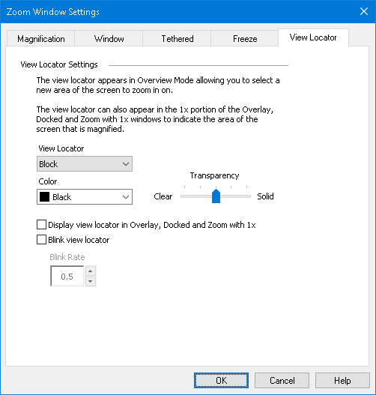
The View Locator tab
Setting | Description
View Locator Settings
View Locator | Selects the type of View Locator that is displayed: Block, Inverted Block, Frame or Cross.
Color | Selects the color that the View Locator will appear in.
Transparency | Sets the level of transparency for the View Locator. The transparency level controls the amount of the desktop image that is visible through the View Locator.
Display view locator in Overlay, Docked and Zoom with 1x views | Enables the display of the View Locator in the 1x portion of the screen when using the Overlay, Docked or Zoom with 1x zoom windows.
Blink view locator | Turns locator blinking on or off.
Blink Rate | Sets the blink rate for the View Locator in seconds (from 0.5 to 5, in increments of 0.5).

Managing Multiple Monitors
In the "Zoom Windows" section you learned about the types of zoom windows that are available and how to select a zoom window.
This section provides information on how to configure ZoomText's multiple monitor options, how to best configure a system with multiple monitors to work with ZoomText, and how to troubleshoot problems related to ZoomText’s multiple monitor support.
ZoomText’s multiple monitor support currently works with two extended displays. Support for three or more extended displays will be added in a future release.
Note: For information on setting up your system with multiple display devices, search the Microsoft website for instructions that pertain to your version of Microsoft Windows.
- Multiple Monitor Options
- Support Hardware
- Recommended Configurations
- Configuring Displays
- Automatic Adjustments
- ZoomText Feature Behaviors
- Troubleshooting

Multiple Monitor Options
Multiple Monitor Options provide a variety of settings for customizing how the zoom windows behave when using multiple monitors. These behaviors include how the mouse pointer moves between desktops and monitors, and how magnification and screen enhancements are applied and adjusted in each monitor’s view.
Note: For descriptions of the zoom window types available in multiple monitor support, see Selecting Zoom Windows.
- To configure the Multiple Monitor Options
- On the Magnifier toolbar tab, click the arrow next to Window or navigate to Window and press the down arrow key.
- In the Window menu, choose Settings.
The Zoom Window Settings dialog box appears.
- Choose the Window tab.
- Choose Multiple Monitor Options...
The Multiple Monitor Options dialog box appears.
- Adjust the multiple monitor settings as desired.
- Click OK.
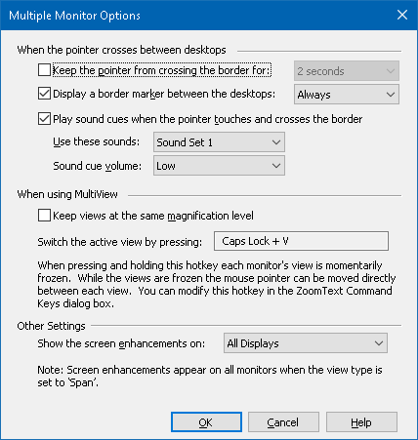
The Multiple Monitor Options dialog box
Setting | Description
When the pointer crosses between desktops
Keep the pointer from crossing the border for: | Keeps the mouse pointer from crossing between desktops until the pointer presses against the border for the amount of time selected in the neighboring combo box. Note: When this option is enabled, you can cross the pointer immediately by tapping the border twice (quickly).
Display a border marker between the desktops: | Displays a border marker on the border between desktops according to the style selected in the neighboring combo box. The border marker helps you to stay oriented in the extended displays.
Play sound cues when the pointer touches and crosses the border | Plays a pair of sound cues to make you aware of when the mouse pointer has bumped the border between desktops and crossed over between desktops.
Use these sound cues: | Selects the sounds that will be played when the pointer touches and crosses the border between desktops. There are four sets of sound cues to choose from.
Sound cue volume: | Sets the volume level for the sound cues.
When using MultiView
Keep views at the same magnification level | When using the MultiView Local or MultiView Global zoom windows; this setting forces the active and inactive views to zoom in and out together at the same magnification level across all of the monitors. When adjusting the magnification level in the active view, the magnification levels on the other monitors will also adjust to the same level.
Switch the active view by pressing: | Displays the assigned hotkey for switching the active view when using the MultiView Local or MultiView Global zoom windows.
Other Settings
Show the screen enhancements on: | Sets the monitors that screen enhancements will be applied to.

Supported Multiple Monitor Hardware
ZoomText’s multiple monitor support will work with most display technologies that are designed for the Windows operating system. These supported technologies include video cards, display monitors and projectors, and display connections, including VGA, DVI, HDMI and DisplayPort. In most cases, if your system is already running with multiple display devices that are set to: "Extend these displays", ZoomText’s multiple monitor support will also run on that system. If you encounter a problem with ZoomText’s multiple monitor support, see "Multiple Monitor Troubleshooting" in this chapter, or contact Freedom Scientific or your local dealer for assistance.

Recommended Monitor Configurations
ZoomText’s multiple monitor support will work with most makes and models of computer monitors and projectors, including a set of monitors that have different physical sizes and display resolutions. However, the following recommendations should be observed to achieve the highest level of display quality, viewing comfort and productivity from your multiple monitor system.
Monitor sizes, orientation and alignment
For best viewing, we recommend using a matched set of monitors that are physically oriented and aligned in a perfect side-by-side or stacked arrangement on your desk. Then, when you have arranged the displays in the Screen Resolution dialog box in the same orientation as the monitors on your desk, you will be able to intuitively move the mouse pointer from one monitor to another, as if it were one seamless screen. For instructions on arranging displays, see Configuring Displays for Multiple Monitor Support.
These factors—size, orientation and alignment—are particularly important when using the Span zoom window, where your screens display a contiguous magnified view across multiple screens. If the monitors are mismatched in size, orientation or alignment, the magnified view displayed in the Span zoom window may be confusing to look at.
Display resolutions
For the clearest magnified views, we recommend always setting the screen resolution for each monitor to its native resolution. Running monitors in non-native resolutions degrades the image quality that appears in a normal view, which is further degraded when magnified. Note: This recommendation also applies when only using one monitor.

Configuring Displays for Multiple Monitor Support
To use ZoomText's multiple monitor support your system must have multiple monitors connected, enabled, and configured with the following settings:
- The monitors must be set to "Extend these displays" in the Screen Resolution dialog box.
- The monitors must be perfectly aligned on one side in the Screen Resolution dialog box.
- The extended displays should be arranged to closely match the physical arrangement of the monitors on your desk.
Instructions for making all of these adjustments are provided below.
- To set your monitors to "Extend these displays"
You can set your monitors to "Extend these displays" using the following methods:
Method 1: Use the Display Switch shortcut: Windows + P
- When you press the Windows + P shortcut the Display Switch bar will appear on your screen. When the Display Switch bar is visible, press the Windows + P shortcut or the left and right arrow keys to cycle through the multiple monitor options in the Display Switch bar. Once you have cycled to the Extend option, press the Enter key.
Method 2: Select in the Screen Resolution dialog box.
- Right-click any empty area of your desktop, and then click Screen resolution.
The Screen Resolution dialog appears.
- Click the Multiple displays drop-down list and select Extend these displays. A dialog may appear asking if you want to keep the adjusted display settings. Choose Keep Changes.
Note: ZoomText’s multiple monitor support also works when using a combination of monitor and projector that are set to "Extend these displays".
- To arrange and align your extended displays
Arranging and aligning your extended displays can be performed as follows:
- Right-click any empty area of your desktop, and then click Screen resolution.
The Screen Resolution dialog appears. This dialog displays an illustrative representation of how your extended displays are currently arranged and aligned.
- Using the mouse, drag the displays so that they are arranged to closely match the physical arrangement of the monitors on your desk, and then perfectly align the same edges of the monitors according to the following alignment rules.
- If the displays are positioned side by side, either the top edges or bottom edges of the displays must be aligned.
- If the displays are positioned in a vertical stack, either the left edges or right edges of the displays must be aligned.
- Click the Apply or OK button. A dialog may appear asking if you want to keep the adjusted display settings. If this dialog appears, choose Keep Changes.

Automatic Adjustment to Display Changes
ZoomText automatically detects all changes that are made to your display devices, including the following:
- Adding and removing display devices
- Enabling and disabling display devices
- Changing the screen resolution for display devices
- Changing the relative position and orientation of display devices
- Changing the presentation of the display devices—i.e. Extend these displays, Duplicate these displays, Show only on {n}
These changes are detected when ZoomText starts up and while ZoomText is running. When a change is detected, ZoomText automatically adjusts to the settings you previously used for that display configuration. If you had not previously used that display configuration, ZoomText will use default settings. Here are a few examples of how ZoomText detects and adjusts for display changes:
- When ZoomText detects a switch from one monitor to multiple monitors with extended displays, ZoomText will automatically switch to the last window type used for multiple monitors. When multiple monitors with extended displays are detected for the first time, ZoomText enables the default zoom window type for multiple monitors, which is MultiView Local.
- When ZoomText detects a switch from multiple monitors with extended displays to one monitor, or to multiple monitors set to "Duplicate these displays", ZoomText will automatically switch to the last zoom window type used for one monitor. When only one monitor is detected for the first time, ZoomText enables the default zoom window type for one monitor, which is Full zoom.

Feature Behaviors in Multiple Monitors
When using ZoomText’s multiple monitor support the behavior of some of ZoomText features will work as described below.
Feature | Current Behavior
AppReader | When using the Span, Clone, Zoom with 1x or MultiView Global zoom windows; the active magnified view always scrolls to follow AppReader’s word highlight, regardless of which desktop the target application is on.  When using the MultiView Local zoom window, if the target application is on the inactive view’s desktop, the inactive view becomes active and scrolls to follow AppReader’s word highlight.
Reading Zones | When using the Span, Clone, Zoom with 1x or MultiView Global zoom windows, the active magnified view scrolls to bring the triggered reading zone into view, regardless of which desktop the reading zone is on.  When using the MultiView Local zoom window, if the triggered reading zone is on the inactive view’s desktop, the inactive view becomes active and scrolls to bring the reading zone into view.
Touch Screen | This feature is currently not supported when using multiple monitors.
ZoomText Camera | This feature is currently not supported when using multiple monitors.
Support for third-party USB CCTVs | This feature is currently not supported when using multiple monitors.

Troubleshooting Multiple Monitors
This topic provides steps for troubleshooting problems that can occur when using ZoomText’s multiple monitor support.
Problem: Your system has three or more monitors (configured with extended displays) and when you attempt to start ZoomText a message appears saying: "ZoomText multiple monitor support requires that you have only one extended display enabled. Please disable all but one extended display, and then try enabling multiple monitors again."
Solution: ZoomText’s multiple monitor support currently works with two extended displays. Support for three or more extended displays will be added in a future release.

Problem: When using Span View the left half of the magnified view is on the right and vice versa.
Solution: The orientation of your extended displays is reversed from the physical arrangements of your monitors. To resolve this problem, reverse the arrangement of the displays in the Screen Resolution settings, which can be accessed by right-clicking any empty area of your desktop, and then clicking Screen resolution.

Problem: The mouse won’t move between my monitors but wraps around from the outside edges.
Solution: The orientation of your extended displays is reversed from the physical arrangements of your monitors. To resolve this problem, reverse the arrangement of the displays in the Screen Resolution settings, which can be accessed by right-clicking any empty area of your desktop, and then clicking Screen resolution.

Problem: ZoomText only magnifies and scrolls across half of the display area.
Solution: ZoomText's multiple monitor support is enabled and you are only looking at one of your monitors. The other half of the display area is displayed on the second monitor.

Screen Enhancements
Screen enhancements improve the legibility of objects that appear on the screen. With these settings you can; enhance the screen colors for improved contrast and clarity; enhance the appearance of the mouse pointer, text cursor and keyboard input focus so that they're easier to see and follow.
- Color Enhancements
- Pointer Enhancements
- Cursor Enhancements
- Focus Enhancements
- Using Smart Invert

Color Enhancements
Color enhancements improve the clarity of text and graphics, providing easier viewing and reduced eyestrain. The color enhancement options consist of a variety of filter effects that adjust color, contrast and brightness. You can choose from preset color schemes or create your own custom color settings.
Tip: When using the Invert Brightness and Invert Color effects in Google Chrome, enabling ZoomText's Smart Invert feature will reverse the invert effect on photos so that they are displayed in their natural colors. For more information on this feature, see Using Smart Invert.
The color enhancement options are enabled and set using the Color split-button control located on the Magnifier toolbar tab. The top portion of this button toggles the color enhancements on and off, while the bottom portion opens the color menu.
- To toggle the color enhancements on and off
Do one of the following:
- On the Magnifier toolbar tab, select the Color button.
- Press the Enhance Colors On/Off hotkey: Caps Lock + C
- To choose a preset color scheme
- On the Magnifier toolbar tab, click the arrow next to Color or navigate to Color and press the down arrow key.
- In the Color menu, choose Scheme.
- In the Scheme menu, choose the desired color scheme.
- To create a custom color scheme
- On the Magnifier toolbar tab, click the arrow next to Color or navigate to Color and press the down arrow key.
- In the Color menu, choose Settings.
The Screen Enhancements Settings dialog box appears with the Color tab displayed.
- Choose Custom...
- Adjust the custom settings as desired.
- Click OK.
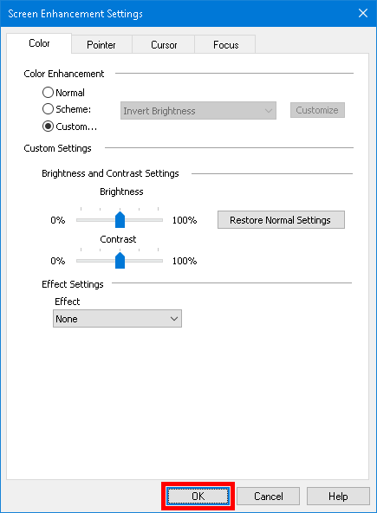
The Color tab
Setting | Description
Color Enhancement
Normal | Disables all color enhancements.
Scheme | Activates a preset color scheme (selected in the neighboring combo box).
Custom | Activates the Custom Settings, allowing you to create your own custom color scheme.
Customize | Activates and configures the Custom Settings to match the selected preset color scheme. This allows you to use a preset scheme as the starting point for a custom scheme.
Brightness and Contrast Settings
Brightness | Increases or decreases the brightness of the screen image from 0% to 100%. Normal brightness is 50%.
Contrast | Increases or decreases the contrast of the screen image from 0% to 100%. Normal contrast is 50%.
Restore Normal Settings | Restores Brightness and Contrast to 50% (normal).
Effect Settings
Effect | Selects the type of color effect and activates the associated settings.  None. No filtering is applied.  Invert Brightness. Inverts the brightness of all screen colors. Light colors become dark and vice-versa.  Invert Colors. Inverts all screen colors.  Dyed. Transforms all screen colors to a single hue while preserving their light and dark values. When the Dye effect is selected, a Color combo box appears, allowing you to select the dye color.  Two-Color. Transforms all screen colors to a two-color spectrum. When the Two-Color effect is selected, Foreground Color and Background Color combo boxes appear, allowing you to define the two-color spectrum.  Replace Color. Replaces one screen color with another. When the Replace Color effect is selected, Replace and With combo boxes appear, allowing you to choose the color to replace and replacement color. A bandwidth slider also appears allowing you to expand the range of color replace to hues close to the selected color.

Pointer Enhancements
Pointer enhancements make it easy to locate and follow the mouse pointer. You can adjust the size and color of the pointer and activate a locator that emphasizes the pointer's position on the screen. You can choose from preset pointer schemes or create your own custom pointer settings.
The pointer enhancement options are enabled and set using the Pointer split-button control located on the Magnifier toolbar tab. The top portion of this button toggles the pointer enhancements on and off, while the bottom portion opens the pointer menu.
- To toggle the pointer enhancements on and off
Do one of the following:
- On the Magnifier toolbar tab, select the Pointer button.
- Press the Enhance Pointer On/Off hotkey: Caps Lock + P
- To choose a preset pointer scheme
- On the Magnifier toolbar tab, click the arrow next to Pointer or navigate to Pointer and press the down arrow key.
- In the Pointer menu, choose Scheme.
- In the Scheme menu, choose the desired pointer scheme.
- To create a custom pointer scheme
- On the Magnifier toolbar tab, click the arrow next to Pointer or navigate to Pointer and press the down arrow key.
- In the Pointer menu, choose Settings.
The Screen Enhancements Settings dialog box appears with the Pointer tab displayed.
- Choose Custom...
- Adjust the custom settings as desired.
- Click OK.
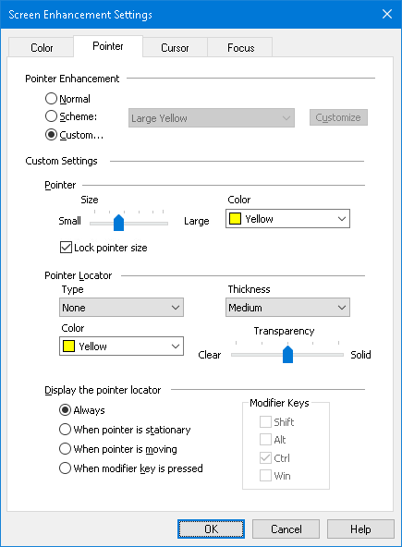
The Pointer tab
Setting | Description
Pointer Enhancement
Normal | Disables all pointer enhancements.
Scheme | Enables a preset pointer scheme (selected in the neighboring combo box).
Custom | Activates the Custom Settings, allowing you to create your own custom pointer scheme.
Customize | Activates and configures the Custom Settings to match the selected preset pointer scheme. This allows you to use a preset scheme as the starting point for a custom scheme.
Custom Settings
Pointer
Size | Sets the size of the enhanced mouse pointer. Fifteen incremental sizes are available.
Color | Sets the color for the mouse pointer.
Lock pointer size | As you zoom in or out, the size of the mouse pointer also changes relative to the zoom level. By locking the pointer, it maintains a consistent size regardless of the changing zoom level.
Pointer Locator
Type | Selects the type of pointer locator:  Circle. Displays a circle that is centered over the pointer's hot spot.  Sonar. Displays animated circles that radiate inward toward the pointer's hot spot.  Full Cross. Displays a set of crosshairs that extend across the entire zoom window and intersect the pointer's hot spot.  Crosshairs. Displays a set of crosshairs that are centered over the pointer's hot spot.
Color | Sets the color for the pointer locator.
Thickness | Sets the thickness of the pointer locator: Thin, Medium or Thick.
Transparency | Sets the level of transparency for the pointer locator. The transparency level controls the amount of the desktop image that is visible through the pointer locator.
Display the pointer locator
Always | The pointer locator is always displayed.
When pointer is stationary | The pointer locator is only displayed when the pointer is stationary (not moving).
When pointer is moving | The pointer locator is only displayed when the pointer is moving.
When modifier key is pressed | The pointer locator is only displayed when the pointer modifier keys are held down.
Modifier Keys | Selects a key or combination of keys that, when pressed, will display the pointer locator.  Note: The Display the pointer locator option must be set to When modifier key is pressed.

Cursor Enhancements
Cursor enhancements make it easy to locate and follow the text cursor. A choice of high visibility locators marks the cursor’s position without obscuring the surrounding text. You can choose from preset cursor schemes or create your own custom cursor settings.
The cursor enhancement options are enabled and set using the Cursor split-button control located on the Magnifier toolbar tab. The top portion of this button toggles the cursor enhancements on and off, while the bottom portion opens the cursor menu.
- To toggle the cursor enhancements on and off
Do one of the following:
- On the Magnifier toolbar tab, select the Cursor button.
- Press the Enhance Cursor On/Off hotkey: Caps Lock + R
- To choose a preset cursor scheme
- On the Magnifier toolbar tab, click the arrow next to Cursor or navigate to Cursor and press the down arrow key.
- In the Cursor menu, choose Scheme.
- In the Scheme menu, choose the desired cursor scheme.
- To create a custom cursor scheme
- On the Magnifier toolbar tab, click the arrow next to Cursor or navigate to Cursor and press the down arrow key.
- In the Cursor menu, choose Settings.
The Screen Enhancements Settings dialog box appears with the Cursor tab displayed.
- Choose Custom...
- Adjust the custom settings as desired.
- Click OK.
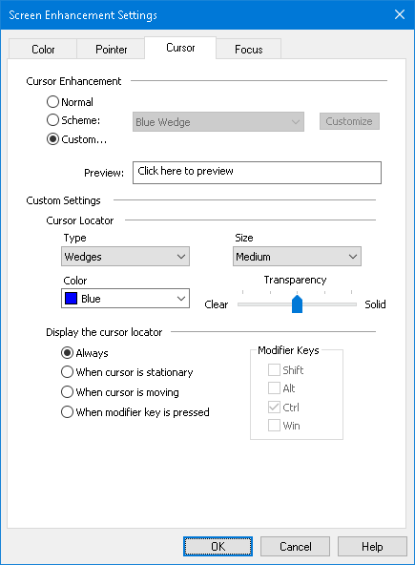
The Cursor tab
Setting | Description
Cursor Enhancement
Normal | Disables all cursor enhancements.
Scheme | Activates a preset cursor scheme (selected in the neighboring combo box).
Custom | Activates the Custom Settings, allowing you to create your own custom cursor scheme.
Customize | Activates and configures the Custom Settings to match the selected preset cursor scheme. This allows you to use a preset scheme as the starting point for a custom scheme.
Preview | When you click in the Preview box a text cursor appears with the selected cursor enhancement settings.
Custom Settings
Cursor Locator
Type | Selects the type of cursor locator:  Wedge. Displays triangular wedges above and below the cursor.  Single Wedges. Displays one triangular wedge above or below the cursor.  Circle. Displays a circle around the cursor.  Frame. Displays a rectangular frame around the cursor.
Size | Sets the size of the cursor locator: Thin, Medium or Thick.
Color | Sets the color for the cursor locator.
Transparency | Sets the level of transparency for the cursor locator. The transparency level controls the amount of the desktop image that is visible through the cursor locator.
Display the cursor locator
Always | The cursor locator is always displayed.
When cursor is stationary | The cursor locator is only displayed when the cursor is stationary (not moving).
When cursor is moving | The cursor locator is only displayed when the cursor is moving.
When modifier key is pressed | The cursor locator is only displayed when the cursor modifier keys are held down.
Modifier Keys | Selects a key or combination of keys that, when pressed, will display the cursor locator.  Note: The Display the cursor locator option must be set to When modifier key is pressed.

Focus Enhancements
Focus enhancements make it easy to locate and follow the control focus when you tab and arrow key through menus, dialogs, tool bars, and other application controls. When enabled, a choice of high visibility locators marks the position of the control with focus without obscuring any surrounding text. You can choose from preset focus schemes or configure your own custom focus settings.
The focus enhancement options are enabled and set using the Focus split-button control located on the Magnifier toolbar tab. The top portion of this button toggles the focus enhancements on and off, while the bottom portion opens the focus menu.
- To toggle the focus enhancements on and off
Do one of the following:
- On the Magnifier toolbar tab, select the Focus button.
- Press the Enhance Focus On/Off hotkey: Caps Lock + F
- To choose a preset focus scheme
- On the Magnifier toolbar tab, click the arrow next to Focus or navigate to Focus and press the down arrow key.
- In the Focus menu, choose Scheme.
- In the Scheme menu, choose the desired focus scheme.
- To create a custom focus scheme
- On the Magnifier toolbar tab, click the arrow next to Focus or navigate to Focus and press the down arrow key.
- In the Focus menu, choose Settings.
The Screen Enhancements Settings dialog box appears with the Focus tab displayed.
- Choose Custom...
- Adjust the custom settings as desired.
- Click OK.
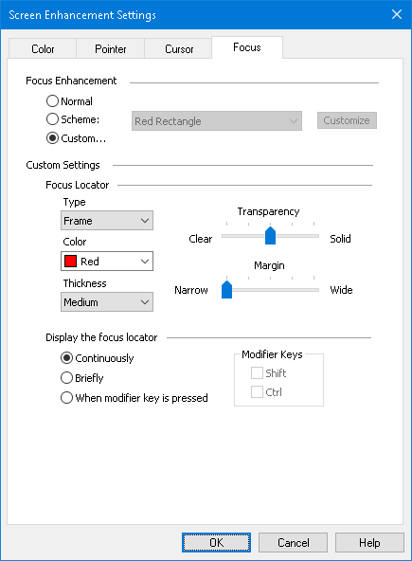
The Focus tab
Setting | Description
Focus Enhancement
Normal | Disables all focus enhancements.
Scheme | Activates a preset focus scheme (selected in the neighboring combo box).
Custom | Activates the Custom Settings, allowing you to create your own custom focus scheme.
Customize | Activates and configures the Custom Settings to match the selected preset focus scheme. This allows you to use a preset scheme as the starting point for a custom scheme.
Custom Settings
Focus Locator
Type | Selects the type of focus locator:  Block. Displays a block over the control that has focus.  Underline. Displays a line beneath the control that has focus.  Frame. Displays a rectangular around the control that has focus.
Color | Sets the color for the focus locator.
Thickness | Sets the thickness of the focus locator: Thin, Medium or Thick.
Transparency | Sets the level of transparency for the focus locator. The transparency level controls the amount of the desktop image that is visible through the focus locator.  Note: This setting is not available when the locator color is set to 'Invert'.
Margin | Increases or decreases the space between the control with focus and the focus locator.
Display the focus locator
Continuously | The focus locator is always displayed (when a control has focus).
Briefly | The focus locator is for 1.5 seconds when a control receives focus.
When modifier key is pressed | The focus locator is only displayed when the focus modifier keys are held down.
Modifier Keys | Selects a key or combination of keys that, when pressed, will display the focus locator.  Note: The Display the focus locator option must be set to When modifier key is pressed.

Using Smart Invert
The use of filter effects to invert the screen brightness and colors is popular among low-vision computer users, providing reduced glare, improved legibility of on-screen text, less eyestrain and increased comfort. However, these effects also result in photo images that look like film negatives, which are unappealing and often unusable to look at.
By enabling ZoomText's Smart Invert feature, when using ZoomText's Invert Brightness and Invert Color effects (in the Color Enhancement feature), ZoomText will reverse or undo the inverted effect on photos so that they are displayed in their natural colors.
Note: This feature is available in Google Chrome. To use it, you must download and install the Smart Invert extension from the Google Chrome store.
- To enable and disable the Smart Invert in the Color menu
- On the Magnifier toolbar tab, click the arrow next to Color or navigate to Color and press the down arrow key.
- In the Color menu, choose Use Smart Invert.
- To enable and disable the Smart Invert by hotkey
Press the Enhance Smart Invert On/Off hotkey: Caps Lock + I
Note: Smart Invert can only be enabled and disabled when either Invert Brightness or Invert Colors is enabled.

Navigation Settings
Navigation settings control how ZoomText will scroll the zoom window to keep moving objects in view, including the mouse pointer, text cursor, keyboard focus and other objects that appear and move about the screen. With these settings you can: choose the objects and events ZoomText will track in the zoom window, choose how tracked objects and events will be positioned in the zoom window, automatically route the mouse pointer into the magnified view or to the active control, and constrain the movement of the mouse pointer.
- Tracking
- Alignment
- Mouse
- Panning

Tracking
As you move the mouse, type text, and navigate menus, dialogs and other program controls, the zoom window automatically scrolls to keep the focus in view. This behavior is driven by ZoomText's tracking options, which allow you to choose the items that you want ZoomText to track when they become active. You can also limit tracking to a selected area of the screen.
- To adjust the tracking settings
- On the Magnifier toolbar tab, select the Navigation button.
- In the Navigation menu, choose Tracking.
The Navigation Settings dialog appears with the Tracking tab displayed.
- Adjust the tracking settings as desired.
- Click OK.
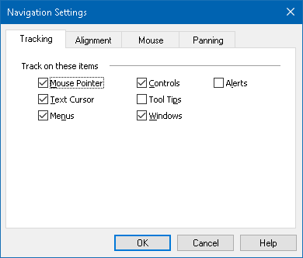
The Tracking tab
Setting | Description
Track on these items
Mouse Pointer | Enables tracking of the mouse pointer.
Text Cursor | Enables tracking of the text cursor.
Menus | Enables tracking of menu items when they receive keyboard focus.
Controls | Enables tracking of controls when the receive keyboard focus.
Tool Tips | Enables tracking on tool tips when they appear.
Windows | Enables tracking on windows when they become active.
Alerts | Enables tracking on alert pop ups when they appear.

Alignment
Alignment options control how the zoom window scrolls to keep tracked items in view. There are two general types of alignment; edge and center. With edge alignment, the zoom window scrolls only as needed to keep the tracked object in view. With center alignment, the zoom window scrolls as needed to keep the tracked object in the center of the zoom window. A third alignment type, "smart alignment", scrolls a control and the maximum portion of its parent menu or window into view.
- To adjust the alignment settings
- On the Magnifier toolbar tab, select the Navigation button.
- In the Navigation menu, choose Alignment.
The Navigation Settings dialog appears with the Alignment tab displayed.
- Adjust the alignment settings as desired.
- Click OK.
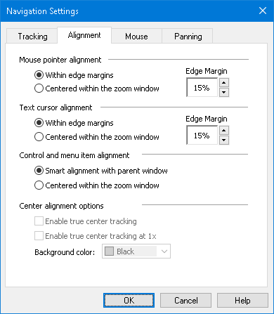
The Alignment tab
Setting | Description
Within edge margins | The zoom window scrolls only as needed to bring the tracked object within the edge margins.
Centered within the zoom window | The zoom window scrolls to keep the tracked object centered in the magnified view.
Edge Margins | Defines how close to the edge of the zoom window a tracked object can move before the window begins to scroll. The edge margin can be set from 0% to 50%; half the width and height of the zoom window.
Smart alignment with parent window | The zoom window scrolls to bring the tracked control or menu item and the maximum portion of its parent window or menu into view.
Enable true center tracking | True center tracking always keeps tracked objects in the center of the monitor. This includes moving the edge of the Windows desktop toward the center of the monitor as needed. When this happens, the area outside the desktop appears as a background color. True center tracking is available when the window type is set to Full, and your system is running with one monitor.
Enable true center tracking at 1x | Enables true center tracking when using 1x magnification. True center tracking always keeps tracked objects in the center of the monitor. True center tracking at 1x is available when your system is running with one monitor.
Background color | Choose a background color for true center tracking.

Mouse
The Mouse navigation options, pointer positioning and pointer constraints, make it easy to explore and move about the screen. With pointer positioning, the mouse pointer is always brought into view when you need it. With pointer constraints, you can limit mouse pointer movement to horizontal or vertical directions, or within the active window.
- To adjust the mouse navigation settings
- On the Magnifier toolbar tab, select the Navigation button.
- In the Navigation menu, choose Mouse.
The Navigation Settings dialog appears with the Mouse tab displayed.
- Click OK.
- Adjust the mouse navigation settings as desired.
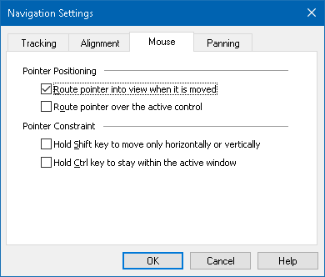
The Mouse tab
Setting | Description
Route pointer into view when it is moved | Automatically moves the pointer to the center of the magnified view, whenever the pointer moves while located outside the view.
Route pointer over the active control | Automatically moves the pointer to menu items and dialog controls when they receive focus.
Hold Shift key to move only horizontally or vertically | While holding down the Shift key, the mouse pointer moves horizontally or vertically only, depending on the initial direction of mouse movement. This constrained movement provides smoother scrolling through rows and columns of information.
Hold Ctrl key to stay within the active window | While holding down the Ctrl key, the mouse pointer moves horizontally or vertically only, depending on the initial direction of mouse movement. This constrained movement provides smoother scrolling through rows and columns of information.

Panning
Smooth panning provides a more natural panning motion when the magnified view scrolls to keep the focus in view. As you type text and navigate menus, dialogs and other program controls the magnified view smoothly pans across the screen, rather than moving in increments.
- To enable and adjust the smooth panning settings
- On the Magnifier toolbar tab, select the Navigation button.
- In the Navigation menu, choose Panning.
The Navigation Settings dialog appears with the Panning tab displayed.
- Adjust the smooth panning settings as desired.
- Click OK.
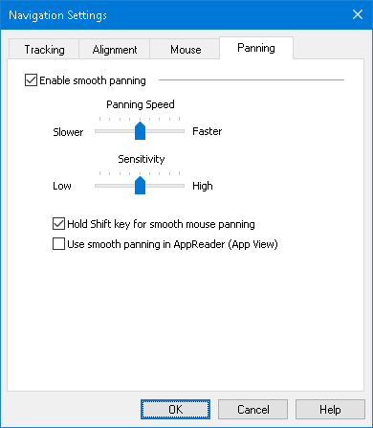
The Panning tab
Setting | Description
Enable smooth panning | Enables ZoomText’s smooth panning feature. Press Caps Lock + S to toggle on and off.
Panning Speed | Controls how fast ZoomText pans from one location to another.
Sensitivity | The sensitivity defines in which situations smooth panning applies. If the sensitivity is set to low, ZoomText will use smooth panning only for small movements. If the sensitivity is set to high, wider movements are also smoothed out.
Hold Shift key for smooth mouse panning | Enables smooth panning when using the mouse pointer to navigate the screen.
Use smooth panning in AppReader | Enables smooth panning between highlighted words in AppReader.

Chapter 6

Reader Features
"Reader Features" represent the core screen reading and document reading features in ZoomText Magnifier/Reader. These features include the ZoomText voice; typing, mouse and program echo; the AppReader and Reading Zones tools, and the Text Cursor and Say Commands.
Note: The Reader Features are not available in ZoomText Magnifier.
- The Reader Toolbar Tab
- The ZoomText Voice
- Echo Features
- AppReader
- Reading Zones
- Reading with the Text Cursor
- Say Commands

The Reader Toolbar Tab
The Reader toolbar tab provides quick-action buttons for enabling and adjusting all of ZoomText's Reader features. Many of these buttons are split-button controls that allow you to toggle the feature on and off and open a menu of related settings. The buttons are grouped by category and have intuitive icons and labels for easy identification.
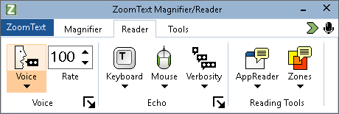
The Reader toolbar tab
Note: The Reader toolbar tab only appears in ZoomText Magnifier/Reader.
- Voice. Enables and disables speech output for screen reading, and allows you to open the Voice Settings dialog box where you can select and customize different voices.
- Rate. Controls how fast ZoomText speaks.
- Keyboard. Toggles the keyboard echo on and off, and selects keyboard echo settings. Keyboard echo provides immediate feedback of the keys and words that you type.
- Mouse. Toggles the mouse echo on and off, and selects mouse echo settings. Mouse echo automatically reads text beneath the pointer.
- Verbosity. Selects a verbosity level. Verbosity allows you to adjust the amount of information spoken when a program item receives focus.
- AppReader. Launches AppReader to read text from the last active application. AppReader provides continuous reading of documents, web pages and email, within the parent application.
- Zones. Allows you to create, edit and navigate reading zones. Reading zones let you instantly see and hear selected locations in an application window.

The ZoomText Voice
ZoomText allows you to select and customize the voice to fit your personal preference. You can choose a male or female voice, adjust how fast and loud the voice speaks, and customize the reading style and audible cues. You can also enable and disable the voice as needed.
- Enabling and Disabling the Voice
- Adjusting the Voice Rate
- Choosing a Voice
- Adding and Removing Voices
- Configuring Text Processing
- Configuring Hints
- Configuring Audio

Enabling and Disabling the Voice
You can turn the voice on and off at any time without disabling the magnification features.
- To enable and disable the voice
Do one of the following:
- On the Reader toolbar tab, select Voice > Enable (or Voice > Disable).
- Press the Voice On/Off hotkey: Caps Lock + Alt + Enter
Note: AppReader will still speak when the voice is disabled.
There may be times when you want to terminate the voice output while it is occurring. For example, when ZoomText is reading a message box that you are already familiar with. You can force ZoomText to stop speaking this text without turning the voice off altogether.
- To terminate speech output as it occurs
Press and release the Ctrl key.
The information that is currently being spoken is terminated.

Adjusting the Voice Rate
The Voice Rate allows you to control how fast ZoomText speaks.
- To adjust the speech rate
Do one of the following:
- On the Reader toolbar tab, adjust the level in the Rate spin box.
- Press the Voice Faster and Voice Slower hotkeys
- Voice Faster: Caps Lock + Alt + Up
- Voice Slower: Caps Lock + Alt + Down
Note: The voice rate can also be adjusted in the Voice Settings dialog box. For more information, see Voice Settings.
A separate voice rate is available for AppReader. This setting is located in the AppReader dialog box (Shared Settings tab). For more information, see AppReader Shared Settings.

Voice Settings
Voice settings let you select and customize the ZoomText voice. You can select from a variety of male and female voices, and adjust their speaking rate, pitch and volume.
- To adjust the voice settings
- On the Reader toolbar tab, click the arrow next to Voice or navigate to Voice and press the down arrow key.
- In the Voice menu, choose Settings.
The Voice Settings dialog appears.
- Choose the Voice tab.
- Make sure the Enable voice output box is checked.
- Choose the desired Language, Synthesizer and Voice, and then adjust the Rate, Pitch and Volume.
- To preview the synthesizer settings, type some text in the Sample Text edit box, and then click Speak Sample.
- Click OK.
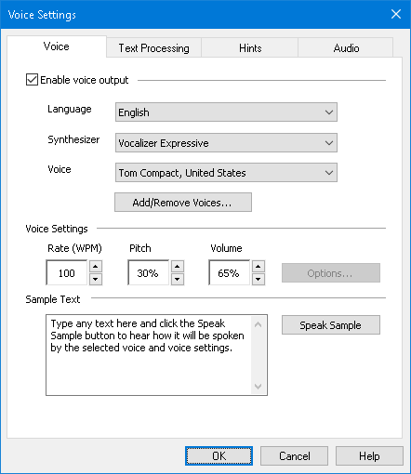
The Voice tab
Setting | Description
Enable voice output | Enables or disables speech output for screen reading.
Language | Displays a list of speech synthesizer languages that are available on your system.
Synthesizer | Displays a list of speech synthesizers available on your system.  Note: ZoomText supports SAPI 4 and SAPI 5 based speech synthesizers.
Voice | Displays a list of voices available in the selected synthesizer.
Add/Remove Voices | Opens the Add/Remove Voices utility. It lets you sample, install, and remove Vocalizer Expressive 2 voices.
Voice Settings
Rate | Controls how fast ZoomText speaks.  A separate reading rate is available for AppReader. * For more information, see Reading Options.
Pitch | Selects the pitch of the current voice. Pitches range from 5% to 100%, in steps of 5%.
Volume | Selects the volume of the current voice. Volumes range from 5% to 100%, in steps of 5%.
Options | Displays optional settings for the selected speech synthesizer, including the synthesizer's pronunciation manager. If the speech device is not pronouncing a word properly, you can adjust the pronunciation by supplying the phonetic spelling.
Sample Text
Sample Text / Speak Sample | Allows you to test particular speech settings. Text can be typed into the Sample Text box and spoken by clicking the Speak Sample button. The current speech settings are used to speak the sample text, including settings in the Text Processing and Hints tabs.
* If AppReader is set to use its own voice rate, this rate setting will be grayed out (disabled) when opening the Voice Settings dialog from the AppReader's Text View toolbar.

Text Processing
Text processing modifies how numbers, punctuations and mixed case words are spoken, so that they are pronounced in the proper context or desired format. With these settings you can create a reading style that clarifies complex words and numbers.
- To adjust the text processing settings
- On the Reader toolbar tab, click the arrow next to Voice or navigate to Voice and press the down arrow key.
- In the Voice menu, choose Settings.
The Voice Settings dialog appears.
- Choose the Text Processing tab.
- Adjust the settings as desired.
- Click OK.
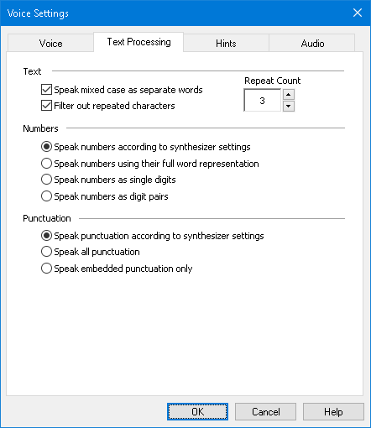
The Text Processing tab
Setting | Description
Text
Speak mixed case as separate words | Breaks mixed case words into separate words for more accurate pronunciation by the speech synthesizer. For example, the word 'ZoomText' is broken apart and spoken as "Zoom Text".
Filter out repeated characters | Limits the number of times that repeated characters are spoken. This is useful when encountering a string of repeated characters used in formatting.
Repeat Count | Sets the maximum number of times a repeated character is spoken. The repeat count range is from 2 to 10.
Numbers
Speak numbers according to synthesizer settings | Numbers are spoken according to the synthesizer's built-in settings.
Speak numbers using their full word representation | Numbers are spoken using their full-word representation. For example, the number '1995' is spoken "one thousand nine hundred and ninety five".
Speak numbers as single digits | Numbers are spoken as individual digits. For example, the number '1995' is spoken "one nine nine five".
Speak numbers as digit pairs | Numbers are spoken as digit pairs. For example, the number '1995' is spoken "nineteen ninety five".
Punctuation
Speak punctuation according to synthesizer settings | Punctuation characters are spoken according to the synthesizer's built in settings.
Speak all punctuation | All punctuation characters are spoken.
Speak embedded punctuation only | Only punctuation characters embedded within words are spoken. For example, sales@freedomscientific.com is spoken "sales at Freedom Scientific dot com".

Hints
Hints provide audible cues when you encounter capital letters, hypertext links, or the start or end of a document. Hints can be heard as a momentary pitch change while the item is read or a verbal announcement such as "Cap" or "Link" prior to the item being read.
- To adjust the hints settings
- On the Reader toolbar tab, click the arrow next to Voice or navigate to Voice and press the down arrow key.
- In the Voice menu, choose Settings.
The Voice Settings dialog appears.
- Choose the Hints tab.
- Adjust the settings as desired.
- Click OK.
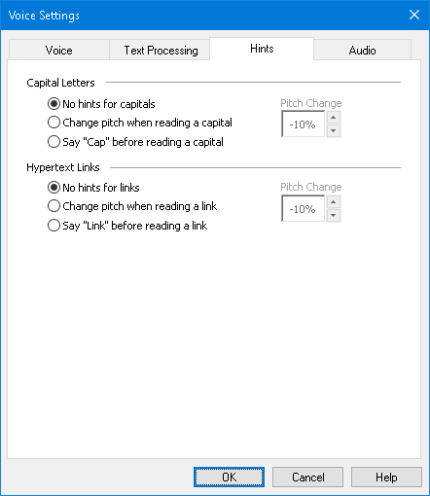
The Hints tab
Setting | Description
Capital Letters
No hints for capitals | No hint is applied when a capital letter is read.
Change pitch when reading a capital | The synthesizer pitch is changed when a capital letter is read.
Say "Cap" before reading a capital | The word "cap" is spoken before a capital letter is read.
Pitch Change  (Capital Letters) | A percentage change to the voice pitch occurs when a capital letter is read. Pitch change ranges from -50% to +50% in steps of 10%.
Hypertext Links
No hints for links | No hint is applied when a hypertext link is read.
Change pitch when reading a link | The synthesizer pitch is changed when a hypertext link is read.
Say "Link" before a link is read | The word "link" is spoken when a hypertext link is read.
Pitch Change  (Hypertext Links) | A percentage change to the voice pitch occurs when a hypertext link is read. Pitch change ranges from -50% to +50% in steps of 10%.

Audio
To conserve battery life, Bluetooth headphones typically enter Power-saving mode when no audio is received. As a result, when speech is detected and the headphones wake up, the first few characters of speech may be clipped and not heard.
To prevent this from happening, you can enable the Avoid Speech Cutoff setting. This will keep your headphones awake by constantly playing silence. You will not hear anything, but your headphones will remain active, resulting in consistent speech.
Note: Your headphones’ battery may drain faster if you choose to use this feature.
- To enable and disable Audio Speech Cutoff
- On the Reader toolbar tab, click the arrow next to Voice or navigate to Voice and press the down arrow key.
- In the Voice menu, choose Settings.
The Voice Settings dialog appears.
- Choose the Audio tab.
- Select or clear the Enable Avoid Speech Cutoff check box.
- Click OK.
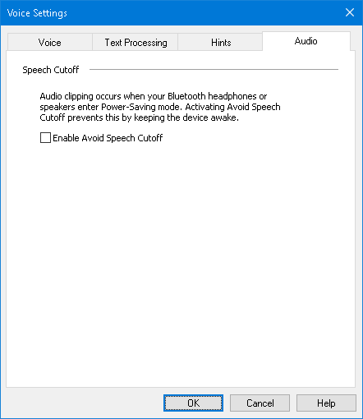
The Audio tab

Echo
Echo settings control how ZoomText speaks as you use type on the keyboard, use the mouse, and navigate your applications. These settings allow you to increase or decrease the amount of detail spoken to fit your personal needs.
- Keyboard Echo
- Mouse Echo
- Program Echo
- Verbosity

Keyboard Echo
Keyboard echo allows you to hear the keys and words that you type. You can choose to have individual keys, words, or both keys and words spoken. Typed words are spoken upon completion when you type a space or punctuation character. You can also choose which groups of printed and non-printed keys are spoken.
- To cycle the keyboard echo mode
Do one of the following:
- On the Reader toolbar tab, select the Keyboard button.
- Press the Echo Keyboard Mode hotkey: Caps Lock + Alt + K
- To adjust the keyboard echo settings
- On the Reader toolbar tab, click the arrow next to Keyboard or navigate to Keyboard and press the down arrow key.
- In the Keyboard menu, choose Settings.
The Echo Settings dialog box appears with the Keyboard tab displayed.
- Adjust the keyboard echo settings as desired.
- Click OK.
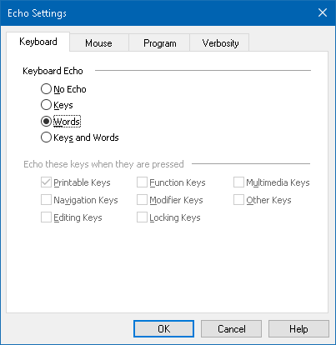
The Keyboard tab
Setting | Description
Keyboard Echo
No Echo | Disables all keyboard echo.
Keys | Activates keyboard echo by keystroke. You can select which keys are echoed using the settings under Echo these keys when they are pressed.
Words | Activates keyboard echo by word. Echoing occurs only when a completed word appears on the screen.
Keys and Words | Activates keyboard echo by keystroke and by word.
Echo these keys when they are pressed
Printable Keys | Echoes all printable characters: letters, numbers and symbols.
Navigation Keys | Echoes navigation keys: arrows, Home, End, Page Up and Page Down.
Editing Keys | Echoes text-editing keys: Backspace, Insert, Delete, Escape and Enter.
Function Keys | Echoes the function keys: F1 through F12.
Modifier Keys | Echoes the modifier keys: Alt, Ctrl, Shift and the Windows key.
Locking Keys | Echoes the locking keys and their state: Caps Lock, Num Lock, and Scroll Lock.
Other Keys | Echoes miscellaneous keys: Pause, Print Screen and the Application Key.
Note: Selections under Echo these keys... are only available when typing echo is set to Keys or Keys and Words.

Mouse Echo
Mouse echo automatically reads text beneath the pointer. As you move the pointer across the screen, single words or complete lines of text are echoed instantly or after hovering briefly.
- To cycle the mouse echo mode
Do one of the following:
- On the Reader toolbar tab, select the Mouse button.
- Press the Echo Mouse Mode hotkey: Caps Lock + Alt + M
- To adjust the mouse echo settings
- On the Reader toolbar tab, click the arrow next to Mouse or navigate to Mouse and press the down arrow key.
- In the Mouse menu, choose Settings.
The Echo Settings dialog box appears with the Mouse tab displayed.
- Adjust the mouse echo settings as desired.
- Click OK.
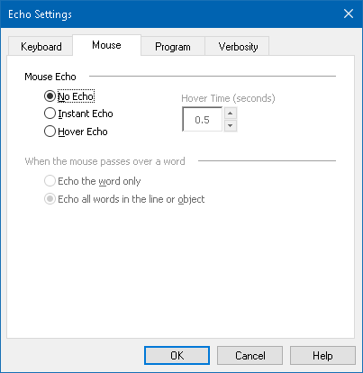
The Mouse tab
Setting | Description
Mouse Echo
No Echo | Disables all mouse echo.
Instant Echo | Enables instant mouse echo. Words are spoken immediately when the mouse pointer is moved over them.
Hover Echo | Enables delayed mouse echo. Words are spoken after the mouse pointer hovers over them for the selected hover time.
Hover Time (seconds) | The amount of time in seconds that the mouse pointer must hover over an object before it is spoken. This setting applies to Hover Echo only.
When the mouse passes over a word
Echo the word only | Only the word beneath the mouse pointer is echoed.
Echo all words in the line or object | When the mouse pointer moves into a new line of text or over a new object, all words in the line or object are spoken. Objects include: title bars, menu items, dialog controls, desktop icons and task bar buttons.
Note: When using mouse echo, holding down the Shift key toggles the echo mode from Echo the word only to Echo all words in the line or object (or vice-versa).

Program Echo
Program echo determines what items are spoken as you navigate and use your applications. These items include: window titles, menus, dialogs, list views, tree views, and text that the cursor moves through. The amount of detail that is spoken for these items can be adjusted using the Verbosity Settings.
- To adjust the program echo settings
- On the Reader toolbar tab, select the Echo Settings button, which appears as a diagonal arrow icon in the lower-right corner of the Echo group.
The Echo Settings dialog box appears with the Program tab displayed.
- Adjust the program echo settings as desired.
- Click OK.
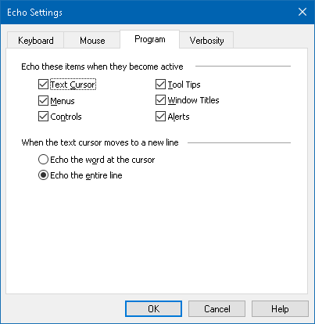
The Program tab
Setting | Description
Echo these items when they become active
Text Cursor | When the text cursor moves, text at the new cursor location is spoken. The amount of text that is spoken is in accordance with how far the cursor has moved; by character, word, line, sentence or paragraph.
Menus | When you pull down a menu, its title is spoken followed by each menu item that becomes highlighted.
Controls | As you navigate through dialog boxes, tree views and list views, each item is spoken as it becomes highlighted or selected.
Tool Tips | When a tool tip appears, it is spoken.
Window Titles | When a window becomes active, the contents of its title bar are spoken.
Alerts | When an alert popup appears, it is spoken.
When the text cursor moves to a new line
Echo the word at the cursor | When the text cursor moves to a new line, the word at the new cursor location is spoken.
Echo the entire line | When the text cursor moves to a new line, the entire line is spoken.

Verbosity
Verbosity allows you to adjust the amount of information spoken about program controls when they become active or highlighted. Program controls include: application and document windows, menus, dialogs, buttons, icons, and more.
Three verbosity levels – Low, Medium and High – allow you to quickly increase or decrease the verbosity. High verbosity provides more information, while Low verbosity provides less information. Each of these verbosity levels can be fully customized according to your personal needs.
- To cycle the verbosity level
Do one of the following:
- On the Reader toolbar tab, select the Verbosity button.
- Press the Echo Verbosity Level hotkey: Caps Lock + Alt + B
- To adjust the verbosity settings
- On the Reader toolbar tab, click the arrow next to Verbosity or navigate to Verbosity and press the down arrow key.
- In the Verbosity menu, choose Settings.
The Echo Settings dialog box appears with the Verbosity tab displayed.
- Adjust the verbosity settings as desired.
- Click OK.
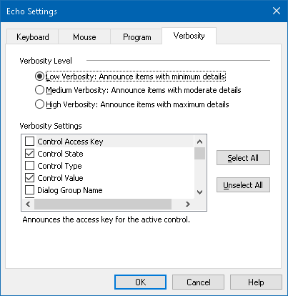
The Verbosity tab
Setting | Description
Verbosity Level
Low Verbosity | Announces program echo items with minimum details.
Medium Verbosity | Announces program echo items with moderate details.
High Verbosity | Announces program echo items with maximum details.
Verbosity Settings | A list of checkboxes that define the verbosity levels. The displayed settings reflect the current verbosity level and automatically update when a different verbosity level is selected.
Select All | Checks all items in the Verbosity Settings list box.
Unselect All | Unchecks all items in the Verbosity Settings list box.

AppReader
AppReader is a productivity tool that automatically reads documents, web pages and email while you visually follow along or relax your eyes and listen. AppReader can automatically read the text from beginning to end, skim forwards and backwards through the text, or read specific areas of text that you select by clicking and dragging with the mouse. Whichever way you read, AppReader makes it easy.
- AppReader Reading Modes
- The Text View Environment
- Starting and Using AppReader
- App View Settings
- Text View Settings
- Shared Settings

AppReader Reading Modes
Before you begin using AppReader you should understand the different reading modes and their availability in different applications. Understanding these features will help you utilize AppReader in the most useful and productive way.
AppReader provides three unique reading modes: App View, Text View and the SpeakIt Tool.
- App View reads right in the source application. Your view of the application and document is not changed, so entering and exiting AppReader is seamless and smooth. App View is ideal for users that want a reading experience that is seamless to the application, or do not require the text enhancement features provided by Text View.
- Text View reads in a special environment where text is reformatted for easier reading. Text is presented in a single line of text that scrolls horizontally, called Ticker View, or multiple wrapped lines of text, called Prompter View. In both views you can select your choice of fonts, high-contrast colors, word highlighting, and magnification level. Text View is ideal for users who want to visually read and desire an enhanced visual reading environment. To learn about the Text View environment, see The Text View Environment.
- SpeakIt Tool reads selected areas of the screen by clicking and dragging with the mouse. Any text that is visible on the screen can be spoken, even if it is outside the active program. SpeakIt tool is ideal for spot reading random blocks of text with simple mouse actions.
You can use AppReader in almost any application, however, the reading modes that are available depend on the level of support that AppReader has for the application: Full Support or Basic Support.
- Full Support allows you to use all three reading modes: App View, Text View and the SpeakIt Tool. Full Support is available in most applications that display long passages of text, as you would find in Microsoft Word, Microsoft Outlook, Adobe Reader and Internet Explorer.
- Basic Support allows you to use the SpeakIt Tool only. If you attempt to start AppReader in App View or Text View and there is only Basic Support for the application, AppReader will automatically start up in the SpeakIt Tool.
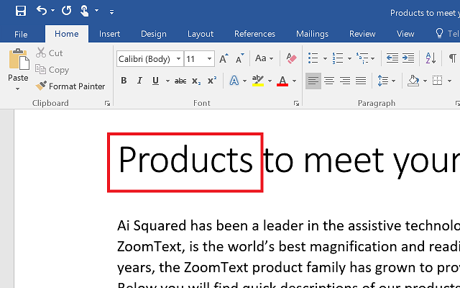
AppReader highlighting the spoken word in Microsoft Word.

The Text View Environment
AppReader's Text View is a special reading environment where text is reformatted for easier reading. Text is presented in a single line of text that scrolls horizontally, called Ticker View, or multiple wrapped lines of text, called Prompter View. In both views you can select your choice of fonts, high-contrast colors, word highlighting, and magnification level.
Text View occupies the entire display with a toolbar at the top of the screen and the document text below it. The document text is formatted and displayed according to the current Text View settings.
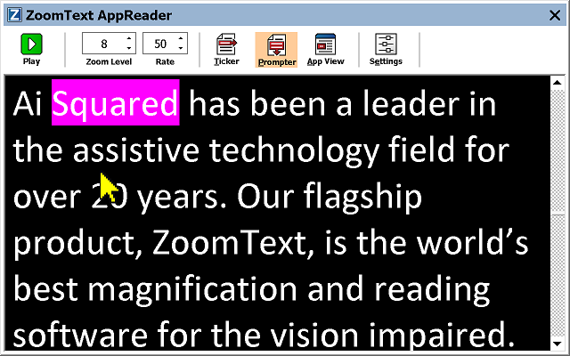
AppReader Text View in Prompter Mode
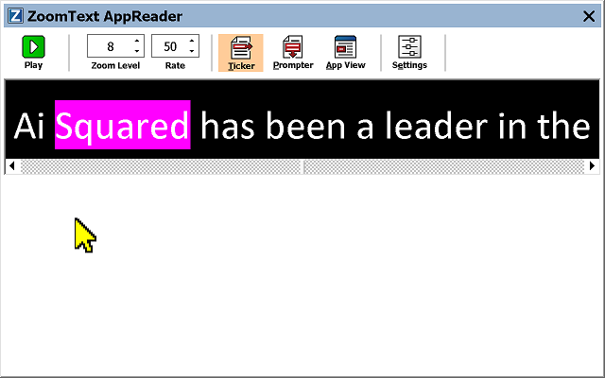
AppReader Text View in Ticker Mode
The Text View toolbar provides the essential controls for operating Text View, and provides access to dialogs for configuring the Text View display.
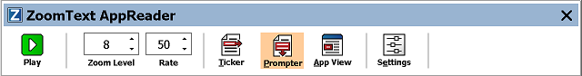
The Text View toolbar
- Play/Pause. Starts and stops reading at the highlighted word. When Play mode is executed, the Pause button appears on the toolbar.
- Zoom Level. Sets the magnification level used by Text View, from 1x to 36x.
- Rate. Controls how fast ZoomText speaks.
- Ticker. Displays a single line of text. When reading, text scrolls horizontally like a ticker tape.
- Prompter. Displays multiple wrapped lines of text that do not exceed the width of the Text View screen. When reading, text scrolls vertically like a teleprompter.
- App View. Switches AppReader from Text View to App View.
- Settings. Opens the AppReader dialog box to change the Text View settings.

Starting and Using AppReader
There are a variety of ways to launch AppReader into the various AppReader modes, including menu selections or hotkeys. These methods are described below, including the unique behaviors of each mode.
- To launch AppReader using the Read from Pointer command
- Position the mouse pointer over the word where you want to start reading, then press the Read from Pointer command: Caps Lock + Alt + Left-Click
AppReader launches in the selected mode and begins reading at the clicked on word. To stop reading, click or press Enter. To start reading, double-click (on any word) or press Enter. For complete instructions on reading with AppReader, see "Reading with AppReader" below.
- To launch AppReader directly into App View or Text View
- Choose Use App View or Use Text View menu item in the AppReader button menu, or press one of the following hotkeys:
- Launch App View: Caps Lock + Alt + A
- Launch Text View: Caps Lock + Alt + T
AppReader launches in the selected mode and begins reading from the current text cursor position. If a text cursor does not exist, AppReader starts reading at the first visible word that is inside of the magnified view that is inside of the target window. Otherwise, AppReader starts reading at the first visible word in the target application. For complete instructions on reading with AppReader, see "Reading with AppReader" below.
- To launch the SpeakIt Tool
- Choose Use SpeakIt Tool in the AppReader button menu, or press the Launch SpeakIt Tool hotkey: Caps Lock + Alt + S
The SpeakIt Tool becomes active.
- To launch AppReader in the selected mode, (the mode selected in the AppReader menu)
- On the Reader toolbar tab, select the AppReader button, or press the Launch AppReader hotkey: Caps Lock + Alt + R
AppReader will launch in the selected AppReader mode.
Reading with AppReader
- To start and stop automatic reading
Press Enter or double-click on the word where you want to start or resume reading.
- To skim read by word, line, sentence and paragraph
Use the AppReader navigation commands (listed below).
- To switch between App View and Text View
Press Tab.
- To exit AppReader
Right-click or press Esc.
When AppReader exits, the cursor is automatically positioned at the last word that was highlighted in AppReader, if a cursor exists in the application.
AppReader Navigation Commands
The following hotkeys can be used to launch the AppReader.
Command | Hotkeys
Launch AppReader from Pointer | Caps Lock + Alt + Left-Click
Launch App View | Caps Lock + Alt + A
Launch Text View | Caps Lock + Alt + T
Launch SpeakIt Tool | Caps Lock + Alt + S
Launch AppReader (selected mode) | Caps Lock + Alt + R
While the AppReader is active, the following modal keys can be used to operate the AppReader.
Command | Modal Keys
Next Word | Ctrl + Right
Previous Word | Ctrl + Left
Next Sentence | Right
Previous Sentence | Left
Next Paragraph | Down
Previous Paragraph | Up
Next Page | Page Down
Previous Page | Page Up
Current Word * | Ctrl + Alt + Shift + Up
Current Line | Ctrl + Alt + Shift + Right
Current Sentence | Ctrl + Alt + Shift + Down
Current Paragraph | Ctrl + Alt + Shift + Left
First Word On Line | Home
Last Word On Line | End
Beginning of Document | Ctrl + Home
End of Document | Ctrl + End
Next Link | L
Previous Link | Shift + L
Execute Link | Ctrl + Enter
* When using the Current Word command, repeated presses within two seconds provides the following behavior:
- First press: speaks the word
- Second press: spells the word
- Third press: spells the word phonetically ("Alpha, Bravo, Charlie, ...")

App View Settings
The App View settings allow you to customize the appearance of word highlighting in AppReader, including the highlight shape, color, and transparency level.
- To adjust the App View settings
- On the Reader toolbar tab, choose AppReader > App View Settings.
The AppReader Settings dialog appears with the App View tab displayed.
- Adjust the App View settings as desired.
- Click OK.
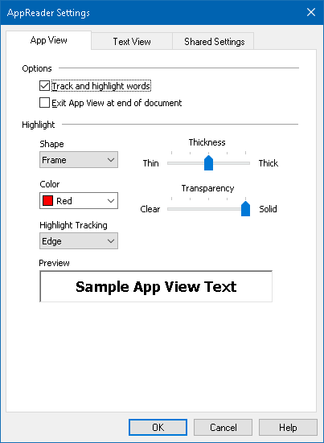
The App View tab
Setting | Description
Options
Track and highlight words | Enables tracking and highlighting of words when AppReader is reading.
Exit App View at end of document | When enabled, AppReader will automatically exit after reading to the end of the document.  Note: AppReader will not automatically exit when manually navigating to the end of a document.
Highlight
Shape | Sets the shape used to highlight words: Block, Underline, Frame, or Wedge.
Color | Sets the highlight color.
Thickness | Sets the thickness of the highlight shape.
Transparency | Sets the transparency of the highlight.  Note: This setting is not available when the highlight color is set to 'Invert.'.
Highlight Tracking | Sets the tracking type: Edge, Center or Jump Ahead. With Edge alignment, the zoom window only scrolls as needed to keep the highlighted word in view. With Center alignment, the zoom window scrolls as needed to keep the highlighted word in the center of the zoom window. With Jump Ahead, when the highlighted word exits the magnified view, the zoom window scrolls to bring the highlighted word to the upper left corner.
Preview | Displays sample text with a preview of the selected highlight settings.
Note: Additional settings for App View are available in the Shared Options tab.

Text View Settings
The Text View settings allow you to customize the appearance of text and word highlighting in the Text View environment.
- To adjust the Text View settings
- On the Reader toolbar tab, choose AppReader > Text View Settings.
The AppReader Settings dialog appears with the Text View tab displayed.
- Adjust the Text View settings as desired.
- Click OK.
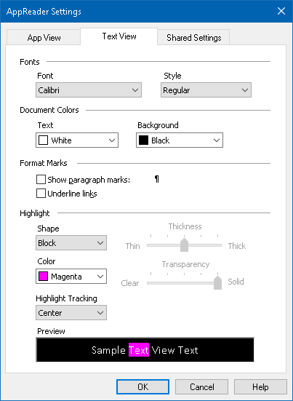
The Text View tab
Setting | Description
Fonts
Font | Sets the font type that the captured document will be displayed in, such as Arial, Tahoma, or Verdana.
Style | Sets the font style that the captured document will be displayed in, such as Regular, Bold or Italic.
Document Colors
Text | Selects the text color that the captured document will be displayed in. The text and background cannot be set to the same color.
Background | Selects the background color for the Text View. The text and background cannot be set to the same color.
Format Marks
Show paragraph marks | Displays paragraph marks where paragraphs end in the source document.
Underline links | When selected, hypertext links are underlined in the Prompter and Ticker view.
Highlight
Shape | Selects the shape used for word highlighting: Block, Underline, Frame, or Wedge.
Color | Sets the color of the word highlight.
Thickness 1, 2 | Sets the thickness of the word highlight.
Transparency 2 | Sets the transparency of the word highlight.
Highlight Tracking | Sets the tracking type: Edge, Center or Jump Ahead. With Edge alignment, The Text View scrolls as needed to keep the highlighted word in view. With Center alignment, Text View scrolls as needed to keep the highlighted word in the center of the zoom window. With Jump Ahead, when the highlighted word exits the view, Text View scrolls to bring the highlighted word to the upper left corner.
Preview | Displays sample text using the selected font, color and highlight settings.
1 This setting is not available when highlight shape is set to 'Block'.
2 This setting is not available when highlight shape is set to 'Block' or highlight color is set to 'Invert'.
Note: Additional settings for Text View are available in the Shared Options tab.

Shared Settings
Shared Settings provide additional settings that are shared by App View and Text View. You can set a special reading rate for AppReader and enable special audible cues.
- To adjust the Shared Settings
- On the Reader toolbar tab, choose AppReader > Shared Settings.
The AppReader Settings dialog appears with the Shared Settings tab displayed.
- Adjust the shared settings as desired.
- Click OK.
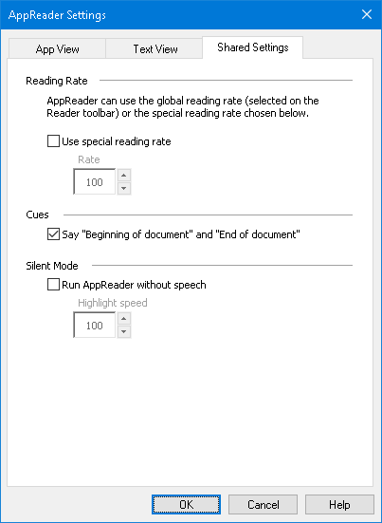
The Shared Settings tab
Setting | Description
Reading Rate
Use special reading rate | When selected, AppReader's reading rate is set independent of the global Rate setting on the Reader toolbar tab and in the Voice Settings dialog box.
Rate | Controls the reading rate for AppReader.  Note: This setting is disabled when Use special reading rate is not enabled.
Cues
Say "Beginning of document" and "End of document" | The words "beginning of document" and "end of document" are spoken when App View and Text View have navigated to the beginning or end of a document.
Silent Mode
Run AppReader without Speech | When selected, App View and Text View speech is muted. This is also known as AppReader Silent Mode.  Note: SpeakIt Tool cannot be muted.
Rate | Controls how fast the highlight moves while reading text in App View and Text View.

Reading Zones
Reading zones let you instantly see and hear selected locations in an application window. For example; your database application may display a dozen or more fields of information. In your normal work flow you may be interested in only a few of these fields. With reading zones, you can instantly see and/or hear these select fields with the press of a hotkey.
You can create up to 10 reading zones for each of your applications. As you open and switch applications, zones defined for the active application are automatically loaded and ready to use.
- Creating, Editing and Deleting
- Using Reading Zones
- The Reading Zones Toolbar
- Reading Zones Settings

Creating, Editing and Deleting Reading Zones
Creating a new reading zone is a straightforward process. For most new zones, you simply define the zone area, type in a descriptive zone name, and choose to have the zone displayed, spoken or both. You can always edit or delete the zone later, so there's no need to worry about mistakes.
- To create a new reading zone
- Open the application in which you want to create a reading zone. Make sure the desired application tab, view or window is displayed.
- Activate the Create Zone Tool by doing one of the following:
- Switch to the ZoomText user interface. On the Reader toolbar tab, select Zones > New.
- Press the Create Zone hotkey: Caps Lock + Alt + C.
The Create Zone Tool becomes active and all existing zones for the active application are displayed.
- Move the mouse pointer to scroll the new zone area into view.
- Hold down the left button, drag the selection rectangle over the desired zone area and release the button.
When you complete the drag by releasing the mouse button, the Reading Zones dialog appears. This dialog allows you to name the zone and select zone options. For information on the Reading Zones dialog, see Reading Zones Settings.
- In the Zone Name box, type a descriptive name for the new zone.
When you navigate to the next dialog control, the new zone name will appear in the Zones list.
- Under Zone is relative to, select the zone's relative position within the application window.
- Under Zone Actions, select the desired options.
- To test the new zone, click Trigger.
The Reading Zones dialog is temporarily hidden while the zone is displayed and/or spoken according to the selected settings.
- To create additional zones, click New Zone and repeat steps 4 through 9.
- When you're finished creating and editing zones, click OK.
- To edit a reading zone
- Open the application that contains the reading zone that you want to edit.
- Activate the Edit Zones Tool by doing one of the following:
- Switch to the ZoomText user interface. On the Reader toolbar tab, select Zones > Edit.
- Press the Edit Zones hotkey: Caps Lock + Alt + E.
The Edit Zones Tool becomes active and all existing zones for the active application are displayed. The Reading Zones toolbar appears over the active zone.
- Move the mouse pointer to scroll the desired zone into view, or click the Next or Previous buttons on the Reading Zones toolbar to bring the desired zone into view.
Note: The Next and Previous buttons are grayed if only one zone has been defined.
- Click inside the zone to activate the sizing handles and toolbar, then adjust the zone as follows:
- To size the zone, drag any handle.
- To move the zone, drag inside the zone frame.
- To test reading of the zone, click the Play button.
- To move to another zone, press the number of the desired zone, or click the Next or Previous buttons.
- To edit another zone, repeat steps 3 and 4.
- To exit the Edit Zones tool, right-click or press Esc.
- To delete a reading zone
- On the Reader toolbar tab, select Zones > Settings.
The Reading Zones dialog appears.
- In the Show zones defined for combo box, select the application that contains the zone you wish to delete.
The Zones list updates to display zones associated with the selected application.
- In the Zones list box, select the zone you wish to delete.
- Click Delete.
The deleted zone is removed from the Zones list.
- To delete another zone, repeat steps 2 through 4.
- When you're finished deleting zones, click OK.

Using Reading Zones
Once you've created reading zones for an application, you can use them any time the application is active. You can trigger a single zone at a time (via menu or hotkey), or enter a mode that allows you to navigate through all of the reading zones.
- To trigger a specific reading zone
- Open the application that contains the reading zones you want to trigger.
- To trigger the desired zone, do one of the following:
- Switch to the ZoomText user interface. On the Reader toolbar tab, select Zones > Trigger > {zone number}.
- Press the Trigger Zone hotkey: Caps Lock + Alt + {Zone number}.
- Press the List Zones hotkey: Caps Lock + Alt + L, then select the desired zone from the menu.
- Use the Next and Previous Reading Zone hotkeys:
Next Zone: Caps Lock + Alt + N
Previous Zone: Caps Lock + Alt + P
The selected reading zone is displayed and/or spoken according to the zone settings.
Each applications set of reading zones are numbered 1 through 10. Reading zone hotkeys correspond to these numbers. For example, the hotkey for reading zone 1 is Caps Lock + Alt + 1, reading zone 2 is Caps Lock + Alt + 2, and so on.
Note: The hotkey for reading zone 10 is Caps Lock + Alt + 0.
- To navigate through all reading zones
- Open the application that contains the reading zones you want to navigate.
- To active the Navigate Zones mode, do one of the following:
- On the Reader toolbar tab, select Zones Navigate.
- Press the Navigate Zones hotkey: Caps Lock + Alt + G
Navigate Mode becomes active and the Reading Zones toolbar appears over the first active zone. The zone name and number are spoken.
- To start and stop reading of the zone, click the Play/Pause button.
Note: The Play/Pause button is disabled (grayed-out) when navigating to non-spoken zones.
- To navigate to another zone, click the Next and Previous buttons.
- To exit Navigate Mode, right-click or press Esc.

The Reading Zones Toolbar
The Reading Zones toolbar appears over the active reading zone whenever you access reading zones. The toolbar provides controls for navigating and reading the defined zones.
Reading Zones toolbar:  Edit and Navigate modes | Reading Zones toolbar:  Trigger mode

Play/Pause/Stop. Starts and stops reading. When Play mode is executed, the Pause or Stop button appears on the toolbar, according to the mode that is active. The Pause button appears in Trigger and Navigate modes where you can pause and restart reading at the highlighted word. The Stop button appears in Edit mode where reading always restarts at the first word in the zone.
Shortcut Key: Enter
Previous. Activates the previous reading zone.
Shortcut Key: Shift + Tab
Note: This button does not appear in 'Trigger' mode.
Next Activates the next reading zone.
Shortcut Key: Tab
Note: This button does not appear in 'Trigger' mode.
Close Exits the Reading Zone mode.
Shortcut Key: Esc

Reading Zones Settings
The Reading Zones settings allow you to create, examine and edit reading zones. When activated, the Reading Zones dialog displays a list of zones that have been defined in the current application. By selecting a zone in the Zones list, you can modify its settings, trigger the zone, or delete the zone. You can also create new zones or navigate through all zones in the current application.
For complete information on creating, editing, navigating and triggering zones, see Creating and Editing Reading Zones and Using Reading Zones.
- To adjust the reading zone settings
- In the Reader toolbar tab, choose Zones > Settings.
The Reading dialog appears with the Zones tab displayed.
- Adjust the reading zone settings as desired.
- Click OK.
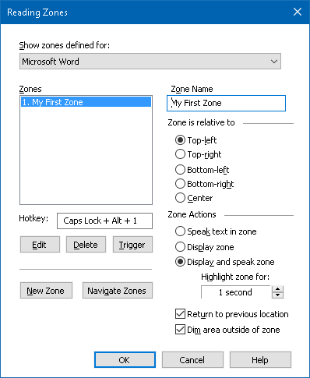
The Reading Zones dialog box.
Setting | Description
Show zones defined for | Displays a list of applications that are currently running. Zones associated with the selected application appear in the Zones list box.
Zones | Displays a list of zones associated with the selected application, selected in the Show zones defined for: list box).
Hotkey | Displays the hotkey for the selected zone.
Edit | Activates the Edit Zone tool. When activated, the Reading Zones dialog is hidden and zones associated with the selected application appear. The Edit Zone tool also appears allowing you to size and move any of the zones.
Delete | Deletes the selected zone.
Trigger | Triggers the selected zone. When triggered, the Reading Zones dialog is hidden and the selected zone is displayed and spoken according to its zone settings. Afterward, the Reading Zone dialog reappears.
New Zone | Activates the New Zone tool. When selected, the Reading Zones dialog is hidden and zones associated with the selected application appear. The New Zone tool also appears allowing you to create a new zone.
Navigate Zones | Activates the Zone Navigation mode. When activated, the Reading Zones dialog is hidden and the selected zone and Navigation toolbar appear. Using the toolbar controls or keyboard commands, you can start and stop reading of the zone, and navigate to the next or previous zone.
Zone Name | Allows you to type a meaningful name for the selected zone. Zone names appear in the Zones list box in the Readings Zones dialog. They also appear in the Reading Zones menu (when pressing the Reading Zones List hotkey: Caps Lock + Alt + L) and when clicking Zones > Trigger on the Reader toolbar tab.
Zone is relative to
top-left, top-right, bottom-left, bottom-right, or center | Sets the relative position of the zone within the application window. This keeps the zone in the correct location even when the application window has been resized or moved.  Note: In some cases, when resizing an application window, controls within the window may also be resized. When this occurs, you may need to resize the individual zones.
Zone Actions
Speak text in zone | When the reading zone is triggered, all text within the zone is spoken.
Display zone | When the reading zone is triggered, the zone is scrolled into view and highlighted.
Display and speak zone | When the reading zone is triggered, the zone is scrolled into view, highlighted and spoken.
Highlight zone for | Sets the amount of time (in seconds) that the reading zone is highlighted.  Note: Highlighting only occurs when Scroll to zone is selected.
Return to previous location | After the zone is displayed, ZoomText scrolls back to the location that was in view prior to triggering the zone.
Dim area outside of zone | When a reading zone is triggered, the area outside of the reading zone is dimmed.

Reading with the Text Cursor
Text cursor reading commands let you navigate and read while creating and editing documents, by word, line, sentence or paragraph. When using these commands, the text cursor moves in accordance with the command. For example, when pressing the Say Next Sentence command, the cursor moves to the beginning of the next sentence and the entire sentence is spoken. The following table lists the text cursor reading commands.
Command | Hotkey | Layered Keys
Say Previous Character | Left | N/A
Say Next Character | Right | N/A
Say Previous Word | Ctrl + Left | N/A
Say Next Word | Ctrl + Right | N/A
Say Previous Line 3 | Up | N/A
Say Next Line 3 | Down | N/A
Say Previous Sentence | Caps Lock + Alt + Left | N/A
Say Next Sentence | Caps Lock + Alt + Right | N/A
Say Previous Paragraph | Ctrl + Up | N/A
Say Next Paragraph | Ctrl + Down | N/A
Say Current Character 1 | Ctrl + Alt + Shift + Enter | N/A
Say Current Word 2 | Ctrl + Alt + Shift + Up | N/A
Say Current Line | Ctrl + Alt + Shift + Right | N/A
Say Current Sentence | Ctrl + Alt + Shift + Down | N/A
Say Current Paragraph | Ctrl + Alt + Shift + Left | N/A
1 Second press of the Say Current Character command speaks the character phonetically: "Alpha, Bravo, Charlie, ...".
2 Repeated presses of the Say Current Word command provide the following behavior:
- First press: speaks the word
- Second press: spells the word
- Third press: spells the word phonetically: "Alpha, Bravo, Charlie, ..."
Note: Repeated presses must occur within two seconds.
3 This command reads the current word or entire line according to the Program Echo setting When the text cursor moves into a new line.

In addition to the Text Reading commands listed above, ZoomText will also speak when using standard text navigation and editing keys, listed in the following table.
Keys | Application Action | ZoomText Action
Backspace | Deletes the character to the left of the cursor. | Speaks the deleted character.
Delete | Deletes the character to the right of the cursor. | Speaks the new character to the right of the cursor.
Home | Moves the cursor to the beginning of the line. | Speaks the first word on the line (or nothing if the line begins with a space or tab).
End | Moves the cursor to the end of the line. | Speaks "End of line."
Page Up | Pages the application window up. | Speaks the word or line that the cursor appears on, according to the program echo setting When the text cursor moves to a new line.
Page Down | Pages the application window down. | Speaks the word or line that the cursor appears on, according to the program echo setting When the text cursor moves to a new line.
Ctrl + Home | Moves to beginning of the document. | Speaks the word or line that the cursor appears on, according to the program echo setting When the text cursor moves to a new line.
Ctrl + End | Moves to the end of the document. | Speaks the word or line that the cursor appears on, according to the program echo setting When the text cursor moves to a new line.

Say Commands
Say Commands announce miscellaneous desktop and application elements on demand. By default, these commands do not have assigned hotkeys and must be triggered using layered key commands. However, hotkeys may be assigned in the Command Keys dialog box.
Command | Hotkey | Layered Keys
Say Current Date | Unassigned | Caps Lock + Spacebar, Y, D
Say Current Time | Unassigned | Caps Lock + Spacebar, Y, T
Say Cell Column Title | Unassigned | Caps Lock + Spacebar, Y, C
Say Cell Comment | Unassigned | Caps Lock + Spacebar, Y, N
Say Cell Formula | Unassigned | Caps Lock + Spacebar, Y, O
Say Cell Row Title | Unassigned | Caps Lock + Spacebar, Y, R
Say Clipboard | Unassigned | Caps Lock + Spacebar, Y, P
Say Dialog Default Button | Unassigned | Caps Lock + Spacebar, Y, B
Say Dialog Group Name | Unassigned | Caps Lock + Spacebar, Y, G
Say Dialog Message | Unassigned | Caps Lock + Spacebar, Y, M
Say Dialog Tab | Unassigned | Caps Lock + Spacebar, Y, A
Say Focus | Unassigned | Caps Lock + Spacebar, Y, F
Say Selected Text | Unassigned | Caps Lock + Spacebar, Y, S
Say Status Bar | Unassigned | Caps Lock + Spacebar, Y, U
Say Windows Title | Unassigned | Caps Lock + Spacebar, Y, W

Chapter 7

Tools Features
"Tools Features" represent extra productivity tools that are available on the "Tools" toolbar tab, including the Finder, Camera, Background Reader, Recorder, and Voice Assistant.
- The Tools Toolbar Tab
- Finder
- Camera
- Background Reader
- Recorder
- Voice Assistant
Note: The Background Reader and Recorder features are not available in ZoomText Magnifier.

The Tools Toolbar Tab
The Tools toolbar tab provides quick-action buttons for launching ZoomText's Tools features. Many of these buttons are split-button controls that allow you to toggle the feature on and off and open a menu of related settings. The buttons are grouped by category and have intuitive icons and labels for easy identification.
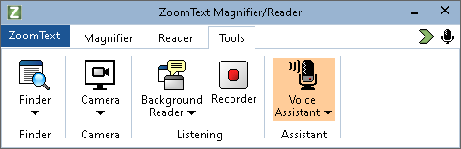
The Tools toolbar tab.
Note: The Background Reader and Recorder only appear in ZoomText Magnifier/Reader.
- Finder. Launches the Finder to search, skim, navigate and read text in documents, web pages and email.
- Camera. Launches the ZoomText Camera feature, when a supported camera is connected and available to ZoomText.
- Background Reader. Launches the Background Reader with text captured from the Windows Clipboard.
- Recorder. Launches the ZoomText Recorder with text captured from the Windows Clipboard.
- Voice Assistant. Launches the ZoomText Voice Assistant so you can use voice commands to perform ZoomText actions by speaking into your computer's microphone.

Finder
The Finder allows you to swiftly search, skim, navigate and read documents, web pages and email. You can search for words or phrases to find topics of interest. When you have found a topic of interest you can have Finder start reading from that location. Finder can also find and execute links and controls allowing you to seamlessly navigate between pages. All of these actions are performed using the Finder’s toolbar/dialog and command keys.
Note: The Voice and AppReader features are not available when running the Finder in ZoomText Magnifier.
Finder provides two modes for searching pages: Page Search and List Search. These modes and how to switch between them are described in the sections below.
Note: Finder can be used in a variety of document based applications, including Internet Explorer, Chrome, Firefox, Microsoft Word and Microsoft Outlook.
Starting Finder
- To start Finder
Do one of the following:
- On the Tools toolbar tab, click the Finder button.
- Press the Launch Finder hotkey: Caps Lock + Ctrl + F
The Finder toolbar/dialog appears.
Page Search
Page Search displays a simple toolbar where you can type a word or phrase that you want to find, and then use toolbar controls or keyboard commands to navigate through all of the instances on the page. You can also limit the page search to specific web page elements such as headings, links or controls.
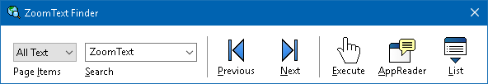
Finder: Page Search toolbar.
- To use Page Search
- If Finder is currently in List Search mode, click the List button to switch to Page Search mode.
- Select the type of Page Items that you want to search. Choose All Text, recommended for most searches, to search for words or phrases anywhere on the page, including hidden labels for images and controls.
- In the Search box, type a word or phrase that you want to find.
If the word or phrase does not exist in the selected type of page item the Search box will turn orange and the navigation buttons will be disabled.
Note: When Page Items is set to All Text, you must type at least one character in the Search box to initiate a search. When Page Items is set to any other type, you can navigate through those items without entering a search word or phrase.
- Click the Next and Previous buttons to navigate forward and backward through the matching items.
As you navigate each item is highlighted. When using ZoomText Magnifier/Reader with Finder speech enabled, the sentence containing the item is announced.
- To have Finder execute a link or control in the current item, click the Execute button.
- To have Finder start reading at the current item, click the AppReader button. *
- To enable and disable Finder speech output, click the Speech button. *
- To exit Finder, click the Exit button in the title bar.
* In ZoomText Magnifier, the AppReader and Speech options are not available so these buttons are disabled (grayed out).
List Search
List Search expands the toolbar into a dialog that displays a list of headings, links, controls and other common elements that are located in the page. You can search, filter and sort the list to quickly locate an item of interest.
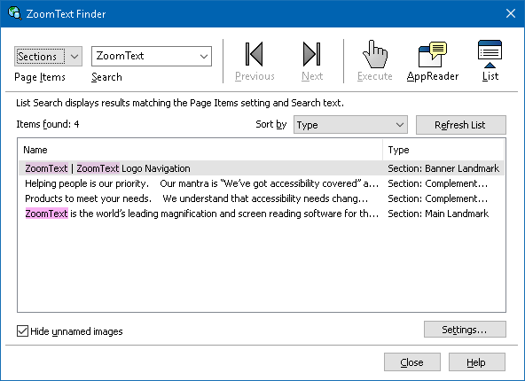
Finder: List Search toolbar/dialog
- To use List Search
- If Finder is currently in Page Search mode, click the List button to switch to List Search mode.
- In the Page Items combo box, select the type of items that you want to view in the Items found list.
- To search (or filter) the list, type a word or phrase in the Search box.
As you type in the Search box the list is automatically filtered to display only items that contain the search string. The Search box turns orange when the typed word or phrase does not exist within the list of items.
- Select the desired sorting order in the Sort by list box. You can also sort the list by clicking on the Name and Type headings at the top of the list.
- To have Finder start reading from the selected item, click the AppReader button. *
- To have Finder execute an item that contains a link or control, click the Execute button.
- To have Finder go to the location of the selected item, click the GoTo button.
- To exit Finder, click the Exit button in the title bar.
* In ZoomText Magnifier, the AppReader option is not available so this button is disabled.
- Refreshing the list in List Search
Some web pages contain areas of dynamically changing content, such as the top headlines on news sites or sports scores. When Finder starts or switches to List Search, it captures the current page content to populate the list and then ignores subsequent dynamic changes. If you know that a web page has been dynamically updated and you want to update the Found items list, click the Refresh List button.
- Hiding unnamed images in List Search
Many web pages contain images that are unnamed and ambiguous to the viewer. To keep these unnamed images from cluttering up the Found items list, place a checkmark next to Hide unnamed items check box.
Finder Command Keys
The following hotkey can be used to launch the Finder.
Command | Hotkeys
Launch Finder | Caps Lock + Ctrl + F
The following layered keys can be used to launch the Finder.
Command | Layered Keys
Launch Finder | Caps Lock + Spacebar, F
While the Finder is active, the following modal keys can be used to operate the Finder.
Command | Keys
Cycle Page Items Type Up | Ctrl + Up
Cycle Page Items Type Down | Ctrl + Down
Execute Item | Ctrl + Enter
First Item (in filtered list) | Ctrl + Home
Last Item (in filtered list) | Ctrl + End
Next Control | Ctrl + C
Next Form | Ctrl + F
Next Heading | Ctrl + H
Next Heading Level 1 ... 6 | Ctrl + 1 ... 6
Next Image | Ctrl + I
Next Link | Ctrl + L
Next List | Ctrl + S
Next Table | Ctrl + T
Next Item | Enter OR Ctrl + Right
Previous Control | Ctrl + Shift + C
Previous Form | Ctrl + Shift + F
Previous Heading | Ctrl + Shift + H
Previous Heading Level 1 ... 6 | Ctrl + Shift + 1 ... 6
Previous Image | Ctrl + Shift + I
Previous Link | Ctrl + Shift + L
Previous List | Ctrl + Shift + S
Previous Table | Ctrl + Shift + T
Previous Item | Shift + Enter OR Ctrl + Left
AppReader | Alt + R
Toggle List Search | Alt + L
Exit Finder | Esc
Finder Highlight and Voice Settings
The Finder settings allow you to configure the search highlight and voice that is used when skimming found items. The highlight makes it easy to see and follow each found item when using the next and previous commands. The Finder highlight settings allow you to customize the appearance of the highlighting including the highlight shape, color and transparency level. The Finder voice announces each found item when using the next and previous commands. The Finder voice settings allow you to enable and disable the announcement of found items.
- To adjust the Finder Highlight settings
- On the Tools toolbar tab, click the arrow next to Finder or navigate to Finder and press the down arrow key.
- In the Finder menu, choose Settings.
The Finder Settings dialog box appears.
- Choose the Highlight tab.
- Adjust the highlight settings as desired.
- Click OK.
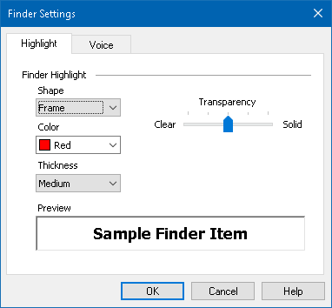
The Finder Settings Highlight tab.
Setting | Description
Finder Highlight
Shape | Sets the shape used to highlight the current search word/phrase or web page item: Block, Underline or Frame.
Color | Sets the highlight color.
Thickness | Sets the thickness of the highlight shape.
Transparency | Sets the transparency of the highlight.  Note: This setting is not available when the highlight color is set to 'Invert.'
Preview | Displays sample text with a preview of the selected highlight settings.

- To adjust the Finder Voice settings
- On the Tools toolbar tab, click the arrow next to Finder or navigate to Finder and press the down arrow key.
- In the Finder menu, choose Settings.
The Finder Settings dialog box appears.
- Choose the Voice tab.
- Adjust the voice settings as desired.
- Click OK.
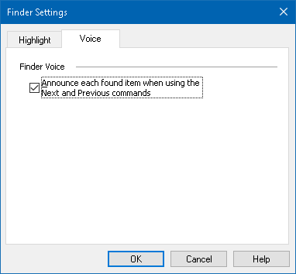
The Finder Settings Voice tab.
Setting | Description
Finder Voice
Announce each found item when using the Next and Previous commands | Enables and disables announcement of found items when using any of the Next and Previous commands.

ZoomText Camera
The ZoomText Camera feature allows you to use any high-definition webcam to magnify printed items and other objects right on your computer screen—including bills, magazines, photographs, medicine labels, craft items and more. Simple controls allow you to quickly zoom in and out and choose between full and high contrast colors. You can also switch between Full and Docked screen views which allow you to see the camera image and your Windows desktop at the same time. And by utilizing affordable and readily available HD webcams, the ZoomText Camera feature offers a portable and affordable compliment or alternative to conventional CCTVs.
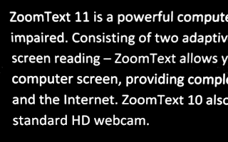 |  | 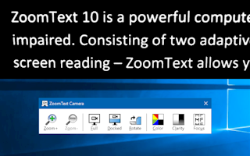
ZoomText Camera: Full view |  | ZoomText Camera: Docked View
Getting Started With ZoomText Camera
Before you can use the ZoomText Camera feature you must acquire a suitable camera and camera stand, set up the camera in your work space and choose your camera in the ZoomText Camera settings.
Acquiring a suitable camera and stand
To use the ZoomText Camera feature, you will need an HD webcam with autofocus. For best quality, your webcam should deliver 1080p video resolution with automatic low-light correction. An available USB 2.0 port is also required to connect your webcam.
In addition to a camera, you will also need a camera stand that can securely position the camera over the items you want to view. The stand should be adjustable and stable.
Setting up your camera in your workspace
To achieve best performance and usability with the ZoomText Camera feature, use the following guidelines when setting up your camera in your workspace:
- Position the camera as close as possible to your computer screen. This will allow you to easily manipulate items under the camera while viewing the image.
- Make sure there is sufficient lighting around the camera to minimize shadows in the camera's view.
- Adjust the camera stand so that the camera is about 4 inches from the target item.
- Selecting a camera (when more than one camera is present).
ZoomText automatically detects all webcams that are attached or built into your system. If your computer has more than one webcam, you will need to tell ZoomText which webcam you want it to use. This setting resides in the Camera settings in ZoomText's Tools dialog box.
- To select a camera
- On the Tools toolbar tab, click the arrow next to Camera or navigate to Camera and press the down arrow key.
- In the Camera menu, choose Settings.
The Camera Settings dialog box appears.
- In the Active Camera list box, choose the camera you want to use.
- Click OK.
Using ZoomText Camera
Use the following steps to start, configure and use ZoomText Camera.
- To start ZoomText Camera
- Do one of the following:
- On the Tools toolbar tab, click the Camera button.
- Press the Launch Camera hotkey: Caps Lock + Ctrl + C
The camera image appears in the top half of the screen while ZoomText's magnified view of the desktop remains on the bottom half of the screen. The ZoomText Camera toolbar appears in the bottom half.
- If the Camera toolbar is not in view, press Caps Lock + Ctrl + C to engage the camera layered key command mode and then press T to bring the toolbar into view.
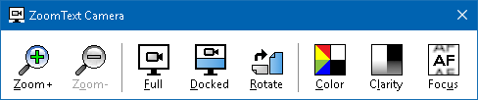
The ZoomText Camera toolbar
- To rotate the camera image
Place a document under the camera so that it is right-side up from your perspective. If the document is not oriented right-side up on the screen, click the Rotate button until the image appears right-side up.
- To zoom the image in and out
Click the Zoom + and Zoom - buttons to adjust the magnification to a comfortable reading size.
- To adjust the image colors
- Select the Color button.
The color menu appears.
- Choose between Normal (full color) and a variety of high-contrast Two-Color Schemes.
- To toggle between Normal colors and the selected Two-Color scheme by pressing Caps Lock + Ctrl + C to engage the camera layered key command mode and then pressing Alt + Enter to toggle the color mode.
- To adjust the camera clarity (Brightness/Contrast)
- Select the Clarity button.
The Camera Clarity dialog appears.
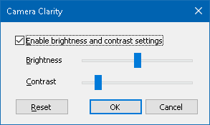
- Place a checkmark next to Enable brightness and contrast settings.
- Move the Brightness and Contrast sliders to adjust the clarity.
- Click the Reset button to return the Brightness and Contrast settings to the camera's defaults.
- Click OK.
Tip: Use the Brightness setting to eliminate glare spots that are appearing in the image.
Note: This button will be disabled (grayed out) if the active camera does not support adjustments to both brightness and contrast.
- To adjust the camera focus
- Select the Focus button.
The Camera Focus dialog appears.
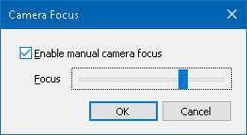
- Place a checkmark next to Enable manual camera focus.
- Move the Focus slider to adjust the image focus.
- Click OK.
Note: This button will be disabled (grayed out) if the active camera does not support autofocus.
- To move the docked view location
Click the Docked button. Each click cycles through the docked views in the following (clockwise) order: Docked Top > Docked Right > Docked Bottom > Docked Left.
- To switch between Full and Docked views
Do one of the following:
- To toggle between Full and Docked view, press Caps Lock + Ctrl + C to engage the camera layered key command mode and then press Tab to toggle the Docked/Full view.
- From Docked View, on the ZoomText Camera toolbar click the Full button.
Note: By default, when starting or switching ZoomText Camera into Full view, a dialog will appear to inform you that the ZoomText Camera toolbar is not available in Full view. The dialog also displays a list of hotkeys you can use to operate ZoomText Camera in Full view (or Docked view). Should you become stuck in Full view, press Esc to exit the ZoomText Camera.
- To exit the ZoomText Camera
Do one of the following:
- From Full view, press Esc.
- From Docked view, click the Exit button.
Camera Video and System Performance
On older computers, when using ZoomText Camera you may experience slow system and camera video performance when the camera is configured to run at a higher resolution, particularly at camera resolutions of 1280 and above. To resolve this problem, lower the camera resolution until your system and camera video performance is at an acceptable level. The resolution setting for ZoomText Camera is located in the Camera tab in ZoomText’s Tools dialog box. See "ZoomText Camera Settings" below.
ZoomText Camera Settings
The ZoomText Camera settings allow you to configure and launch the ZoomText Camera.
- To configure the ZoomText Camera settings
- On the Tools toolbar tab, click the arrow next to Camera or navigate to Camera and press the down arrow key.
- In the Camera menu, choose Settings.
The Camera Settings dialog box appears.
- Adjust the camera settings as desired.
- Click OK.
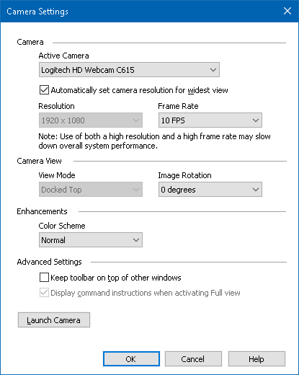
The ZoomText Camera dialog box.
Setting | Description
Camera
Active Camera | Displays the name of the camera currently being used by ZoomText and allows you to select a different camera.
Automatically set camera resolution for widest view | ZoomText auto-selects a camera resolution that provides the closest match to the screen resolution.
Resolution | Displays the current camera resolution and allows you to select a specific camera resolution. To use this setting you must uncheck Automatically set camera resolution for widest view.  Note: Use of both a high resolution and a high frame rate may slow down overall system performance.
Frame Rate | Displays the current camera frame rate and allows you to select a specific camera frame rate.  Note: Use of both a high resolution and a high frame rate may slow down overall system performance.
Camera View
View Mode | Displays the current camera view and allows you to select a different view for the ZoomText Camera.
Image Rotation | Displays the current image rotation of the camera image and allows you to select a different image rotation.
Enhancements
Color Scheme | Displays the current color filter setting and allows you to select a different color filter.
Advanced Settings
Keep toolbar on top of other windows | When checked, the Camera toolbar stays in view (on top of other windows) even when it does not have focus.  Note: This setting is also available in the system menu in the Camera title bar (displayed by clicking the Camera icon in the title bar of the Camera toolbar).
Display command instructions when activating Full view | Enables or disables displaying an alert with command instructions when switching to Full view.
Launch Camera | Launches the ZoomText Camera. This button is grayed out if the ZoomText Camera is already active.
ZoomText Camera Command Keys
The following hotkey can be used to launch the ZoomText Camera.
Command | Hotkeys
Launch Camera | Caps Lock + Ctrl + C
The following layered keys can be used to launch the ZoomText Camera.
Command | Layered Keys
Launch Camera | Caps Lock + Spacebar, C
While the Camera Toolbar is active, the following modal keys can be used to adjust the ZoomText Camera settings.
Command | Modal Keys
Show Toolbar | T
Zoom In | Up
Zoom Out | Down
Rotate Image | Left/Right
Docked/Full Toggle | Tab
Docked Position | Caps Lock + Left/Right
Clarity On/Off | Shift + Enter
Clarity Reset | Shift + Backspace
Brightness Increase | Shift + Up
Brightness Decrease | Shift + Down
Contrast Increase | Shift + Left
Contrast Decrease | Shift + Right
Two-Color On/Off | Alt + Enter
Two-Color Scheme | Alt + Left/Right
Focus Automatic/Manual | Ctrl + Enter
Focus In | Ctrl + Up
Focus Out | Ctrl + Down
Exit | X

Background Reader
Background Reader allows you to copy and listen to documents, web pages, email or any text while you simultaneously perform other tasks. You simply copy the text you want to listen to into the Windows clipboard and start Background Reader. While the text is being read aloud, you are free to type notes, browse the web or do other work on your computer.
- To launch the Background Reader
- Select the text that you want to listen to and copy it to the Windows Clipboard.
- Do one of the following to launch the Background Reader:
- On the Tools toolbar tab, select the Background Reader button.
- Press the Launch Background Reader hotkey: Caps Lock + Ctrl + B
The Background Reader toolbar appears and automatically starts reading the text that you copied into the Windows Clipboard.
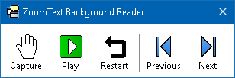
The Background Reader toolbar
Note: If the toolbar does not appear when starting Background Reader the "Start toolbar minimized" option has been selected in the Background Reader settings. To access and disable this setting, see Background Reader Settings below.
Once you have started Background Reader you can operate it using the toolbar or the command keys.
- To bring the Background Reader toolbar into view
Press the Launch Background Reader hotkey: Caps Lock + Ctrl + B, then press T.
- To operate Background Reader using the toolbar
- To start and stop reading, click the Play/Pause button.
- To skim forward and backward, click the Next and Previous buttons.
- To restart reading at the beginning, click the Restart button.
- To read new text that you have placed in the Windows Clipboard, click the Capture button.
- To exit Background Reader, click the Close button in the title bar.
- To operate Background Reader using command keys
- If the Background Reader is not active, press the Background Reader hotkey: Caps Lock + Ctrl + B
- To start and stop reading, press Enter.
- To skim forward and backward by next and previous sentence, press Right or Left.
- To skim forward and backward by word, press Ctrl + Right or Ctrl + Left.
- To restart reading at the beginning, press Shift + Enter.
- To read new text that you have placed in the Windows Clipboard, press C.
- To exit Background Reader, press X.
Background Reader Settings
The Background Reader settings allow you to choose how the toolbar appears when you start and run Background Reader.
- To adjust the Background Reader settings
- On the Tools toolbar tab, click the arrow next to Background Reader or navigate to Background Reader and press the down arrow key.
- In the Background Reader menu, choose Settings.
The Background Reader Settings dialog box appears.
- Adjust the Background Reader settings as desired.
- Click OK.
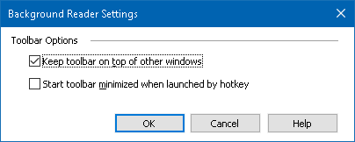
The Background Reader dialog box.
Setting | Description
Toolbar Options
Keep toolbar on top of other windows | The Background Reader toolbar will remain on top of all other application windows even when ZoomText is not the active application.
Start toolbar minimized when launched by hotkey | When Background Reader is started by a hotkey (Read Clipboard Text or Read Selected Text), the toolbar starts up minimized to the Windows taskbar.
Background Reader Command Keys
The following hotkey can be used to launch the Background Reader.
Command | Hotkeys
Launch Background Reader | Caps Lock + Ctrl + B
The following layered keys can be used to launch the Background Reader.
Command | Layered Keys
Launch Background Reader | Caps Lock + Spacebar, B
While the Background Reader toolbar is active, the following modal keys can be used to operate the Background Reader.
Command | Modal Keys
Show Toolbar | T
Capture | C
Play / Pause | Enter
Restart (from the beginning) | Shift + Enter
Next Sentence | Right
Previous Sentence | Left
Next Word | Ctrl + Right
Previous Word | Ctrl + Left
Current Word | Ctrl + Alt + Shift + Up
Current Sentence | Ctrl + Alt + Shift + Down
Exit | X

ZoomText Recorder
ZoomText Recorder allows you to turn text from documents, web pages, email or other sources into audio recordings that you can listen to on your computer or transfer to your mobile device for listening to on the go. You simply copy the text you want to record and start ZoomText Recorder. With a few simple steps you give your recording a friendly name, choose a destination to record to and click the record button. And each recording is created using your choice of ZoomText voices or any other voices available on your system. When choosing iTunes or Windows Media Player as your destination your recordings are conveniently placed in a "ZoomText Recorder" playlist. And when using iTunes your recordings can be automatically synced when you plug in your iPod, iPhone or other iDevice.
- To record text from the Windows Clipboard
- Select the text that you want to listen to and copy it to the Windows Clipboard.
- Do one of the following to launch the Background Reader:
- On the Reader toolbar tab, select the Recorder button.
- Press the Launch Recorder hotkey: Caps Lock + Ctrl + D
The Background Reader toolbar appears with the text you copied into the Windows Clipboard.
Completing the Recording Process
When you start ZoomText Recorder its dialog appears with the captured text ready to record. All you have to do is choose the desired recording options and select the Record Text button. A progress indicator appears during the recording process to let you know that it is working. You can stay and watch the progress indicator or switch to another application and make better use of your time. A friendly chime will sound when the recording process is complete.
Recording times vary depending on the size of the text selection, chosen synthesizer, destination and speed of the system. However, our general rule of thumb for recording time is about 5 to 10 seconds per page of text.
Note: When "Record text to:" is set to iTunes the iTunes application will open at the end of the recording process.
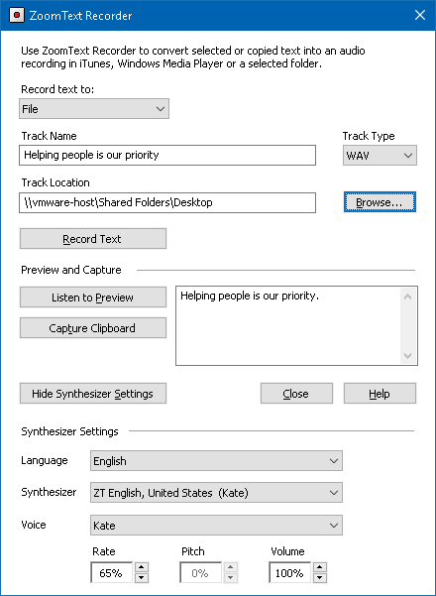
The ZoomText Recorder dialog box.
Setting | Description
Record text to: | Selects the destination for your recording. Choices are iTunes, Windows Media Player or to a file. Note: iTunes and Windows Media Player will not appear in the list if they are not installed on the system.
Track Name | Allows you to type a meaningful name for your recording. Each time new text is captured the track name is automatically set to the first 5 words of the captured text. You can type over this text. Note: Invalid file naming characters are replaced with the underscore character.
Track Type | Selects or displays the type of audio file format in which the recorded text will be saved.  - If "Record Text To" is set to File, you can choose WAV or WMA.  - If "Record Text To" is set to iTunes, the audio file is automatically set to MP3.  - If "Record Text To" is set to Windows Media Player, the audio file is automatically set to WMA.
Track Location | Displays the current folder location where the audio file will be saved and allows you to enter a new folder location. Note: The control is disabled (grayed out) when the Track Location is set to iTunes—because the location is predefined for iTunes.
Browse... | Opens a Windows Explorer dialog for selecting a location to save the audio file. Note: The button is disabled (grayed out) when the Track Location is set to iTunes.
Record Text | Initiates the recording process. During the recording process this button changes to "Cancel Recording".
Preview and Capture
Listen to Preview / Cancel Preview | Speaks up to the first 400 words of the captures text. During the preview this button changes to "Cancel Preview".
Capture Clipboard | Captures the text currently in the Windows Clipboard (replacing the previously captured text).
Show / Hide Synthesizer Settings | Expands and collapses the section of the ZoomText Recorder dialog that contains the synthesizer settings.
Synthesizer Settings
Language | Displays a list of speech synthesizer languages available on your system.
Synthesizer | Displays a list of available synthesizers on your system. Note: ZoomText supports SAPI 4 and SAPI 5 based speech synthesizers.
Voice | Displays a list of available voices in the selected synthesizer.
Rate | Adjusts the voice rate (if supported by the synthesizer).
Pitch | Adjusts the voice pitch (if supported by the synthesizer).
Volume | Adjusts the voice volume (if supported by the synthesizer).

Voice Assistant
Voice Assistant provides a way to interact with ZoomText and Fusion in Windows 10 using speech input. Ask Voice Assistant to help you with various ZoomText or Fusion features using natural language and speech. This means that the same action can be performed using similar phrases instead of a single predefined voice command. For instance, to increase magnification, you could say "zoom in" or "increase zoom level" or "increase magnification."
Unlike keyboard shortcuts, which can be hard to remember, natural voice commands are an easier way to interact with ZoomText and Fusion. Using voice input to control actions can also benefit users with any conditions that prevent or limit them from using a keyboard effectively.
Using Voice Assistant
Voice Assistant accepts voice commands to perform ZoomText and Fusion functions. To activate the feature and the listening process, you can use either a wake word, a key combination, or the user interface. You can speak voice commands using your computer's internal microphone, an external microphone, or a wired headset's microphone.
Note: Since all voice recognition processing is performed over the Internet using Microsoft Services in the cloud, there may be a slight delay depending on your connection.
- To begin listening for a specific command, do one of the following:
- Press the key combination, CAPS LOCK+ALT+SPACEBAR.
- Speak the wake word which alerts the software to begin listening for a voice command, similar to using an Alexa or Google Home device. You can use one of two wake words for ZoomText and Fusion: "Zoomy" or "Hey Zoomy." Speak the wake word followed by a specific command, such as, "Zoomy, speech off" or "Zoomy, zoom in."
- Click the microphone button in the upper right corner in the ZoomText or Fusion toolbar.
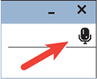
Note: The wake word is not available if you are using a Bluetooth microphone. In this case, you must press CAPS LOCK+ALT+SPACEBAR before speaking the voice command.
- When Voice Assistant starts listening for a voice command, a short audible notification plays, and a visual indicator appears on the screen.
You can now speak the command. After hearing a voice command, a different audio and visual indicator plays and displays until the command is processed.
See Voice Commands below for a list of supported and suggested voice commands.
- When complete, the visual indicator disappears, another audio indicator plays, and the requested action is performed.
If Voice Assistant does not hear anything, it says, "Sorry, I didn’t hear anything."
If Voice Assistant does not understand or if the voice command is not supported, it says, "Sorry, I didn’t catch that."
Turning Voice Assistant On and Off
To turn off and disable Voice Assistant, do one of the following:
- Use the voice command, "Voice Assistant off."
- On the Tools toolbar tab, select the Voice Assistant button.
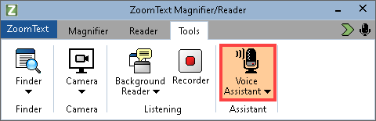
- Click the down arrow on the Voice Assistant button and choose Settings.
In the Voice Assistant Settings dialog box, clear the "Enable Voice Assistant" setting.
- In the Startup Wizard, clear "Enable Voice Assistant" in the Voice Assistant page.
(ZoomText > Preferences > Run Startup Wizard)
Note: When Voice Assistant is off, the microphone button in the upper right corner in the ZoomText and Fusion toolbar is unavailable.
Turning Off the Wake Word
You can turn off the wake word and use CAPS LOCK+ALT+SPACEBAR instead to make Voice Assistant begin listening for a command. You can then speak the command after pressing the keystroke.
To turn off the wake word, do one of the following:
- Use the voice command, "Wake word off."
- Choose "Do not listen for wake word" in the Voice Assistant Settings.
Note: When the wake word is off, you must always press CAPS LOCK+ALT+SPACEBAR first to tell Voice Assistant to begin listening for a command.
Turning Off Voice Assistant Sounds
To turn off the sounds associated with the wake word and command processing, do the following:
- On the Tools toolbar tab, click the arrow next to Voice Assistant or navigate to Voice Assistant and press the down arrow key.
- In the Voice Assistant menu, choose Settings.
The Voice Assistant Settings dialog box appears.
- Choose "Enable Voice Assistant sounds" to turn wake word and command processing sounds on or off.
Selecting a Microphone to Use with Voice Assistant
When your computer has more than one microphone, you can choose which microphone Voice Assistant uses when listening for commands. (This is helpful if you are using a headset and you are muted on a Teams or Zoom call.)
To select a microphone for Voice Assistant, do the following:
- On the Tools toolbar tab, click the arrow next to Voice Assistant or navigate to Voice Assistant and press the down arrow key.
- In the Voice Assistant menu, choose Settings.
The Voice Assistant dialog box appears.
- Choose a microphone from the Microphone Input Device list.
Voice Assistant Settings
The Voice Assistant settings are enabled and set using the Voice Assistant split-button located on the Tools toolbar tab. The bottom portion of the button opens the Voice Assistant settings.
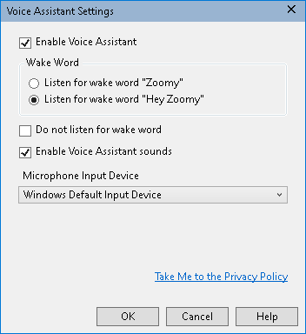
The Voice Assistant Settings
Setting | Description
Enable Voice Assistant | Enables or disables Voice Assistant.
Wake Word | You can choose to speak the single word "Zoomy" (selected by default) or the phrase "Hey Zoomy" to activate Voice Assistant. The phrase Hey Zoomy is helpful if you are in a noisy environment, and ZoomText or Fusion accidentally interprets other sounds as the wake word Zoomy.
Do not listen for wake word | Select to have the Voice Assistant no longer listen for a wake word.  If you choose not to listen for the wake word, you must always press CAPS LOCK+ALT+SPACEBAR first before saying a voice command.
Enable Voice Assistant sounds | Enables or disables Voice Assistant messages and audio indicators.
Microphone Input Device | Displays a list of all available microphones on your computer (for example, an internal microphone and a connected headset) and lets you choose which microphone Voice Assistant uses when listening for commands. By designating a different microphone for this feature than what is being used for other applications such as Teams or Zoom, it allows you to mute those applications during meetings and still use the Voice Assistant with ZoomText or Fusion.
Voice Commands
The following are examples of supported and suggested voice commands to perform various actions. Practice and try your own variations of these commands.
To perform this action... | Say this command...
Magnification Commands
To increase magnification | - Increase magnification  - Increase zoom level  - Zoom in  - Zoom x, where x is a zoom level, for example, Zoom 5 to zoom to 5X magnification  - Bigger
To decrease magnification | - Decrease magnification  - Decrease the zoom level  - Zoom out  - Smaller
To turn magnification on or off | - Zoom to 1x  - Magnification on  - Magnification off  - 1x mode off
To set magnification to a specific zoom level | - Set the magnification level to x, where x is a specific zoom level, for example, set zoom level to 5  - Zoom 10  - Mag 5
Speech Commands
To turn speech on or off | - Speech on  - Speech off  - Voice on  - Voice off
To change the speech rate | - Change voice rate to x, where x is a specific rate, for example 140 words per minute  - Set voice rate to x  - Voice rate x  - Talk faster  - Talk slower  - Increase the voice rate  - Decrease the voice rate
Color Enhancements
To change color enhancements | - Change color  - Color on  - Color off
Pointer Enhancements
To change the pointer | - Change pointer enhancement  - Pointer on  - Mouse off  - Pointer scheme 2  - Pointer large yellow
Cursor Enhancements
To change the cursor | - Change cursor enhancement  - Activate cursor enhancement  - Cursor off  - Cursor on  - Cursor scheme 3  - Cursor green circle
Focus Enhancements
To change focus enhancements | - Change focus enhancement  - Activate focus enhancement  - Focus off  - Focus scheme 4  - Focus yellow block
Keyboard Echo
To change keyboard echo | - Change keyboard echo  - Keyboard off
Mouse Echo
To change mouse echo | - Change mouse echo  - Activate mouse echo  - Mouse echo on
Quick Access Bar
To launch Quick Access Bar | - Quick Access Bar  - Quick Access  - Show shortcut list  - Shortcut list
To switch to ZoomText Toolbar | - Show user interface  - User interface  - Toolbar
Verbosity
To change the verbosity level | - Change reader verbosity level  - Set verbosity level to low  - Change the verbosity to the highest  - Verbosity medium
Finder
To launch or close the Finder | - Open Finder  - Close Finder
Camera
To launch or close the Camera | - Launch Camera  - Close Camera
AppReader (app view)/AppReader (text view)
To launch or exit AppReader | - Launch Reader app view  - Exit Reader app view  - Launch Reader text view  - Exit reader
Background Reader
To launch or exit Background Reader | - Launch Background Reader  - Exit Background Reader
Recorder
To launch or close the Recorder | - Start recorder  - Exit recorder
Freeze View
To launch the Freeze tool | - New freeze view  - New freeze window  - Create freeze view  - Create freeze window
To turn Freeze View on or off | - Freeze view x, where x is 1, 2, 3, or 4  - Freeze window x, where x is 1, 2, 3, or 4  - Freeze view x on, where x is 1, 2, 3, or 4  - Freeze view x off, where x is 1, 2, 3, or 4  - Enable freeze view x, where x is 1, 2, 3, or 4  - Enable freeze windows x, where x is 1, 2, 3, or 4  - Disable freeze view x, where x is 1, 2, 3, or 4  - Disable freeze window x, where x is 1, 2, 3, or 4
Multiple Screens
To move between screens | - Switch screen  - Window next  - Window docked left  - Window span
Scroll
To move the zoom window to the left, up, right, down, center | - Show me the bottom part of the screen  - Jump to the right  - Jump to the left  - Jump up  - Jump down  - Move to Windows search  - Move to notification area
To move to an item with focus | - Move to focus  - Find my focus
Message Center
To open Message Center | - Open Message Center
Information
To view Voice Assistant help or program version and license information | - Help (opens Voice Assistant help)  - Open Help (opens Voice Assistant help)  - About dialog  - Open About window  - Open About dialog
Keyboard Help for JAWS Commands - Fusion Only
To turn on or off JAWS keyboard help when running Fusion  Note: Keyboard help for JAWS commands can be toggled on and off in Fusion using the Voice Assistant feature. When keyboard help is on, you can press a key combination, and hear what it does when running JAWS or Fusion. When keyboard help is off, the same key combination will perform the command.  To turn keyboard help on or off with Voice Assistant, say, "Hey Zoomy, toggle keyboard help" or "Hey Sharky, toggle keyboard help." You can also turn on keyboard help by pressing INSERT+1, and turn it off by pressing ESC or INSERT+1 again. | - Toggle keyboard help

Chapter 8

Configurations
All ZoomText settings can be saved and restored using configuration files. Configuration files control all ZoomText features; including magnification level, the zoom window type, screen enhancements, reading options, application settings and hotkeys. There is no limit on the number of configuration files that you can save, so feel free to create and use as many as you like. You can also create application specific settings that automatically load each time the application becomes active.
- The Default Configuration
- Saving and Loading Configurations
- Configuration Hotkeys
- Application Settings

The Default Configuration
When you start ZoomText, the default configuration file, ZT.ZXC, is automatically loaded. This file contains the built-in defaults for all ZoomText settings. You can create your default configuration, which will load your custom settings whenever ZoomText is run. Don't worry about losing the built-in settings; the original default file can be easily restored.
- To save a custom default configuration
- Set all ZoomText features as desired.
- In the ZoomText menu, choose Configurations > Save As Default.
A dialog appears prompting you to confirm saving the configuration.
- Select Yes to overwrite the current default configuration.
- To restore the original default configuration file
- In the ZoomText menu, choose Configurations > Restore Factory Defaults.
A dialog appears prompting you to confirm restoring the configuration.
- Select Yes to overwrite the current default configuration.

Saving and Loading Configurations
The current ZoomText settings can be saved to a configuration file at any time. This configuration file can be loaded at a later time and the saved settings will take effect immediately.
- To save settings to a configuration file
- Set all ZoomText features as desired.
- In the ZoomText menu, choose Configurations > Save Custom Configuration.
The Save Configuration dialog box appears displaying the existing configuration files.
- Type the name of the new configuration in the File name: box.
- Click OK.
- To load settings from a configuration file
- In the ZoomText menu, choose Open Custom Configuration.
The Open Configuration dialog box appears displaying the existing configuration files.
- Highlight the desired configuration file.
- Click Open.

Configurations Hotkeys
You can use hotkeys to load configuration files, without activating the ZoomText user interface. Before a configuration hotkey can be used, a configuration file must be assigned to it. The following table lists the default configuration hotkeys. For information on assigning configurations to hotkeys, see " To assign a configuration file to a Load Configuration command" in The Command Keys Dialog.
Setting | Description
Load Configuration File 1 | Caps Lock + 1
Load Configuration File 2 | Caps Lock + 2
Load Configuration File 3 | Caps Lock + 3
Load Configuration File 4 | Caps Lock + 4
Load Configuration File 5 | Caps Lock + 5
Load Configuration File 6 | Caps Lock + 6
Load Configuration File 7 | Caps Lock + 7
Load Configuration File 8 | Caps Lock + 8
Load Configuration File 9 | Caps Lock + 9
Load Configuration File 10 | Caps Lock + 0

Application Settings
Within each ZoomText configuration, you can define custom settings for each application that you use. For example, you can have ZoomText display your web browser at one magnification level and your word processor at another. Whenever these applications become active their application settings are automatically restored. Applications for which settings have not been defined are displayed and spoken according to the default settings of the configuration file.
- To define and save application settings
- Open the application for which you want to define custom settings.
- Use the ZoomText command keys to select the desired ZoomText settings or switch directly to the ZoomText toolbar to select the desired settings.
- Press the Save Application Settings hotkey: Caps Lock + Ctrl + S, or on the ZoomText toolbar, choose ZoomText > Configurations > Application Settings > Save Application Settings.
A dialog prompts you to save the application settings.
- Click Yes to save the settings.
At any time, you can disable or delete application settings. Disabled application settings remain in your configuration and may be re-enabled at any time. Deleted application settings are removed from your configuration.
- To disable or delete application settings
- Press the Manage Application Settings hotkey: Caps Lock + Ctrl + M, or on the ZoomText toolbar, choose ZoomText > Configurations > Application Settings > Manage Application Settings.
The Manage Application Settings dialog appears.
- To disable application settings; in the Use application Settings for list box, uncheck the desired applications.
The selected application remains in the list, but application settings are not invoked when using the application.
- To delete application settings, select the desired application, and then choose Delete Selected.
The selected application is removed from the list.
- Click OK.
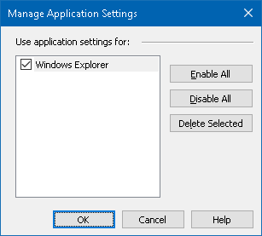
The Manage Application Settings dialog.
Setting | Description
Use application settings for: | Displays a list of application settings that have been saved in the current ZoomText configuration.
Enable All | Enables all items listed in the Use Application Settings for list box.
Disable All | Disables all items listed in the Use Application Settings for list box.
Delete Selected | Deletes the selected items in the Use Application Settings for list box.

Chapter 9

Preference Settings
Preference settings allow you to control how ZoomText starts and exits, how ZoomText updates itself, the appearance of the ZoomText user interface, and the type of smoothing that ZoomText applies in the magnified view.
- Program Preferences
- User Interface Preferences
- Smoothing Preferences
- Legacy Reading Preferences
- Run ZoomText As

Program Preferences
Program preferences control how ZoomText starts and exits, and allows you to enable automatic updating.
- To adjust the program preferences
- In the ZoomText menu, choose Preferences > Program.
The Preferences dialog appears with the Program tab displayed.
- Adjust the program preference settings as desired.
- Select OK.
The Program tab.
Setting | Description
Logon Support
Enable ZoomText in the Windows logon prompt | Enables the ZoomText Secure Mode utility in the Windows logon prompt and other Windows secure mode prompts. ZoomText Secure Mode provides essential magnification and screen reading features in the secure mode prompts.
Startup Settings
Start ZoomText automatically when Windows starts | ZoomText will automatically run each time you start your system.
Start ZoomText with the toolbar minimized | The ZoomText user interface is minimized when ZoomText is started.
Display the “Welcome” window when ZoomText starts | Each time ZoomText is started the Welcome window appears along with the ZoomText toolbar. The Welcome window displays instructions and hotkeys that are helpful for new users.
Display a ZoomText icon on the desktop | Displays the ZoomText desktop icon.
If launched on a remote server, wait for a client to connect | When ZoomText (or Fusion) is started on a remote server, if ZoomText (or Fusion) is not running on the client machine, it will start up in dormant mode and wake up when ZoomText (or Fusion) has been launched on the client machine.
Exit Settings
Save ZoomText settings automatically when exiting | All ZoomText settings are saved to the active configuration when the program exits.
Prompt to confirm intent to exit ZoomText | You are prompted to confirm your choice to exit the program.
Unload magnification process when exiting ZoomText | Unloads ZoomText's magnification process when you exit ZoomText. This process will otherwise continue running to provide faster restart of ZoomText in the same Windows session.
Automatic Updating
Check for online updates each time ZoomText is launched | Each time you start ZoomText, if an Internet connection is established, ZoomText will check online for available program updates. If updates are available, the Update Wizard will give you the option to download and install the updates.
Seamless Updates for xFont support (requires admin privileges) | ZoomText (or Fusion) checks for and automatically applies updates to the xFont support if required by OS or third-party app changes. When disabled, updates to the xFont support are not installed.
Fusion
When ZoomText Keyboard is installed, prompt to select a product to launch when pressing "Start/Toggle ZoomText" feature key. | This setting prompts you to open ZoomText or Fusion when using the F1 key on the ZoomText keyboard.  Note: The following criteria must be met to display the prompt.  - Both ZoomText and Fusion are installed. (If Fusion is not installed, ZoomText is the default application.)  - You are using a ZoomText keyboard, and the ZoomText keyboard software is installed and enabled.  - You use the F1 function key (also called the Start/Toggle feature key) to start either application.
Anonymous Data
Participate in our effort to improve Freedom Scientific products by submitting Anonymous Usage Data | Enable or disable submission of anonymous data to improve the software.

User Interface Preferences
User interface preferences control how the ZoomText user interface appears on the Windows desktop.
- To adjust the user interface preferences
- In the ZoomText menu, choose Preferences > User Interface.
The Preferences dialog appears with the User Interface tab displayed.
- Adjust the user interface preference settings as desired.
- Select OK.
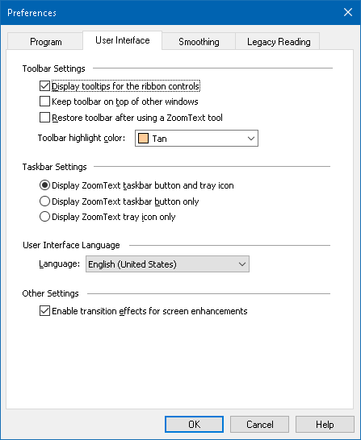
The User Interface tab.
Setting | Description
Toolbar Settings
Display tooltips for the ribbon controls | Enables display of informative tooltips when moving the mouse over the controls on the ZoomText toolbar.
Keep toolbar on top of other windows | The ZoomText user interface window will remain on top of all other windows, even when ZoomText is not the active application.
Restore toolbar after using a ZoomText tool | The ZoomText toolbar is always restored when exiting a ZoomText tool.
Toolbar highlight color | Selects the color that is used to highlight the controls on the ZoomText toolbar.
Taskbar Settings
Display ZoomText taskbar button and tray icon | When ZoomText is running, its taskbar button and tray icon are both displayed.
Display ZoomText taskbar button only | When ZoomText is running, only its taskbar button is displayed.
Display ZoomText tray icon only | When ZoomText is running, only its system tray icon is displayed.
User Interface Language
Language | Selects the language that the ZoomText user interface will appear in.  Note: This option is not available in English only versions.
Other Settings
Enable transition effects for screen enhancements | Enables smooth visual shifts when switching between ZoomText’s screen enhancement schemes.

Smoothing Preferences
Smoothing preferences control how ZoomText smooths and sharpens text and graphics (including photographs) in the magnified view. ZoomText provides two types of smoothing, xFont® and Geometric Smoothing, which can be enabled individually or together.
- xFont applies only to text and displays the highest quality of magnified text. It is not available in all applications. When xFont is not available, Geometric Smoothing will smooth the magnified text (if enabled).
- Geometric Smoothing provides high-quality smoothing both to graphics and to text where xFont magnification cannot be applied. Two types of Geometric Smoothing are available: ClearSharp and Legacy.
- ClearSharp is the newer type of geometric smoothing that produces enhanced smoothing quality with better system performance.
- Legacy is the older type of geometric smoothing that remains available for users that prefer the appearance of legacy smoothing.
When ZoomText is enabled and magnifying the screen, you can cycle through the smoothing modes to determine individual or combined types of smoothing that work best for you.
- To cycle the smoothing mode
- Press the Smoothing Mode hotkey: Caps Lock + X
You can view and configure the Smoothing settings in the Preferences dialog box.
- To adjust the smoothing preferences
- In the ZoomText menu, choose Preferences > Smoothing.
The Preferences dialog appears with the Smoothing tab displayed.
- Adjust the smoothing preference settings as desired.
- Select OK.
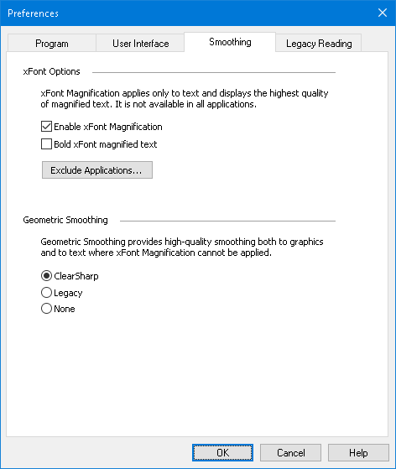
The Smoothing tab.
Setting | Description
xFont Options
Enable xFont Magnification | Enables xFont magnification. xFont displays the highest quality of magnified text. It is not available in all applications.
Bold xFont magnified text | Adds boldness to text magnified by xFont.
Exclude Applications | Displays settings for excluding the use of xFont in problem applications. See "Excluding xFont in Problem Applications" below.
Geometric Smoothing
ClearSharp | Enables ClearSharp geometric smoothing.
Legacy | Enables Legacy geometric smoothing.
None | Disables geometric smoothing.

Excluding xFont in Problem Applications
Some applications contain user-interface components that are not compatible with ZoomText's xFont feature, resulting in missing or corrupted text. When this occurs, you can exclude the use of xFont within the problem application by selecting (checking) the application's name in the Exclude Applications dialog box.
Note: Applications that have known conflicts with xFont have been excluded in the default ZoomText configuration.
- To exclude xFont in selected applications
- In the ZoomText menu, choose Preferences > Smoothing
The Preferences dialog appears with the Smoothing tab displayed.
- Select Enable xFont Magnification.
- Choose Exclude Applications...
The Exclude Applications dialog box appears.
- In the Exclude xFont from list box, check the applications in which you would like to exclude the use of xFont.
- Click OK.
- Restart ZoomText. This step is required to activate the changes applied in the Exclude Applications dialog box.
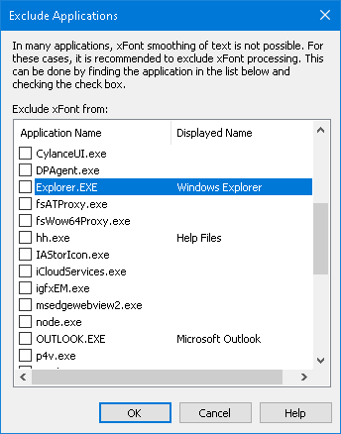
The Exclude Applications dialog box
Setting | Description
Exclude xFont from: | Displays a list of applications that are currently running on the system. Checked applications are excluded from xFont processing.

Legacy Reading Preferences
Note: Legacy Reading Preferences is a support tool used to troubleshoot speech issues with legacy applications (legacy apps). You may be asked by technical support to change these settings.
An enterprise business may be running older or proprietary legacy apps that do not have support for an accessibility API such as UI automation, MSAA (Microsoft Active Accessibility), IAccessible2, or DOM (Document Object Model). This is not a problem for modern apps such as Chrome, Edge, and Office apps such as Excel and Outlook. If you have magnification but no speech or tracking when running a legacy app with the latest ZoomText or Fusion release, you may need to enable legacy reading for that specific app.
- To turn on legacy reading for an application
- In the ZoomText menu, choose Preferences > Legacy Reading.
The Preferences dialog appears with the Legacy Reading tab displayed.
- In the Enable legacy reading for list box, check the applications in which you would like to use legacy reading.
- Select OK.
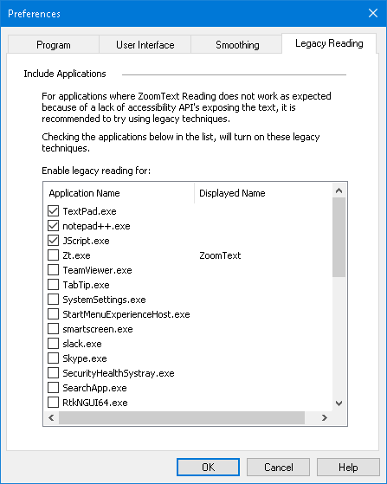
The Legacy Reading tab.
Setting | Description
Enable legacy reading for: | Displays a list of applications that are currently running on the system. Checked applications use legacy reading techniques.

Run ZoomText As
In certain situations, you may want an installation of ZoomText Magnifier/Reader to startup and run as ZoomText Magnifier. You can do this in the Run ZoomText As dialog box.
- To switch with product type ZoomText runs as
- In the ZoomText menu, choose Preferences > Run ZoomText As.
The ZoomText Run As dialog box appears.
- Select the product type that you want ZoomText to run as.
- Click Restart ZoomText Now.
ZoomText will exit and restart as the selected product type.
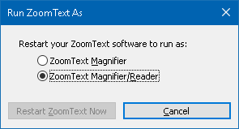
The Run ZoomText As dialog box.
Setting | Description
ZoomText Magnifier | Sets ZoomText to start up as ZoomText Magnifier.
ZoomText Magnifier/Reader | Sets ZoomText to start up as ZoomText Magnifier/Reader.
Restart ZoomText Now | Exits and restarts ZoomText as the selected product type.

Chapter 10

ZoomText Commands
This section provides a complete listing of ZoomText Command keys, including hotkeys, layered keys, and modal keys.
- AppReader Commands
- Background Reader Commands
- Camera Commands
- Finder Commands
- Layered Keys Command Mode
- Magnifier Commands
- Program Commands
- Reader Commands
- Reading Zones Commands
- Recorder Commands
- Say Commands
- Scroll Commands
- Support Commands
- Text Cursor Commands
- Window Commands

AppReader Commands
The following hotkeys can be used to launch the AppReader.
Command | Hotkeys
Launch AppReader from Pointer | Caps Lock + Alt + Left-Click
Launch App View | Caps Lock + Alt + A
Launch Text View | Caps Lock + Alt + T
Launch SpeakIt Tool | Caps Lock + Alt + S
Launch AppReader (selected mode) | Caps Lock + Alt + R
The following layered keys can be used to launch the AppReader.
Command | Layered Keys
Launch AppReader | Caps Lock + Spacebar, A
While the AppReader is active, the following modal keys can be used to operate the AppReader.
Command | Modal Keys
Next Word | Ctrl + Right
Previous Word | Ctrl + Left
Next Sentence | Right
Previous Sentence | Left
Next Paragraph | Down
Previous Paragraph | Up
Next Page | Page Down
Previous Page | Page Up
Current Word * | Ctrl + Alt + Shift + Up
Current Line | Ctrl + Alt + Shift + Right
Current Sentence | Ctrl + Alt + Shift + Down
Current Paragraph | Ctrl + Alt + Shift + Left
First Word On Line | Home
Last Word On Line | End
Beginning of Document | Ctrl + Home
End of Document | Ctrl + End
Next Link | L
Previous Link | Shift + L
Execute Link | Ctrl + Enter
* When using the Current Word command, repeated presses within two seconds provides the following behavior:
- First press: speaks the word
- Second press: spells the word
- Third press: spells the word phonetically ("Alpha, Bravo, Charlie, ...")

Background Reader Commands
The following hotkeys can be used to launch the Background Reader.
Command | Hotkeys
Launch Background Reader | Caps Lock + Ctrl + B
The following layered keys can be used to launch the Background Reader.
Command | Layered Keys
Launch Background Reader | Caps Lock + Spacebar, B
While the Background Reader toolbar is active, the following modal keys can be used to operate the Background Reader.
Command | Modal Keys
Show Toolbar | T
Capture | C
Play / Pause | Enter
Restart (from the beginning) | Shift + Enter
Next Sentence | Right
Previous Sentence | Left
Next Word | Ctrl + Right
Previous Word | Ctrl + Left
Current Word | Ctrl + Alt + Shift + Up
Current Sentence | Ctrl + Alt + Shift + Down
Exit | X

Camera Commands
The following hotkeys can be used to launch the ZoomText Camera.
Command | Hotkeys
Launch Camera | Caps Lock + Ctrl + C
The following layered keys can be used to launch the ZoomText Camera.
Command | Layered Keys
Launch Camera | Caps Lock + Spacebar, C
While the Camera Toolbar is active, the following modal keys can be used to adjust the ZoomText Camera settings.
Command | Modal Keys
Show Toolbar | T
Zoom In | Up
Zoom Out | Down
Rotate Image | Left/Right
Docked/Full Toggle | Tab
Docked Position | Caps Lock + Left/Right
Clarity On/Off | Shift + Enter
Clarity Reset | Shift + Backspace
Brightness Increase | Shift + Up
Brightness Decrease | Shift + Down
Contrast Increase | Shift + Left
Contrast Decrease | Shift + Right
Two-Color On/Off | Alt + Enter
Two-Color Scheme | Alt + Left/Right
Focus Automatic/Manual | Ctrl + Enter
Focus In | Ctrl + Up
Focus Out | Ctrl + Down
Exit | X

Finder Commands
The following hotkeys can be used to launch the Finder.
Command | Hotkeys
Launch Finder | Caps Lock + Ctrl + F
The following layered keys can be used to launch the Finder.
Command | Layered Keys
Launch Finder | Caps Lock + Spacebar, F
While the Finder is active, the following modal keys can be used to operate the Finder.
Command | Keys
Cycle Page Items Type Up | Ctrl + Up
Cycle Page Items Type Down | Ctrl + Down
Execute Item | Ctrl + Enter
First Item (in filtered list) | Ctrl + Home
Last Item (in filtered list) | Ctrl + End
Next Control | Ctrl + C
Next Form | Ctrl + F
Next Heading | Ctrl + H
Next Heading Level 1 ... 6 | Ctrl + 1 ... 6
Next Image | Ctrl + I
Next Link | Ctrl + L
Next List | Ctrl + S
Next Table | Ctrl + T
Next Item | Enter OR Ctrl + Right
Previous Control | Ctrl + Shift + C
Previous Form | Ctrl + Shift + F
Previous Heading | Ctrl + Shift + H
Previous Heading Level 1 ... 6 | Ctrl + Shift + 1 ... 6
Previous Image | Ctrl + Shift + I
Previous Link | Ctrl + Shift + L
Previous List | Ctrl + Shift + S
Previous Table | Ctrl + Shift + T
Previous Item | Shift + Enter OR Ctrl + Left
AppReader | Alt + R
Toggle List Search | Alt + L
Exit Finder | Esc

Layered Keys Command Mode
The following hotkeys can be used to launch the layered keys command mode.
Command | Hotkeys
Command Mode Selection | Caps Lock + Spacebar
When the command mode is active, the following layered keys can be used to enter the available command mode groups.
Command | Layered Keys
AppReader Commands | A
Launch Background Reader | B
Launch Camera | C
Launch Finder | F
Launch Recorder | D
Magnifier Commands | M
Program Commands | P
Reader Commands | R
Say Commands | Y
Scroll Commands | S
Support Commands | U
Window Commands | W
Zones Commands | Z

Magnifier Commands
The following hotkeys can be used to operate the Magnifier Commands.
Command | Hotkeys
Magnifier Commands | Unassigned
Enhance Colors On/Off | Caps Lock + C
Enhance Cursor On/Off | Caps Lock + R
Enhance Focus On/Off | Caps Lock + F
Enhance Pointer On/Off | Caps Lock + P
Enhance Smart Invert On/Off | Caps Lock + I
Smoothing Mode | Caps Lock + X
Toggle Zoom and 1x | Caps Lock + Enter
xFont Bold On/Off | Caps Lock + B
Zoom In | Caps Lock + Up
Zoom Out | Caps Lock + Down
The following layered keys can be used to operate the Magnifier Commands.
Command | Layered Keys
Magnifier Commands | Caps Lock + Spacebar, M
Enhance Colors On/Off | C
Enhance Cursor On/Off | R
Enhance Focus On/Off | F
Enhance Pointer On/Off | P
Enhance Smart Invert On/Off | I
Smoothing Mode | X
Toggle Zoom and 1x | Enter
xFont Bold On/Off | B
Zoom In | Up
Zoom Out | Down

Program Commands
The following hotkeys can be used to operate the Program Commands.
Command | Hotkeys
Program Commands | Unassigned
ZoomText On/Off | Caps Lock + Ctrl + Enter
Show User Interface | Caps Lock + Ctrl + U
Load Configuration 1 ... 10 | Caps Lock + Ctrl + 1 ... 0  Note: 0 is used to load configuration 10
Manage Application Settings | Caps Lock + Ctrl + M
Save Application Settings | Caps Lock + Ctrl + S
The following layered keys can be used to operate the Program Commands.
Command | Layered Keys
Program Commands | Caps Lock + Spacebar, P
ZoomText On/Off | Enter
Show User Interface | U
Load Configuration 1 ... 10 | 1 ... 10  Note: 0 is used to load configuration 10
Manage Application Settings | M
Save Application Settings | S

Reader Commands
The following hotkeys can be used to operate the Reader Commands.
Command | Hotkeys
Reader Commands | Unassigned
Echo Keyboard Mode | Caps Lock + Alt + K
Echo Mouse Mode | Caps Lock + Alt + M
Echo Verbosity Level | Caps Lock + Alt + B
Voice On/Off | Caps Lock + Alt + Enter
Voice Select | Caps Lock + Alt + V
Voice Faster | Caps Lock + Alt + Up
Voice Slower | Caps Lock + Alt + Down
The following layered keys can be used to operate the Reader Commands.
Command | Layered Keys
Reader Commands | Caps Lock + Spacebar, R
Echo Keyboard Mode | K
Echo Mouse Mode | M
Echo Verbosity Level | B
Voice On/Off | Enter
Voice Select | V
Voice Faster | Up
Voice Slower | Down

Reading Zones Commands
The following hotkeys can be used to operate the Magnifier Commands.
Command | Hotkeys
Zones Commands | Caps Lock + Alt + Z
Create Zone | Caps Lock + Alt + C
Edit Zone | Caps Lock + Alt + E
List Zone | Caps Lock + Alt + L
Navigate Zones | Caps Lock + Alt + G
Next Zone | Caps Lock + Alt + N
Previous Zone | Caps Lock + Alt + P
Trigger Zone 1 ... 10 | Caps Lock + Alt + 1 ... 0  Note: 0 triggers Zone 10.
The following layered keys can be used to operate the Magnifier Commands.
Command | Layered Keys
Zones Commands | Caps Lock + Spacebar, Z
Create Zone | C
Edit Zone | E
List Zone | L
Navigate Zones | G
Next Zone | N
Previous Zone | P
Trigger Zone 1 ... 10 | 1 ... 0  Note: 0 triggers Zone 10.

Recorder Commands
The following hotkeys can be used to launch the ZoomText Recorder.
Command | Hotkeys
Launch Recorder | Caps Lock + Ctrl + D
The following layered keys can be used to launch the ZoomText Recorder.
Command | Layered Keys
Launch Recorder | Caps Lock + Spacebar, D

Say Commands
The following hotkeys can be used to trigger the Say Commands.
Command | Hotkeys
Say Commands | Unassigned
The following layered keys can be used to trigger the Say Commands.
Command | Layered Keys
Say Commands | Caps Lock + Spacebar, Y
Say Current Date | D
Say Current Time | T
Say Cell Column Title | C
Say Cell Comment | N
Say Cell Formula | O
Say Cell Row Title | R
Say Clipboard | P
Say Dialog Default Button | B
Say Dialog Group Name | G
Say Dialog Message | M
Say Dialog Tab | A
Say Focus | F
Say Selected Text | S
Say Status Bar | U
Say Window Title | W

Scroll Commands
The following hotkeys can be used to operate the Scroll Commands.
Command | Hotkeys
Scroll Commands | Unassigned
Scroll Up | Caps Lock + Shift + Up
Scroll Down | Caps Lock + Shift + Down
Scroll Left | Caps Lock + Shift + Left
Scroll Right | Caps Lock + Shift + Right
Scroll Stop | Caps Lock + Shift + Enter
Jump Up | Caps Lock + Ctrl + Up
Jump Down | Caps Lock + Ctrl + Down
Jump Left | Caps Lock + Ctrl + Left
Jump Right | Caps Lock + Ctrl + Right
Jump Center | Caps Lock + Ctrl + Home
Save View | Caps Lock + Ctrl + Page Up
Restore View | Caps Lock + Ctrl + Page Down
The following layered keys can be used to operate the Scroll Commands.
Command | Layered Keys
Scroll Commands | Caps Lock + Spacebar, S
Scroll Up | Up
Scroll Down | Down
Scroll Left | Left
Scroll Right | Right
Scroll Stop | Enter
Jump Up | Ctrl + Up
Jump Down | Ctrl + Down
Jump Left | Ctrl + Left
Jump Right | Ctrl + Right
Jump Center | Ctrl + Home
Save View | Ctrl + Page Up
Restore View | Ctrl + Page Down

Support Commands
The following hotkeys can be used to operate the Magnifier Commands.
Command | Hotkeys
Support Commands | Unassigned
AHOI On/Off | Ctrl + Alt + Shift + A
AHOI Report | Ctrl + Alt + Shift + R
Capture Screen | Ctrl + Alt + Shift + C
Detect Cursor | Ctrl + Alt + Shift + D
Pass Next Hotkey | Ctrl + Alt + Shift + P
Tracking On/Off | Ctrl + Alt + Shift + T
Refresh Screen Model | Ctrl + Alt + Shift + U
ZoomText Information | Ctrl + Alt + Shift + I
The following layered keys can be used to operate the Magnifier Commands.
Command | Layered Keys
Support Commands | Caps Lock + Spacebar, U
AHOI On/Off | A
AHOI Report | R
Capture Screen | C
Detect Cursor | D
Pass Next Hotkey | P
Tracking On/Off | T
Refresh Screen Model | U
ZoomText Information | I

Text Cursor Commands
The following hotkeys can be used to operate the Text Cursor Commands.
Command | Hotkeys
Current Character | Ctrl + Alt + Shift + Enter
Current Word | Ctrl + Alt + Shift + Up
Current Line | Ctrl + Alt + Shift + Right
Current Sentence | Ctrl + Alt + Shift + Down
Current Paragraph | Ctrl + Alt + Shift + Left
Next Sentence | Caps Lock + Alt + Right
Previous Sentence | Caps Lock + Alt + Left
The following keys are standard Windows keyboard commands for moving the text cursor through text.
Command | Windows Keys
Next Character | Right
Previous Character | Left
Next Word | Ctrl + Right
Previous Word | Ctrl + Left
Next Line | Up
Previous Line | Down
Next Paragraph | Ctrl + Down
Previous Paragraph | Ctrl + Up

Window Commands
The following hotkeys can be used to operate the Window Commands.
Command | Hotkeys
Window Commands | Unassigned
Zoom Window Type | Caps Lock + Z
Zoom Window Adjust Tool | Caps Lock + A
Freeze Views 1–4 On/Off | Caps Lock + Ctrl + 1–4
Freeze View New | Caps Lock + N
Route Mouse to View | Unassigned
Route View to Mouse | Unassigned
Switch Active View | Caps Lock + V
Overview Mode On/Off | Caps Lock + O
The following layered keys can be used to operate the Window Commands.
Command | Layered Keys
Window Commands | Caps Lock + Spacebar, W
Zoom Window Type | Z
Zoom Window Adjust Tool | A
Freeze View 1-4 On/Off | Caps Lock + Spacebar, W, x, where x is 1, 2, 3, or 4
Freeze View New | N
Route Mouse to View | Down
Route View to Mouse | Up
Switch Active View | V
Overview Mode On/Off | O

Chapter 11

ZoomText Support
ZoomText comes with a variety of built-in and online support tools and services that are available 24 hours a day, 7 days a week. These tools and services include information gathering utilities, technical and how-to-articles, and a way to report a problem to the ZoomText product support team. Some of these tools may also be called on when working a problem with a ZoomText support representative.
- System Info
- FS Support Tool
- Data Reporting
- Remote Desktop
- Fix-It Commands
- Display Adapter
- Early Adopter Program
- Training Center
- About ZoomText

System Information
The System Info dialog displays a collection of information about your system's hardware, software and configuration that may be useful in diagnosing a problem.
- To view the System Info dialog
In the ZoomText menu, choose Help > System Info.
The ZoomText Support dialog box appears with the System Info tab displayed.
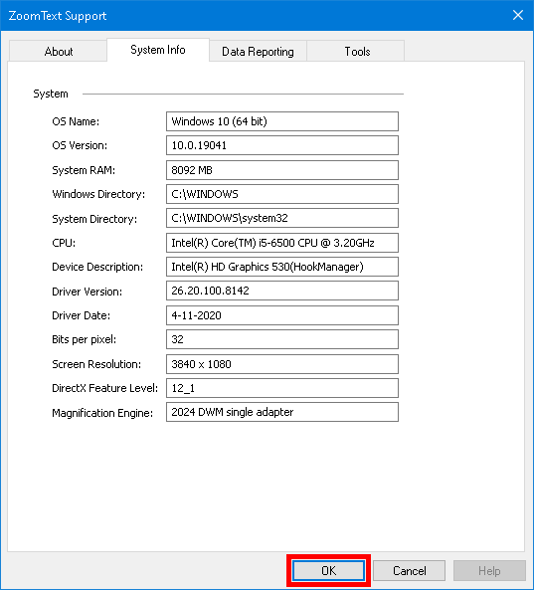
The System Info tab.

Data Reporting
Data Reporting lets you send information over the Internet to Freedom Scientific about any ZoomText or Fusion errors.
Choosing to send any error reports helps Freedom Scientific improve its products. The information transmitted to Freedom Scientific is limited to the memory dump file as well as generic information allowing Freedom Scientific to investigate the source of the issue, such as your product version number, the date and time the error occurred, number of times your system has experienced an error, and the error code related to the problem. The only information related to your specific environment that is transmitted is your computer's MAC address to find trends on a particular system. However, there is no way for us to map MAC addresses to any particular individual, and no personal identification information is transmitted.
Anonymous Data lets you choose whether or not to send anonymous user data to Freedom Scientific. This includes items such as performance and software configuration.
- To set up error and data usage reporting, do the following:
- In the ZoomText menu, choose Help > Advanced > Data Reporting.
The ZoomText Support dialog box appears with the Data Reporting tab displayed.
- Choose how or if you want to send errors reports.
- Choose if you want to send anonymous data usage.
- Select OK.
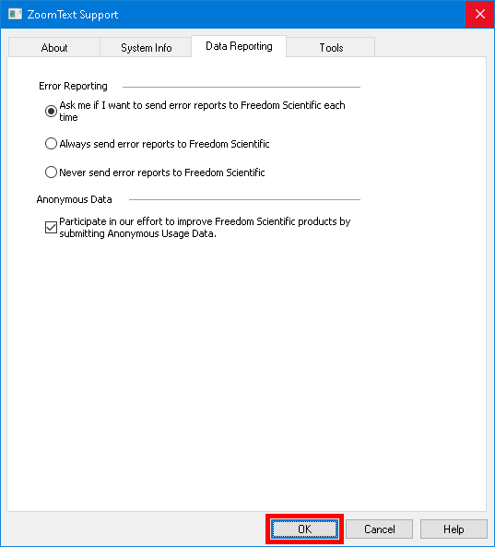
The Data Reporting tab
Setting | Description
Error Reporting
Ask me if I want to send error reports to Freedom Scientific each time | The Error Reporting dialog box displays each time an error is detected. This is the default setting.
Send all error reports to Freedom Scientific without asking | Future error reports are automatically sent to Freedom Scientific without displaying a dialog box.
Never send error reports to Freedom Scientific | Any future error reports are not sent to Freedom Scientific and you are not prompted to send an error report.
Anonymous Data
Participate in our effort to improve Freedom Scientific products by submitting Anonymous Usage Data | When selected, we collect information about the use of this product. This includes data about:  - How you configured the product  - How you use the product  - The performance of the product  We do not collect any personal identifiable information.  Having this feature on is necessary to use certain features such as Voice Assistant. See our Anonymous Data Collection Policy for more information about what we collect.

Tools (Support)
ZoomText Support Tools are utilities used to help Technical Support troubleshoot issues with your installation of ZoomText or Fusion.
- FS Support Tool
- Remote Desktop
- Fix-It

FS Support Tool
The FS Support Tool opens a utility which collects information about your computer and sends a report to our Technical Support and Software Development teams. Usually, you will only need to run this when asked to by Technical Support in order to obtain additional information about your system to help with troubleshooting an issue.
Some information that is collected includes:
- System information such as processor
- RAM, operating system, architecture, and more
- Event logs
- Version of Adobe Reader (if installed)
- Information on installed Microsoft Office applications
- Crash dumps
- Installation logs
- Currently running system processes
- User settings
- To create and send a report, do the following:
- In the ZoomText menu, choose Help > Advanced > Tools.
The ZoomText Support dialog box appears with the Tools tab displayed.
- Click FS Support Tool.
- Follow the prompts and choose Send Report when finished.
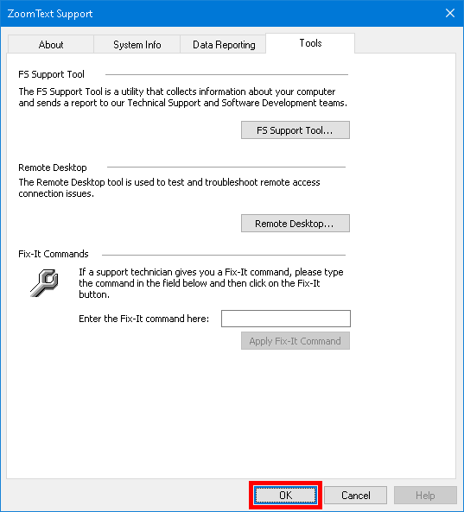
The Tools tab

Remote Desktop
The Remote Desktop tool is used to test and troubleshoot remote access connection issues.
From the Remote Desktop dialog box, you can:
- See whether or not your Freedom Scientific software is authorized for remote access.
- Check the status for each supported remote channel (Remote Desktop, Citrix, or VMWare Horizon).
- Repair any channel that is reported to not be working.
- Test the connection between the client and server/remote computers.
- To verify if you are authorized for remote access, do the following:
- In the ZoomText menu, choose Help > Advanced > Tools.
The ZoomText Support dialog box appears with the Tools tab displayed.
- Click Remote Desktop.
The Remote Desktop dialog box appears.
- Near the top of the dialog box the Remote Access Authorization is shown as Enabled or Disabled.
- To verify the status of each supported remote channel, do the following:
- In the ZoomText menu, choose Help > Advanced > Tools.
The ZoomText Support dialog box appears with the Tools tab displayed.
- Click Remote Desktop.
The Remote Desktop dialog box appears.
- If running on a client machine, a list of all supported remote channels appears.
- If running on a server machine, the remote channel used by the server appears.
- The list also shows if a channel is working or not working.
- To test the connection between client and server machines, choose Test connection.
- To repair a channel that is not working, choose Repair.
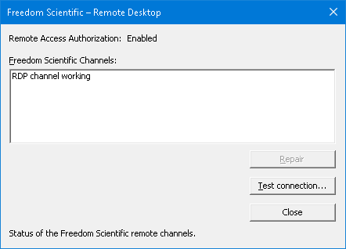
The Remote Desktop dialog box.

Fix-It Command
Fix-It commands are used to fix unique performance and behavioral problems that have been diagnosed by a ZoomText support technician. The Fix-It command is provided by the support technician and entered and applied as instructed in the Fix-It dialog.
- To use the Fix-It Command dialog
- In the ZoomText menu, choose Help > Advanced > Tools.
The ZoomText Support Tools dialog box appears with the Tools tab displayed.
- In the Fix-It command box, enter the Fix-It command provided by Technical Support.
- Click Apply Fix-It Command.
The Tools tab.

Display Adapter
Note: If you are having video display or system performance issues, you may be asked by Technical Support to change Display Adapter settings.
ZoomText is often run on computers that contain multiple graphics cards. Integrated graphics cards, which share system memory with other components, are fine for running basic applications and browsing the web. Dedicated graphics cards have their own memory and graphics processor, which leads to better video performance for more video-intensive apps.
If you notice a decline in ZoomText or system performance (sluggish behavior or a blank screen), you may want to set ZoomText to use a different display adapter (graphics card) in your computer.
- To change which display adapter ZoomText uses, do the following.
- In the ZoomText menu, choose Help > Advanced > Display Adapter.
The Display Adapter dialog appears.
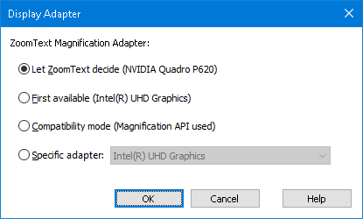
- Select one of the following display adapter options:
- Let ZoomText decide. When ZoomText starts, it will detect and choose the best display adapter to use.
- First available. Select to let Windows choose the display adapter to use with ZoomText.
- Compatibility mode. Select this option if ZoomText does not work well with your display adapter.
- Specific adapter. Select this setting to assign ZoomText to always use a specific display adapter. The available display adapters appear in the list.
- Select OK, and then YES to restart ZoomText for the change to take effect.

Early Adopter Program
Note: The Early Adopter Program lets you preview new and updated product features that are in development. As we gradually introduce features, you can evaluate them and provide feedback that will help us make improvements before final release.
Using the Early Adopter Program
- To turn on or off Early Adopter Program features
- In the ZoomText menu, choose Help > Early Adopter Program.
The Early Adopter Program dialog appears and shows the features available to evaluate. The dialog is empty if no features are currently available.
- Select one or more check boxes to activate features. Clear one or more check boxes to deactivate features.
Note: If you are evaluating changes to an existing product feature, it will revert to its original operation when you clear the check box.
- Click OK and restart the software. Features that were turned on are available for use.
Submitting feedback
While evaluating a feature, you are encouraged to give feedback about your experience. Feedback can be given whether the feature is activated or not.
- To give feedback
- In the ZoomText menu, choose Help > Early Adopter Program.
The Early Adopter Program dialog displays the features available to evaluate.
- Select the Send Feedback button for the feature you are evaluating.
The Early Adopter Program Feedback form appears.
- Complete the Early Adopter Program Feedback form and click Send Feedback.
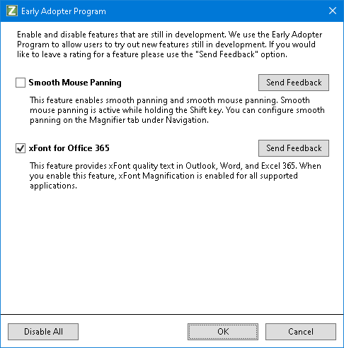
An example of the Early Adopter Program dialog.
Setting | Description
Features in Development: | Displays the name and description of features available to preview. Select the checkbox to turn on the feature. Clear the check box to turn off the feature. When you turn off a feature, it will revert to its earlier functionality.
Send Feedback | Opens a form for you to provide feedback about a feature.
Disable All | Turns off all features.

Training Center
The Training Center provides a wide variety of how-to and technical articles on ZoomText.
- To open the Training Center
- In the ZoomText menu, choose Help > Training Center.

About ZoomText
The About ZoomText dialog shows program and license information, including the product type, version, serial number and user name.
- To view the About ZoomText information
- In the ZoomText menu, choose Help > About.
The About ZoomText dialog appears.
- When you are done viewing the dialog, click OK.
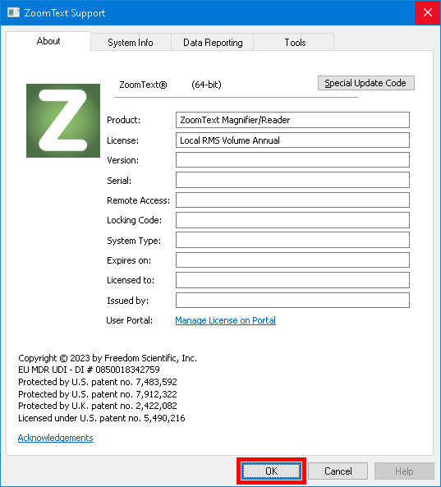
The About ZoomText dialog box
Setting | Description
Product | Displays the type of product: 'Magnifier' or 'Magnifier/Reader'.
Type | Displays the type of installation: 'Product' or 'Trial'.
Version | Displays the ZoomText product version and build number.
Serial Number | Displays the product serial number.  Note: a serial number is not displayed when running a trial version of ZoomText.
Name | Displays the name of the registered user.
Company | Displays the company name of the registered user.
Chapter 12

Message Center
Message Center is your hub for timely announcements from Freedom Scientific to help maximize your experience with ZoomText and Fusion. The messages cover various topics, including:
- Product specific training tips to explore key features.
- Information about new features and changes in updates.
- Details about upcoming webinars and additional training opportunities.
- Notifications about new FSCast podcast episodes.
By default, a notification is spoken and displayed when new messages are available. This is a standard Windows background notification, similar to those received from other apps such as Outlook.
Note: This feature may not be supported by your user interface language.
- To open Message Center
Do one of the following:
- Choose Message Center from the ZoomText menu or the Fusion menu. The number of unread messages also appears next to the Message Center command. For example, Message Center (2) means you have two unread messages.
- Use Voice Assistant. For example, "Hey Zoomy, open message center."
- For Fusion, use the layered keystroke, INSERT+SPACEBAR, followed by SHIFT+M.
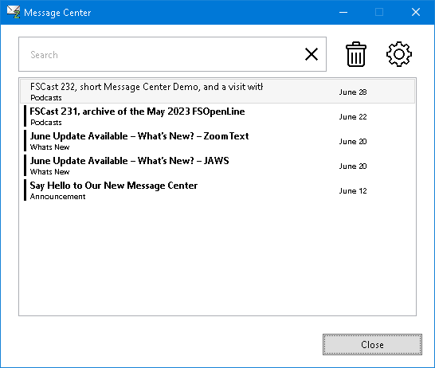
The Message Center dialog box
- To access your messages
- When Message Center opens, you are placed in the list of messages.
- Pressing ENTER on the currently selected message displays additional details, such as release notes for an update, step-by-step instructions for a training tip, or an overview of an FSCast episode.
- If the message includes links to external content, pressing ENTER opens the resource in the appropriate app on your computer. For instance, links to web pages open in your default web browser.
Message Center also offers the following options:
- Filter the list by entering a category like "podcast" into the Search edit box to only show specific messages.
- Use the Settings dialog box to choose whether or not you are notified when new messages arrive. You can also configure what types of messages you receive. For example, you may only want to receive announcements about upcoming training opportunities and software updates.
- Delete messages you no longer need.

Chapter 13

Scripting
In today's computer-centric world, visually-impaired individuals are challenged to meet the same performance goals as their normal-sighted peers. In many situations, especially job related, it can be difficult for these individuals to meet their goals, even when equipped with ZoomText.
With ZoomText’s scripting feature you can create and utilize scripts to customize the behavior of ZoomText and other applications, providing more informative visual and audible feedback, and automation of tasks. This is turn allows you to work with improved speed and efficiency.
Here are just a few examples of things you can do with ZoomText scripting:
- Automatically announce selected fields of information in a database or spreadsheet.
- Automatically announce new items in your email inbox and automatically read email when opened.
- Automatically announce application controls and data in more meaningful way.
- Automatically read new text that arrives in a chat window.
- Automatically announce when a selected field of information changes, such as the balance in spreadsheet dipping below a specified value.
This section provides instructions for writing, registering, managing ZoomText scripts.
- What Are Scripts?
- Writing Scripts
- Registering Scripts
- Managing Scripts
- Script Hotkeys
- Documentation

What are Scripts and Scripting Languages?
What is a script? A script is a text file containing programming commands that initiate a given ZoomText or application task. Scripts can consist of a few lines of very simple commands or many lines of complex programming. ZoomText scripts are written using one of the industry standard scripting languages, such as VBScript, Jscript/JavaScript, C# or Perl. No special tools are required to write a script, in fact, scripts can be written using the Windows Notepad. However, you must have some knowledge and experience writing scripts.
What are scripting languages? Scripting languages are programming languages that control existing applications or their components. Scripting languages can be created and used without special programming software or the need for traditional compiling and building of program code. Thus, they favor rapid development and the ability to communicate with other programs. There are many different scripting languages, each of which is generally designed for a specific type of use.
What scripting languages can be used to write ZoomText scripts? The standard industry scripting languages that we suggest are: VBScript, Jscript/JavaScript, C# and Perl.

Writing ZoomText Scripts
Although most anyone can learn to write basic ZoomText scripts, writing true productivity scripts requires an amount of experience and expertise. Therefore, Freedom Scientific recommends using an experienced script writer to design, create and test scripts – preferably one that is understands the challenges faced by visually-impaired computer users.
An experienced script writer may be available within your company or organization – start by checking with your department manager or IT department. You may also find an experienced script writer through services advertised on the Internet. If you are unable to find a script writer on your own, Freedom Scientific may be able to assist you in finding a script writer – contact Freedom Scientific’s product support department at 727-803-8600 or send email to support@freedomscientific.com.
Other Sources of ZoomText Scripts
With growing popularity of ZoomText scripting a variety of scripts for mainstream applications will become available for users to download and purchase. These scripts will be made available in the ZoomText Scripting Library on Ai Squared’s website. For more information, go to www.aisquared.com/scripting.

Registering Scripts
In order to use scripts written for ZoomText they must first be registered using ZoomText's Script Manager. There are two types of ZoomText scripts that can be registered; script programs and script components.
- A script program is a text file and can be registered by simply browsing to and selecting its corresponding file. Script program files are typically written in VBscript (.VBS), Jscript (.JS) or Perl (.PL) scripting languages.
- A script component is a program file that must first be registered with Windows and ZoomText. These program files typically have a .DLL or .WSC files extension.
Important! You must have administrative privileges to register scripts and make changes in the ZoomText Script Manager. Registering and modifying scripts can adversely affect the behavior of your system and should only be performed by a qualified individual or according to their instructions.
- To register a 'script program' with ZoomText (e.g. VBS, JS, PL)
- In the ZoomText menu, choose Help > Advanced > Scripting > Script Manager.
The Script Manager dialog appears.
- In the Script Manager dialog, choose Register a Script...
The Register Script dialog appears.
- Browse to folder containing the script program you want to register.
- Select the script program and click OK.
The Script Manager dialog appears.
- Click OK.
- To register a 'script component' with ZoomText (e.g. DLL, WSC)
- If your script component is already registered with the Windows operating system, proceed to step 2. Otherwise, register your script with Windows as follows:
- To register a Windows scripting component (.WSC file):
a) In Windows Explorer, locate the scripting file.
b) Right-click on the file and select Register.
- To register a COM scripting component (.DLL file):
a) Click on the Windows Start button and select Run...
b) Type: COMMAND
c) Click OK.
The command prompt appears.
d) At the command prompt, type: REGSVR32 {path\filename of script}
e) Press the Enter key.
The script is registered with Windows.
f) Type: EXIT
g) Press the Enter key.
The command prompt window closes.
- In the Settings menu, choose Scripting Script Manager...
The Script Manager dialog appears.
- In the Script Manager dialog, choose Register a Script...
The Register Script dialog appears.
- In the Script component program ID field, type the program ID (aka ProgID) for the script component you want to register.
- Click OK.
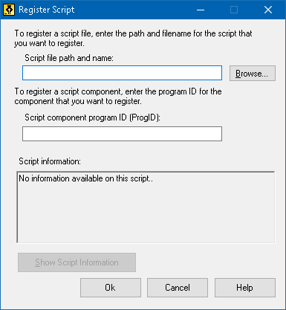
The Register Script dialog box.
Setting | Description
Script file path and name: | Provides a place for you to type the location and file name of the script program you want to register. If you are not sure of the program's location or file name, click Browse.
Browse... | Displays the Select Script File dialog box, which allows you to navigate files folders and select existing script files.
Script component program ID (ProgID): | Provides a place for you to type the program ID for the script component you want to register. Program IDs are provided by the script author.
Script information | Displays information about the specified script file or script component (if provided within the script), including the author date, version, contact information and a description of the script's purpose.
Show Script Information | When entering a program ID, clicking the Show Script Information button will display the script information (if provided within the script).

Managing Scripts
ZoomText’s scripting feature allows you to register and run scripts for any application. Some users may only require a few scripts for a single application, while other may need many scripts for many applications. The ZoomText Script Manager makes the process of registering, viewing and managing scripts a simple and intuitive task.
Here's what you can do with the ZoomText Script Manager:
- Register new scripts written for ZoomText
- Quickly enable and disable scripts as needed (without having to unregister them)
- Open and edit scripts. Important: Editing scripts should only be performed by a qualified script writer.
- View a description of each script, including the scripts purpose
Note: You must have administrative privileges to make changes in the ZoomText Script Manager. Registering and modifying scripts can adversely affect the behavior of your system and should only be performed by a qualified individual or according to their instructions.
- To view and manage ZoomText scripts
- In the ZoomText menu, choose Help > Advanced > Scripting > Script Manager.
The Script Manager dialog appears.
- Modify the registered scripts as desired.
- Click Close.
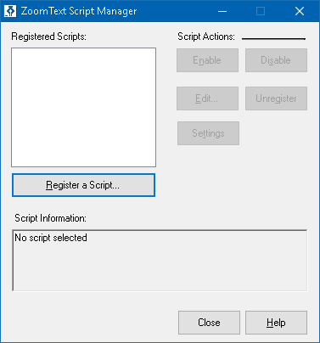
The ZoomText Script Manager dialog box.
Setting | Description
Registered Scripts: | Displays a list of scripts that are currently registered for use when ZoomText is running. Scripts that appear in this list may be enabled and disabled, moved up and down to prioritize their execution (when triggered by the same event), or removed altogether by unregistering the script. To perform these actions, select the desired script (or scripts) and then choose the desired script action.
Register a Script... | Opens the Register Script dialog where you can specify scripts that you want to register for use with ZoomText. For information on how to register a script, see Registering Scripts.
Script Information: | Displays information about the highlighted script (if provided by the script author), including the author date, version, contact information and a description of the script's purpose.
Script Actions
Enable | Enables the highlighted script (or scripts). When a script is enabled it is executed whenever ZoomText is running — according to its designed purpose.  Note: A script can also be enabled or disabled by clicking its associated check box.
Disable | Disables the highlighted script (or scripts). When a script is disabled it remains registered with ZoomText but is not executed.  Note: A script can also be enabled or disabled by clicking its associated check box.
Edit... | Opens the selected script in the Windows Notepad where it may be viewed and edited.
Unregister | Removes the selected script so that it is no longer loaded by ZoomText. When a script is unregistered it is immediately terminated and removed from the list of Registered Scripts.
Settings | Displays the Settings Interface for the selected script.
For more information about creating and registering scripts, see the ZoomText Scripting Documentation for Script Writers. In the ZoomText menu, choose Scripting > Documentation.

Script Hotkeys
ZoomText scripts can be written so that they execute automatically in response to specified events or when pressing a hotkey (or hotkeys). When a script is written for execution by hotkey(s), the hotkey(s) will appear in ZoomText's Hotkeys dialog box. Like all ZoomText hotkeys, you can view and modify the script hotkey assignments.
- To view the script hotkeys
- In the ZoomText menu, choose Preferences > Command Keys
The ZoomText Command Keys dialog appears.
- In the Search box, type: SCRIPTS.
A list of script hotkeys appear in the Hotkeys Command list.
- To view a script hotkeys assigned key combination, click on the desired script hotkey.
The hotkey's assigned key combination appears in the Primary Key and Modifier Keys settings.
- Adjust the hotkey combination as desired.
- Repeat steps 3 and 4 for each hotkey you wish to view or modify.
- Click OK.

Scripting Documentation for Script Writers
The ZoomText Scripting Documentation for Script Writers provides instructional information for writing and testing ZoomText scripts.
- To view the Documentation for Script Writers
In the ZoomText menu, choose Help > Advanced > Scripting > Documentation.

Index
about ZoomText, 328
activation
activating ZoomText, 16
dongle authorization, 17
network license, 17
adding more voices, 19
adjusting zoom windows, 88
alignment (navigation), 139
anonymous data usage, 312
application settings
about, 263
managing, 263
saving, 263
AppReader, 177
App View, 178
App View settings, 187
reading modes, 178
Shared Settings, 194
SpeakIt Tool, 178
starting and using, 183
Text View, 178
Text View environment, 180
Text View settings, 190
audio settings, 163
Background Reader, 235
camera, 225
Caps Lock key (using), 25
color enhancements, 119
command keys
about, 45
all commands, 282
dialog, 50
essential command keys, 48
hotkeys, 46
layered keys, 46
types of, 46
commands (by group)
AppReader, 283
Background Reader, 285
Finder, 289
Layered Mode, 291
Magnifier, 293
Program, 295
Reader, 296
Reading Zones, 297
Say, 211, 300
Scroll, 302
Support, 304
Text Cursor, 208, 306
Window, 307
ZoomText Camera, 287
ZoomText Recorder, 299
configurations
about, 259
hotkeys, 262
saving and loading, 261
the default configuration, 260
cursor enhancements, 127
data reporting, 312
display adapter, 322
dongle authorization, 17
EAP, 324
Early Adopter Program, 324
echo settings
about, 165
Keyboard Echo, 166
Mouse Echo, 169
Program Echo, 172
Verbosity, 174
enabling and disabling ZoomText, 24
error report, 316
excluding xFont from applications, 276
exiting ZoomText, 26
features
Magnifier, 3
Magnifier/Reader, 5
Finder, 215
commands, 219
highlight and voice settings, 221
list search, 217
page search, 215
starting, 215
toolbar, 215, 217
Fix-It command, 320
focus enhancements, 131
Freeze View, 94
FS support tool, 316
Fusion keyboard help, 245
getting help, 27
getting started
new users, 7
help, 27
using help, 27
Hey Zoomy, 245
hints (voice), 160
hotkeys
configuration hotkeys, 262
resolving conflicts, 57
installing ZoomText, 14
JAWS keyboard help, 245
keyboard echo, 166
legacy reading preferences, 279
legal
Copyrights, 2
Trademarks, 2
logon prompt, 29
Magnifier features (about), 67
Magnifier toolbar tab, 68
Message Center, 330
mouse (navigation), 142
mouse echo, 169
mouse panning, 144
multiple monitors
about, 105
Automatic Adjustment to Display Changes, 113
Configuring Displays, 111
Feature Behaviors in Multple Monitors, 114
Options, 106
Recommended Monitor Configurations, 110
Supported Multiple Monitor Hardware, 109
Troubleshooting, 116
navigation settings
about, 136
Alignment, 139
Mouse, 142
Panning, 144
Tracking, 137
network license, 17
overview mode, 102
panning (navigation), 144
pointer enhancements, 123
preferences
about, 266
excluding xFont, 276
legacy reading, 279
program, 267
Run ZoomText As, 281
smoothing, 274
user interface, 271
program echo, 172
program preferences, 267
Quick Access Bar, 35
Reader features (about), 146
Reader toolbar tab, 147
Reading Zones
about, 197
creating, editing and deleting, 198
settings, 204
toolbar, 203
using, 201
remote desktop, 318
Run ZoomText As, 281
running with one or multiple monitors, 79
running ZoomText, 22
Say commands, 211
screen enhancements
about, 118
Color Enhancements, 119
Cursor Enhancements, 127
Focus Enhancements, 131
Pointer Enhancements, 123
Smart Invert, 135
Screen Shade, 44
scripting
about, 333
documentation, 345
managing scripts, 341
registering scripts, 337
script hotkeys, 344
what are scripts?, 335
writing scripts, 336
scrolling the magnified view, 76
secure mode support, 29
sensitivity, 144
setting up ZoomText, 12
adding more voices, 19
Step 1—Install ZoomText, 14
Step 2—Start ZoomText, 15
Step 3—Activate ZoomText, 16
Step 4—Update ZoomText, 18
System Requirements, 13
Uninstalling ZoomText, 21
Using the Startup Wizard, 20
smart invert, 135
smoothing preferences, 274
excluding xFont, 276
SpeakIt Tool, 178
starting ZoomText, 15, 23
starting automatically, 23
support
about ZoomText, 328
data reporting, 312
display adapter, 322
error reporting, 312
Fix-It command, 320
FS support tool, 316
online support, 327
remote desktop, 318
system information, 310
ZoomText support, 309
system information, 310
system requirements, 13
technical support, 27
Technical Support, 315
Tethered View, 89
Text Cursor commands, 208
text processing (voices), 156
toolbar
Magnifier tab, 68
minimizing and restoring, 34
operating with the keyboard, 34
Reader tab, 147
Tools tab, 214
tooltips, 27
ZoomText toolbar, 33
toolbar tooltip
enabling and disabling, 28
tools
Background Reader, 235
Finder, 215
support, 315
Technical Support, 315
Voice Assistant, 245
ZoomText Camera, 225
ZoomText Recorder, 240
Tools (support), 315
Tools features (about), 213
Tools toolbar tab, 214
tooltips, 27
touch screen support
about, 58
Accessing ZoomText Features, 63
Using the ZoomText Touch Icon, 60
Using ZoomText On a Touch Screen, 59
tracking (navigation), 137
training center, 327
UAC, 29
uninstalling ZoomText, 21
updating ZoomText, 18
enabling and disabling automatic updating, 18
using automatic updating, 18
using manual updating, 18
user guide
ZoomText user guide, 27
user interface, 32
user interface preferences, 271
using the Startup Wizard, 20
verbosity, 174
view locator, 102
voice
adjust the voice rate, 151
enabling and disabling, 150
The ZoomText Voice, 149
Voice Assistant, 245
voice settings, 152
Audio, 163
Hints, 160
Text Processing, 156
Voice, 152
wake word, 245
Welcome to ZoomText, 1
zoom level
Choosing a Set of Zoom Levels, 71
All Zoom Levels, 71
Favorite Zoom Levels, 71
Whole Powers, 71
Customizing Mouse Wheel Zooming, 73
mouse wheel zooming, 70
Using Zoom to 1x, 75
Zooming In and Out, 70
Zoom to 1x, 75
zoom windows
about, 78
adjusting, 88
Freeze View, 94
running with one or multiple monitors, 79
scrolling the magnified view, 76
selecting, 80
Tethered View, 89
Using OverView Mode and the View Locator, 102
Using Zoom to 1x, 75
when using multiple monitors, 78, 80
when using one monitor, 78, 80
zooming in and out, 70
ZoomText Camera, 225
acquiring a camera, 225
camera settings dialog, 230
getting started, 225
setting up a camera, 226
using, 227
video and system performance., 230
ZoomText Help, 27
ZoomText Recorder, 240
ZoomText Secure Mode, 29
enabling and disabling, 30
toolbar, 29
ZoomText support, 309
ZoomText toolbar, 33
minimizing and restoring, 34
ZoomText touch icon, 60
ZoomText Voice, 149
Zoomy, 245

Notes

